Blue Mountain Piedmonts
Plain [Landscape Term] A general term referring to an extensive, lowland area that ranges from level to gently sloping or undulating. A plain has few or no prominent hills or valleys, and usually occurs at low elevation relative to surrounding areas. (Bates and Jackson, 1980)

Landform Association:
Piedmonts:
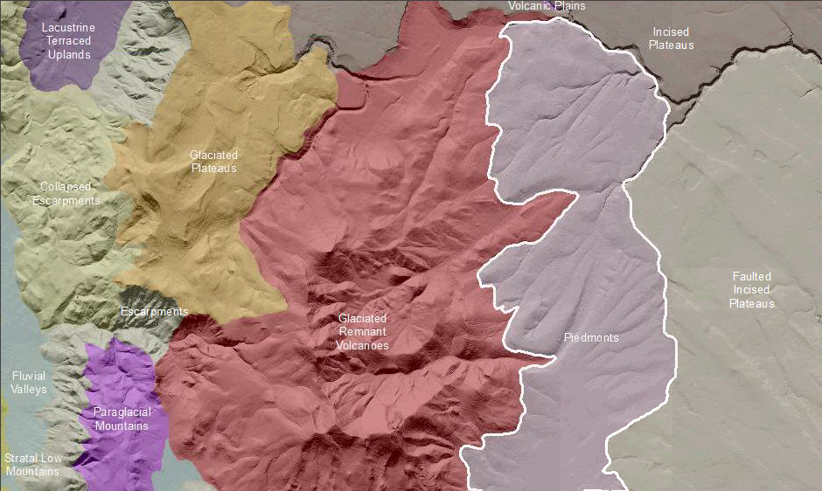

Piedmonts are incised and eroded low sloping aprons at the front of a mountain, typically with underlying bedrock. Where incised by channels, rugged steep sided slopes and non-linear concave slopes feed into gully bottoms. Piedmonts can be so dissected by fluvial erosion so that isolated hills are formed. Piedmonts ridge-tops are the last vestiges of a once broad plain, typically formed by coalescing fluvial fans. These ridge-tops form accordant ridges which together define a planear surface some several meters below the elevation of the original piedmont surface (e.g. fluvial plain). Weathering and other processes have removed material at a relatively uniform rate to form relatively symmetrical ridge slopes. In the Blue Mountains the piedmont is a degradational transition from mountain to river bottom, not constructional.
Piedmont soils vary with geomorphic position, from relatively deep residual profiles on ridgetops to toeslope bottoms where soil profiles are deep and rich with organic matter, with shallow soils on the backslopes. Ridgetop soils have mima mounds and pattern ground. This map unit typically supports rangelands although those at higher elevations support mixed grassland and forest.

This Landform Association is rare on National Forest System Lands.
Landtype Associations: Landtype Associations are formed by intersecting vegetation series or groups of vegetation series with Landform Associations.

Topography:
The following tables represent the average conditions for the Landform Association. Only lands within and adjacent to National Forest System Lands were mapped by this project. The entire EPA Level III Ecoregion is not covered by this mapping.

The percent of Landform Association (% of LfA) in bold in the table below refers to the percent of the Ecoregion represented by that Landform Association. The (% of LfA) numbers not in bold in the table below refer to the percent of each Landtype Association within the Landform Association.
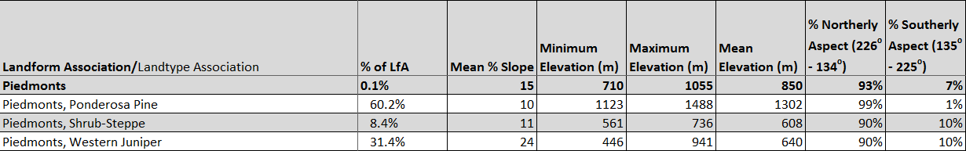

Climate:
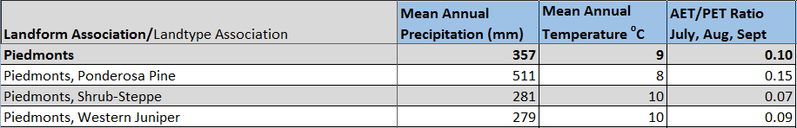

The ratio of Actual Evapotranspiration to Potential Evapotranspiration (AET/PET) is used as a broad-scale indicator of potential drought stress. We obtained modeled actual and potential evapotranspiration datasets from the Numerical Terradynamic Simulation Group at the University of Montana (http://www.ntsg.umt.edu/project/mod16) for a 30 year climate average. AET/PET ratio in the table above is based on a scale of zero to one. A value closer to 1 means the vegetation is transpiring close to its potential. A value farther from 1means that the Actual Evapotranspiration is below potential based on this climatic zone (Ringo, et. al. 2016 in draft).

