Blue Mountain Volcanic Plains
Plain [Landscape Term] A general term referring to an extensive, lowland area that ranges from level to gently sloping or undulating. A plain has few or no prominent hills or valleys, and usually occurs at low elevation relative to surrounding areas. (Bates and Jackson, 1980)

Landform Association:
Volcanic Plains:

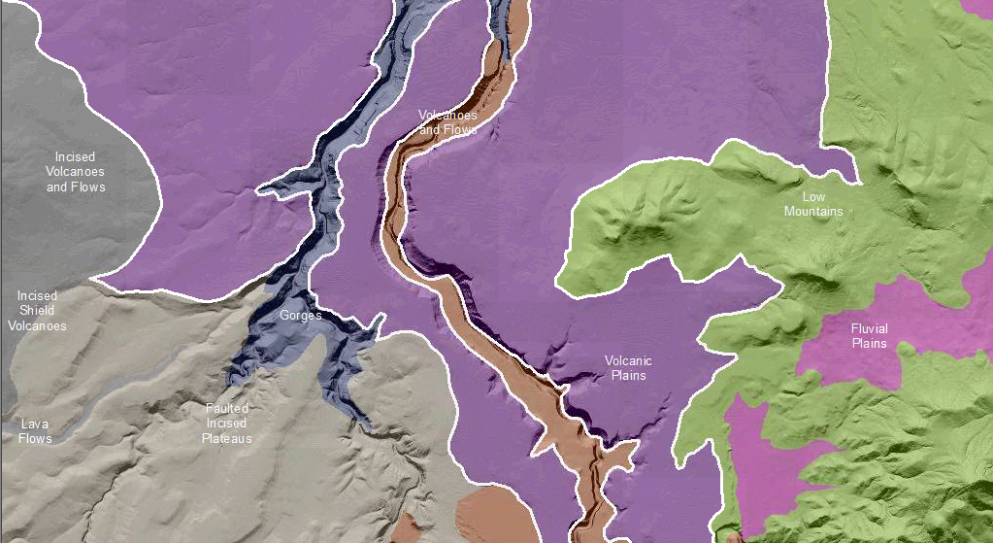

Volcanic Plains are broad expanses of volcanic lava flows issued from extant or now-absent volcanoes or vents. They are characterized by undulating to irregular hill-flat flow topography typical of basalt. Locally vents and small cinder cones, as well as spatter mounds and lava flow pressure ridges form topographic highs on these plains. Tephra deposits and local stream deposits provide some weatherable materials on top of the volcanic flow rock. Soils classify as Andisols.

This Landform Association has a limited spatial extent on National Forest System Lands.

Landtype Associations: Landtype Associations are formed by intersecting vegetation series or groups of vegetation series with Landform Associations.

Topography:
The following tables represent the average conditions for the Landform Association. Only lands within and adjacent to National Forest System Lands were mapped by this project. The entire EPA Level III Ecoregion is not covered by this mapping.

The percent of Landform Association (% of LfA) in bold in the table below refers to the percent of the Ecoregion represented by that Landform Association. The (% of LfA) numbers not in bold in the table below refer to the percent of each Landtype Association within the Landform Association.
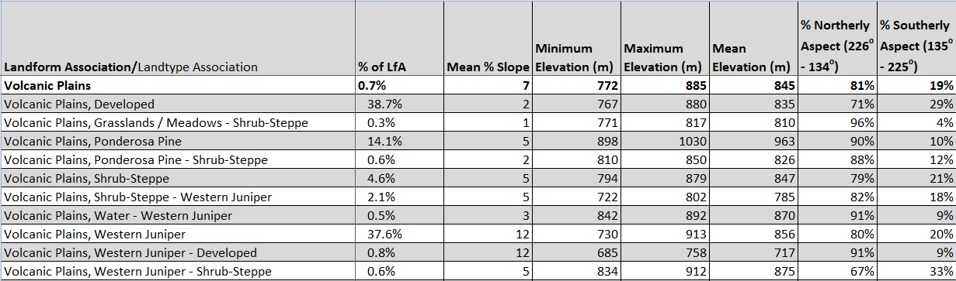

Climate:
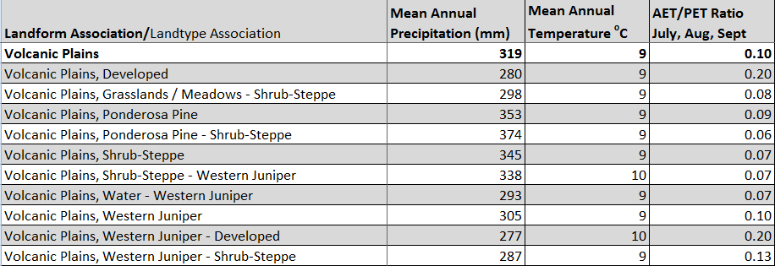

The ratio of Actual Evapotranspiration to Potential Evapotranspiration (AET/PET) is used as a broad-scale indicator of potential drought stress. We obtained modeled actual and potential evapotranspiration datasets from the Numerical Terradynamic Simulation Group at the University of Montana (http://www.ntsg.umt.edu/project/mod16) for a 30 year climate average. AET/PET ratio in the table above is based on a scale of zero to one. A value closer to 1 means the vegetation is transpiring close to its potential. A value farther from 1means that the Actual Evapotranspiration is below potential based on this climatic zone (Ringo, et. al. 2016 in draft).

