Blue Mountains Faulted Incised Plateaus
Plateaus in the Pacific Northwest are predominantly underlain by stacked flows of the Columbia River Basalts and form extensive elevated plains bounded on one or more sides by steep slopes hundreds of feet above adjoining areas. Plateaus are differentiated from each other by the most-evident surficial processes of alteration.

Landform Association:
Faulted Incised Plateaus:

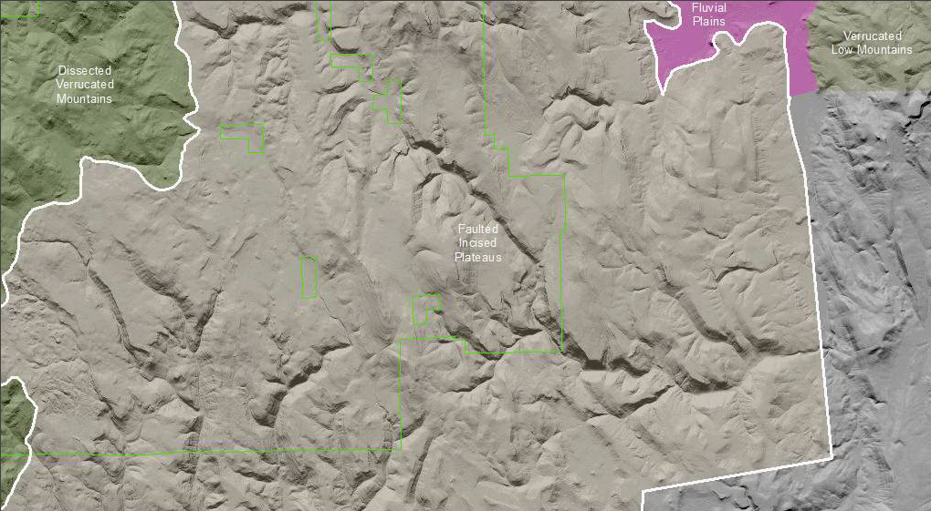

Faulted Incised Plateaus are narrow elongate upland plains cut by parallel and sub-parallel faults. Typically these are normal faults with much more vertical than lateral displacement. The faulting has created positive (uplands) and negative (drainages) patterns with repeating topographic elements. These plateaus are characterized by numerous faults over a broad area up to several kilometers in extent. Many of these faults show evidence of movement during the recent geologic past.

The drainages in the Faulted Incised Plateaus are captured and redirected by displacement of the fault blocks. The rearrangement and redirection of precipitation runoff by the fault blocks gives a zig-zag appearance to catchment channels. The faults are zones of weakness and set up water flows along these zones. Sediment is impounded by fault scarps, in closed depressions, and at locations with lower slope angle. In these pockets of sediment accumulation there is increased soil development.

The slopes in this landform are a mix of steep (tectonic) and not so steep (erosion processes) slope. Bedrock slopes within this map unit occur more as a result of tectonic activity than erosion. The tectonic created slopes are steeper than the angle of repose of slopes created by erosion. These slopes have developed little if any soil mantle. There are valleys with flows that have been diverted or captured flow by other drainages. These captured or diverted drainages are essentially “hanging valleys.” These hanging valleys are dominated by sheet flow at a reduced rate and sediment transport is reduced.

This Landform Association has a limited spatial extent on National Forest System Lands.

Landtype Associations: Landtype Associations are formed by intersecting vegetation series or groups of vegetation series with Landform Associations.

Topography:
The following tables represent the average conditions for the Landform Association. Only lands within and adjacent to National Forest System Lands were mapped by this project. The entire EPA Level III Ecoregion is not covered by this mapping.

The percent of Landform Association (% of LfA) in bold in the table below refers to the percent of the Ecoregion represented by that Landform Association. The (% of LfA) numbers not in bold in the table below refer to the percent of each Landtype Association within the Landform Association.
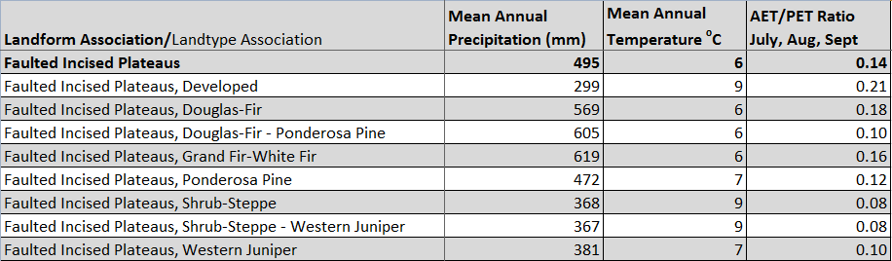

Climate:
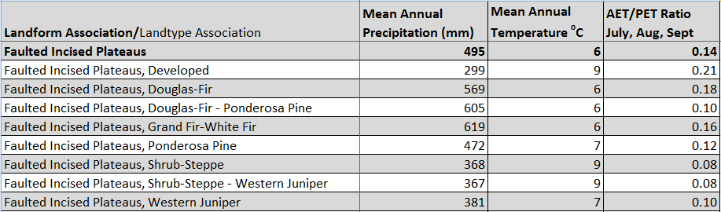

The ratio of Actual Evapotranspiration to Potential Evapotranspiration (AET/PET) is used as a broad-scale indicator of potential drought stress. We obtained modeled actual and potential evapotranspiration datasets from the Numerical Terradynamic Simulation Group at the University of Montana (http://www.ntsg.umt.edu/project/mod16) for a 30 year climate average. AET/PET ratio in the table above is based on a scale of zero to one. A value closer to 1 means the vegetation is transpiring close to its potential. A value farther from 1means that the Actual Evapotranspiration is below potential based on this climatic zone (Ringo, et. al. 2016 in draft).

