Blue Mountain Fluvial Terraces
Overall Terrain:
Valley [Landscape Term] (a) Any low-lying land bordered by higher ground; esp. an elongate, relatively large, gently sloping depression of the Earth's surface, commonly situated between two mountains or between ranges of hills or mountains, and often containing a stream with an outlet. It is usually developed by stream erosion, but may be formed by faulting. (b) A broad area of generally flat land extending inland for a considerable distance, drained or watered by a large river and its tributaries; a river basin (Bates and Jackson, 1995).

Landform Association:
Fluvial Terraces:

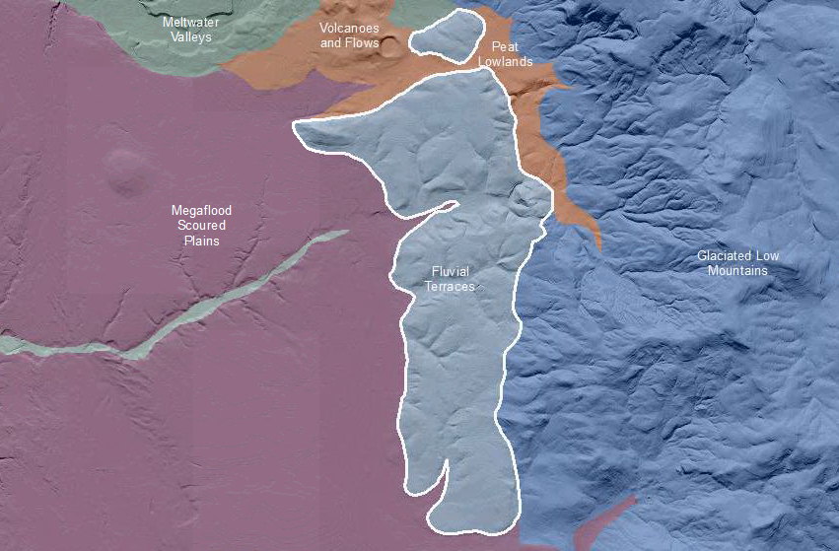

Fluvial Terraces are a step-like surface, bordering a valley floor that represents the former position of a flood plain. Fluvial Terraces characteristics are similar to Fluvial Valleys except this area is recognized as an ancient remnant of an earlier fluvial valley floor (flood plain) now preserved as an upland element. Soils are more mature than the lower, more recent Fluvial Valley landscapes and are classified as Alfisols.

Landtype Associations: Landtypes are formed by intersecting vegetation series or group of vegetation series with landform associations.

Landtype Association | % of LfA | Mean  % Slope | Minimum  Elevation (m) | Maximum Elevation  (m) | Mean Elevation  (m) | %  Northerly Aspect  (240º – 120º) | % Southerly Aspect  (121º – 239º)

Climate:
Landtype Association | Mean Annual Precipitation (mm) | Mean Annual Temperature ºC | AET/PET ratio  June July Aug

