Blue Mountain Meander Belts
Valley [Landscape Term] (a) Any low-lying land bordered by higher ground; esp. an elongate, relatively large, gently sloping depression of the Earth's surface, commonly situated between two mountains or between ranges of hills or mountains, and often containing a stream with an outlet. It is usually developed by stream erosion, but may be formed by faulting. (b) A broad area of generally flat land extending inland for a considerable distance, drained or watered by a large river and its tributaries; a river basin. (Bates and Jackson, 1995)

Landform Association:
Meander Belts
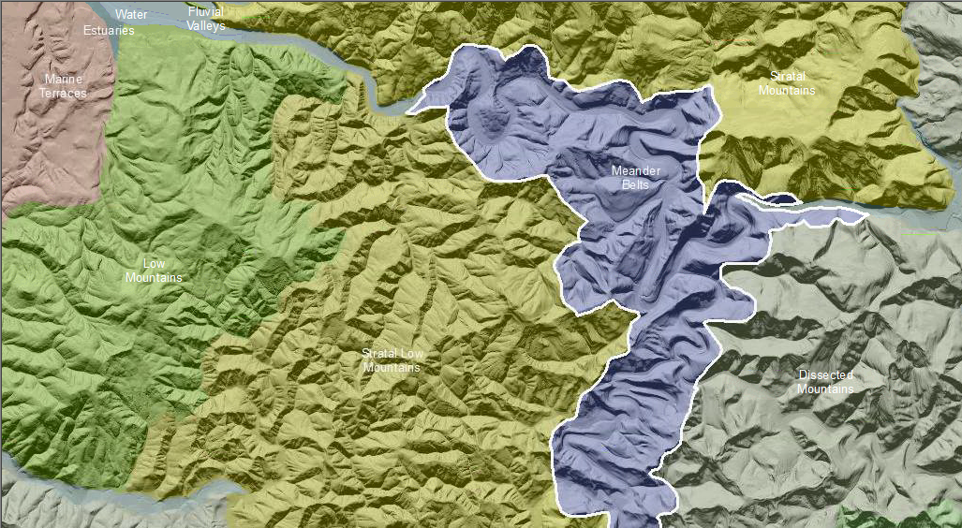

Meander Belts are deep to very deeply incised meander plains; they contains similar landforms to a meandering river except most are greatly exaggerated in relief and are underlain by bedrock. Meander belts initially developed during previous geologic episodes when streams flowed in a sinuous pattern across a plain. Subsequent geologic uplift of the plain led the river to downcut at a rate similar to the uplift resulting in an incised meander belt. The current stream channel at the base of the Meander Belt is undersized in relation to the valley form. During the downcutting process, slopes were scoured, terraces and other stream geomorphic features, now elevated in the landscape, were deposited. The landscape within the Meander Belt is quite complex, resembling the elements of a current floodplain although they are found high on the valley walls above the current floodplain level. Soils vary from immature Entisols near the present stream to more mature soils on terraces at higher elevations.
This Landform Association is rare on National Forest System Lands.
Landtype Associations: Landtype Associations are formed by intersecting vegetation series or groups of vegetation series with Landform Associations.

Topography:
The following tables represent the average conditions for the Landform Association. Only lands within and adjacent to National Forest System Lands were mapped by this project. The entire EPA Level III Ecoregion is not covered by this mapping.

The percent of Landform Association (% of LfA) in bold in the table below refers to the percent of the Ecoregion represented by that Landform Association. The (% of LfA) numbers not in bold in the table below refer to the percent of each Landtype Association within the Landform Association.
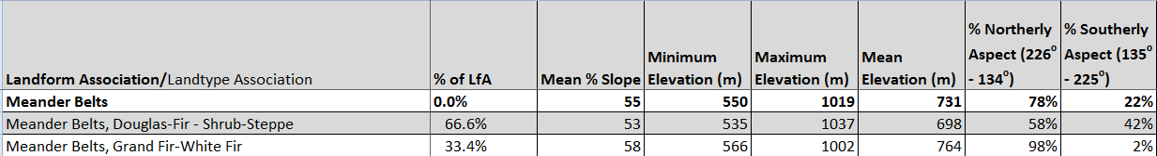

Climate:
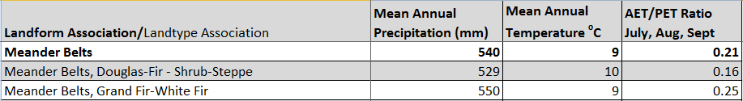

The ratio of Actual Evapotranspiration to Potential Evapotranspiration (AET/PET) is used as a broad-scale indicator of potential drought stress. We obtained modeled actual and potential evapotranspiration datasets from the Numerical Terradynamic Simulation Group at the University of Montana (http://www.ntsg.umt.edu/project/mod16) for a 30 year climate average. AET/PET ratio in the table above is based on a scale of zero to one. A value closer to 1 means the vegetation is transpiring close to its potential. A value farther from 1means that the Actual Evapotranspiration is below potential based on this climatic zone (Ringo, et. al. 2016 in draft).

