Blue Mountain Washboard Canyons
Valley [Landscape Term] (a) Any low-lying land bordered by higher ground; esp. an elongate, relatively large, gently sloping depression of the Earth's surface, commonly situated between two mountains or between ranges of hills or mountains, and often containing a stream with an outlet. It is usually developed by stream erosion, but may be formed by faulting. (b) A broad area of generally flat land extending inland for a considerable distance, drained or watered by a large river and its tributaries; a river basin. (Bates and Jackson, 1995)

Landform Association:
Washboard Canyons
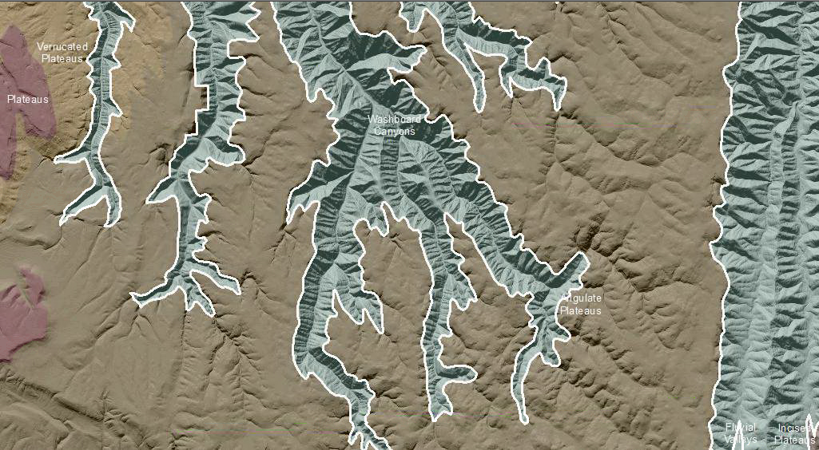

Washboard Canyons are an extensive landform north of the Wallowa Mountains. This is a subset of the Canyonlands Landform Associations. Washboard Canyons are long, linear concave features with a river or an intermittent stream along their central axis. The valley walls of these fluvial channels have a repeating pattern of ridges arrayed perpendicular to the streamcourse, giving the walls a washboard appearance. Rock removal out of this part of the landscape occurs because of mass collapse or creep down slope, that feeds the central active stream. Side channels and swales of the stream network locally have debris flow deposits that spread out along the stream channel, diverting its course. Erosion of the channel with the supplied rock leads to a rejuvenation of the cycle of slope instability and fresh rock supply for transport out of the canyons.
In the Blue Mountains, Washboard Canyons have repeating elements from river to “washboard” hill-slopes up to a ridge and then downslope in reverse in the next catchment. These repeating elements continue across the landscape for hundreds and locally thousands of acres. As with the nearby Canyonlands, hill slopes exhibit a layering pattern due to the underlying Columbia River Basalts. Deep, V-shaped channel erosion of the thin-bedded basalts yield a stepped morphology away from the stream and up the steep rocky slope. The benched landscape is cut by small drainages or gullies so that much of the Washboard Canyons are dominated by right angle (trellis) pattern of the streams.
Limited by the rate the resistant basalt bedrock is decomposed, soil development is limited to thin, rockly prfiles. Capture of loess in older hillslopes deposits of rock debris are common as ridge caps along canyon walls. In general, sediment supply is limited from this LfA. The horizontal strata intercept what sediments accumulate and thin soils form in wedges on some of the benches. These increase in thickness as you move downslope. Soils are typically droughty. Locally, however, northeast-facing slopes have accumulated volcanic ash that results in well-developed soils that hold moisture and facilitate better vegetation, timber and habitat.
This Landform Association has a limited spatial extent on National Forest System Lands.

Landtype Associations: Landtype Associations are formed by intersecting vegetation series or groups of vegetation series with Landform Associations.

Topography:
The following tables represent the average conditions for the Landform Association. Only lands within and adjacent to National Forest System Lands were mapped by this project. The entire EPA Level III Ecoregion is not covered by this mapping.

The percent of Landform Association (% of LfA) in bold in the table below refers to the percent of the Ecoregion represented by that Landform Association. The (% of LfA) numbers not in bold in the table below refer to the percent of each Landtype Association within the Landform Association.
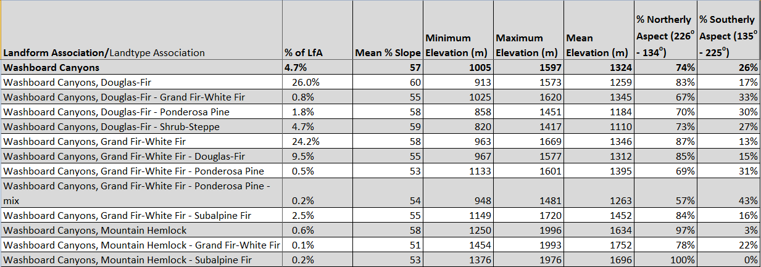

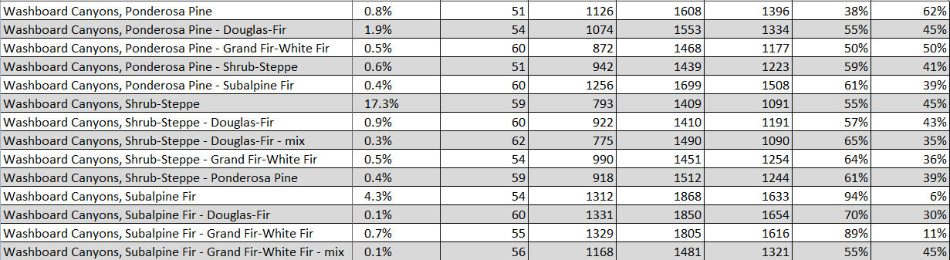

Climate:
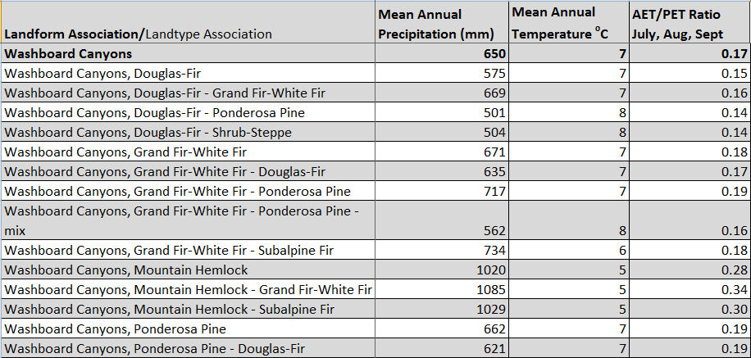
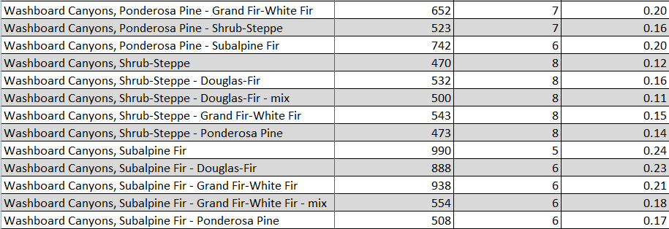
The ratio of Actual Evapotranspiration to Potential Evapotranspiration (AET/PET) is used as a broad-scale indicator of potential drought stress. We obtained modeled actual and potential evapotranspiration datasets from the Numerical Terradynamic Simulation Group at the University of Montana (http://www.ntsg.umt.edu/project/mod16) for a 30 year climate average. AET/PET ratio in the table above is based on a scale of zero to one. A value closer to 1 means the vegetation is transpiring close to its potential. A value farther from 1means that the Actual Evapotranspiration is below potential based on this climatic zone (Ringo, et. al. 2016 in draft).

