Cascades Peat Lowlands

Lowland [Common Landform and Landscape Term] (a) A general term for low-lying land or an extensive region of low land, esp. near the coast and including the extended plains or country lying not far above tide level. (b) The low and relatively level ground of a region, in contrast with the adjacent, higher country; e.g. a vale between two cuestas. (c) A low or level tract of land along a watercourse; a bottom. (Bates and Jackson, 1995)

Landform Association:
Peat Lowlands
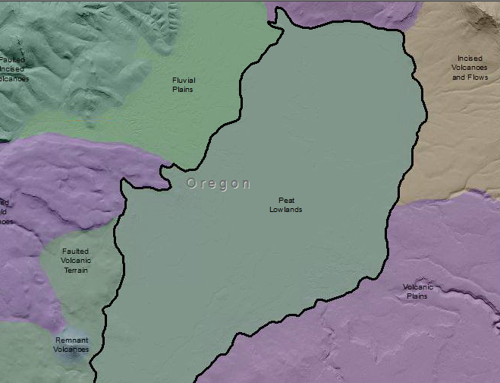

Peat Lowlands are areas of low topographical relief with internal drainage and high water table or surface water evident. Peat or muck accumulation is known or likelihood is high. Peat Lowlands occur in ancient or current marshes and bogs or lakes trapped in glacial valleys which have accumulated marsh or bog vegetation for long periods. Under high water table, anerobic, and acidic conditions the marsh vegetation fails to decay fully turning to peat. Soils are dominantly Histosols, with local inclusions of Entisols and Inceptisols.

This Landform Association is rare on National Forest System Lands.

Landtype Associations: Landtype Associations are formed by intersecting vegetation series or groups of vegetation series with Landform Associations.

Topography:
The following tables represent the average conditions for the Landform Association. Only lands within and adjacent to National Forest System Lands were mapped by this project. The entire EPA Level III Ecoregion is not covered by this mapping.

The percent of Landform Association (% of LfA) in bold in the table below refers to the percent of the Ecoregion represented by that Landform Association. The (% of LfA) numbers not in bold in the table below refer to the percent of each Landtype Association within the Landform Association.
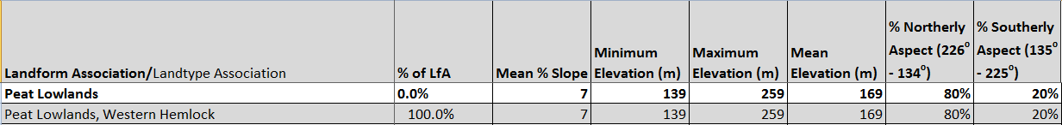

Climate:
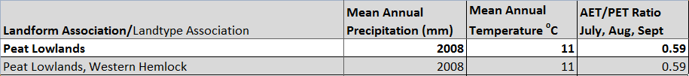

The ratio of Actual Evapotranspiration to Potential Evapotranspiration (AET/PET) is used as a broad-scale indicator of potential drought stress. We obtained modeled actual and potential evapotranspiration datasets from the Numerical Terradynamic Simulation Group at the University of Montana (http://www.ntsg.umt.edu/project/mod16) for a 30 year climate average. AET/PET ratio in the table above is based on a scale of zero to one. A value closer to 1 means the vegetation is transpiring close to its potential. A value farther from 1means that the Actual Evapotranspiration is below potential based on this climatic zone (Ringo, et. al. 2016 in draft).

