Cascades Collapsed Glacial Stratal Mountains
Terrain Class: Mountains - No one process responsible for construction of mountains. They can be uplifted, tectonic, subduction of plates, folding, uplift, up and down warping of the mantle, inflation of molten lower crustal (batholiths), etc. Erosion of mountain systems occurs over time. The rate of erosion is dependent on the geomorphic process, the underlying rock structure, and the climate, including both freeze thaw and the amount and intensity of precipitation and runoff. Mountains are further defined and distinguished based on morphology, including the pattern and density of drainages, depth of drainages, overall morphology of the area between the drainages, evidence of a strong imprint of a surficial process such as glaciation, and presence of visible underlying rock structure.
Mountains have simple to very complex forms that have arisen due to inherited rock structure, rock history, and are the net result of local to regional spatial scales of competing rates of upbuilding/uplift and downgrading/erosion. Mountains will have an inherited history from weathering and degradation of the underlying stack of earth materials that forms them. Vegetation, habitat, water interception, collection and transport will share a similar history in the same type of uplift and rock.

Landform Association: Collapsed Glacial Stratal Mountains
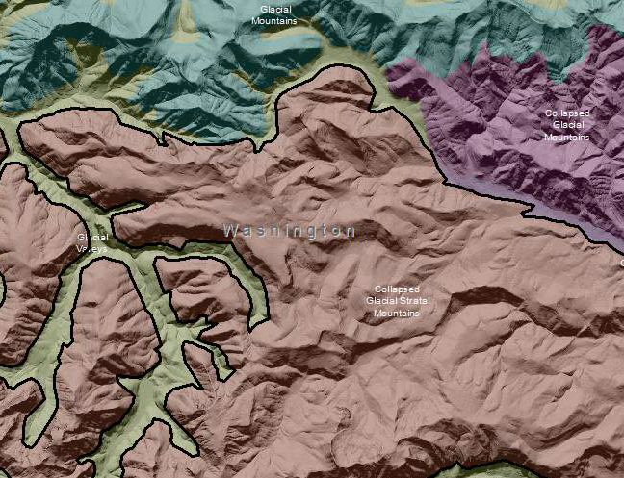

Collapsed Glacial Stratal Mountains are areas shaped by past glaciers yet have obvious signs of glacial scour that have been subject to large-scale landslide events. Ridges have been sculpted by alpine glacial movement, steep cirque basin or glacial valley headwalls are evident in this mapping unit. These areas have strong bedrock structural components that have been subject to large-scale landslide events. These areas have morphologies which reflect the underlying rock structure, which is exposed as a consequence of degradation or denudation of an upland area by glacial and, to a lesser extent, hillslope processes. Glacial sculpting of the mountains reveals obvious layering of the underlying rock structure principally expressed as dip and anti-dip slopes. Synonymous terms used for these features are cuesta and cuestaform. Anti-dip slopes are benchy, rocky and relatively steep slopes. Following the colluvium downhill on an anti-dip slope you find a repeating pattern of bedrock outcrops with intervening areas of accumulated sediment. Habitat and vegetation distribution corresponds to this pattern. Dip slopes, on the other hand, are broad plains with shallow soils and broad expanses of exposed rock. This is an almost featureless terrain with few features to orient by. Potential vegetation and habitat are largely invariable across these sloping plains.

Many large landslides that have collapsed large extents of mountainsides are present within this landform association. Landslide areas can cover many miles and may be from the pre-historic past or a recent and current development. Landslide features can consist of active and inactive zones. Many of these landslides are recognized and the more discreet, well-formed slide areas have been identified in geological maps.

Water routing through this landscape may be irregular due to recent and on-going slope failure with its accompanying surface and subsurface drainage diversions and impoundments. These areas are considered as sources of cool water to streams. Sediment recruitment by streams is significant along the margins of landslides. Sediment and water storage is locally significant. Because of irregular slopes and varied surface water availability, this Landform Association has a diverse upland habitat. The slide areas can hold deep soils, retain moisture and provide micro-climates that offer a variety of excellent resources for numerous floral and faunal communities.

This Landform Association has a limited spatial extent on National Forest System Lands.

Landtype Associations: Landtype Associations are formed by intersecting vegetation series or groups of vegetation series with Landform Associations.

Topography:
The following tables represent the average conditions for the Landform Association. Only lands within and adjacent to National Forest System Lands were mapped by this project. The entire EPA Level III Ecoregion is not covered by this mapping.

The percent of Landform Association (% of LfA) in bold in the table below refers to the percent of the Ecoregion represented by that Landform Association. The (% of LfA) numbers not in bold in the table below refer to the percent of each Landtype Association within the Landform Association.

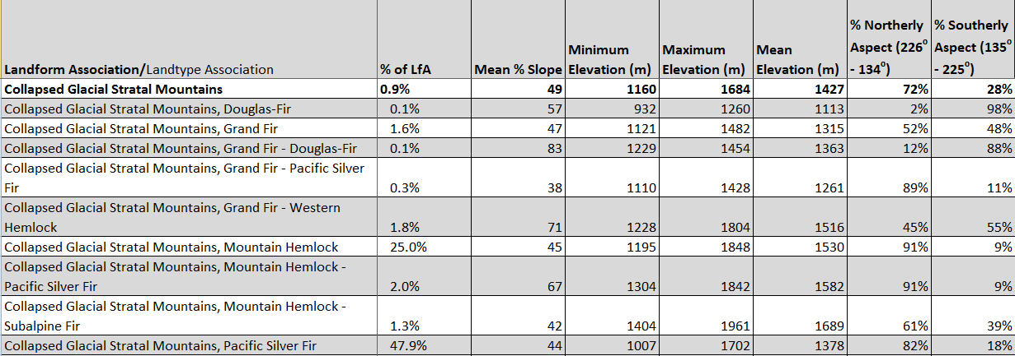
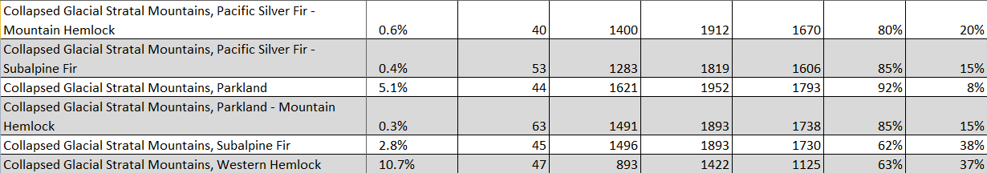

Climate:

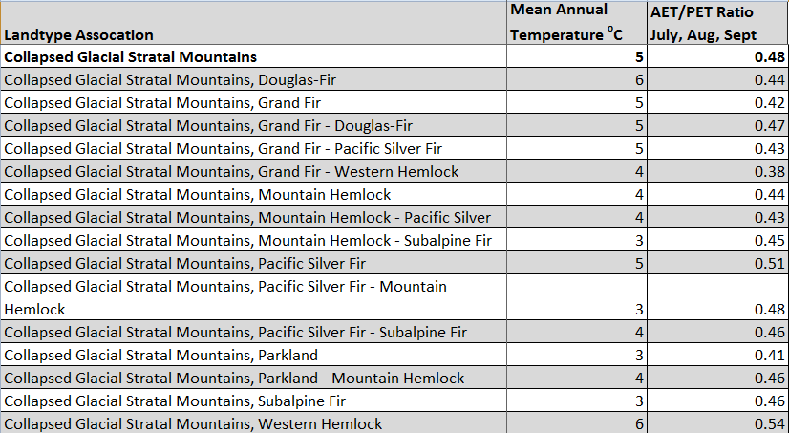

The ratio of Actual Evapotranspiration to Potential Evapotranspiration (AET/PET) is used as a broad-scale indicator of potential drought stress. We obtained modeled actual and potential evapotranspiration datasets from the Numerical Terradynamic Simulation Group at the University of Montana (http://www.ntsg.umt.edu/project/mod16) for a 30 year climate average. AET/PET ratio in the table above is based on a scale of zero to one. A value closer to 1 means the vegetation is transpiring close to its potential. A value farther from 1means that the Actual Evapotranspiration is below potential based on this climatic zone (Ringo, et. al. 2016 in draft).

