Cascades Megaflood Scoured Plains
Overall Terrain:
Plains [Landscape Term] A general term referring to an extensive, lowland area that ranges from level to gently sloping or undulating. A plain has few or no prominent hills or valleys, and usually occurs at low elevation relative to surrounding areas. (Bates and Jackson, 1980)

Landform Association:
Megaflood Scoured Plains:

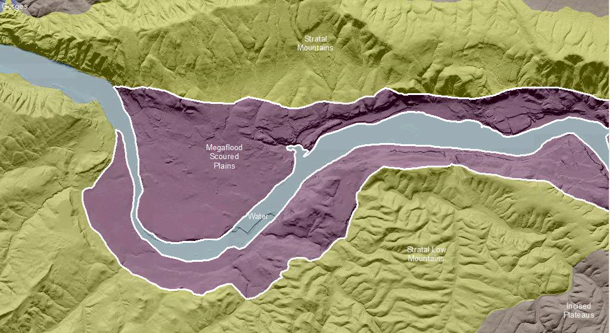

Megaflood Scour Plains are extensive lowlands that formed by scour and erosion during glacial outburst floods (Missoula Floods) along the Columbia River system. The scoured plain consists largely of exhumed tabular basalt flow units within the Columbia Flood Basalts bedrock; the exhumation occurred along flow rock units coincident with elevation of the flood waters. Bare basalt rock is common with surrounding sheets of flood-derived gravelly sediments typically a few meters thick at most. Soil profile development is limited to these sheet sediments and are typically classified as Andisols and Mollisols.

This Landform Association is rare on National Forest System Lands.

Landtype Associations: Landtype Associations are formed by intersecting vegetation series or groups of vegetation series with Landform Associations.

Topography:
The following tables represent the average conditions for the Landform Association. Only lands within and adjacent to National Forest System Lands were mapped by this project. The entire EPA Level III Ecoregion is not covered by this mapping.

The percent of Landform Association (% of LfA) in bold in the table below refers to the percent of the Ecoregion represented by that Landform Association. The (% of LfA) numbers not in bold in the table below refer to the percent of each Landtype Association within the Landform Association.
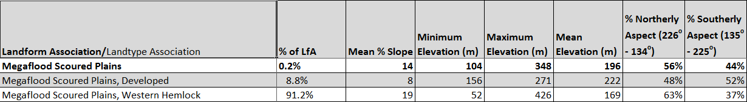

Climate:
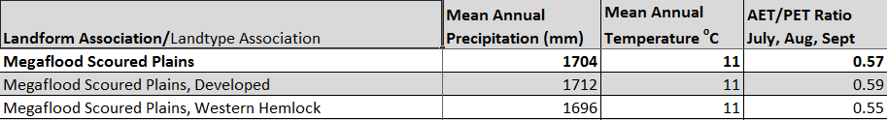

The ratio of Actual Evapotranspiration to Potential Evapotranspiration (AET/PET) is used as a broad-scale indicator of potential drought stress. We obtained modeled actual and potential evapotranspiration datasets from the Numerical Terradynamic Simulation Group at the University of Montana (http://www.ntsg.umt.edu/project/mod16) for a 30 year climate average. AET/PET ratio in the table above is based on a scale of zero to one. A value closer to 1 means the vegetation is transpiring close to its potential. A value farther from 1means that the Actual Evapotranspiration is below potential based on this climatic zone (Ringo, et. al. 2016 in draft).

