Cascades Glaciovolcanic Scours
Terrain Class: Valley [Landscape Term] (a) Any low-lying land bordered by higher ground; esp. an elongate, relatively large, gently sloping depression of the Earth's surface, commonly situated between two mountains or between ranges of hills or mountains, and often containing a stream with an outlet. It is usually developed by stream erosion, but may be formed by faulting. (b) A broad area of generally flat land extending inland for a considerable distance, drained or watered by a large river and its tributaries; a river basin. (Bates and Jackson, 1995)

Landform Association: Glaciovolcanic Scours
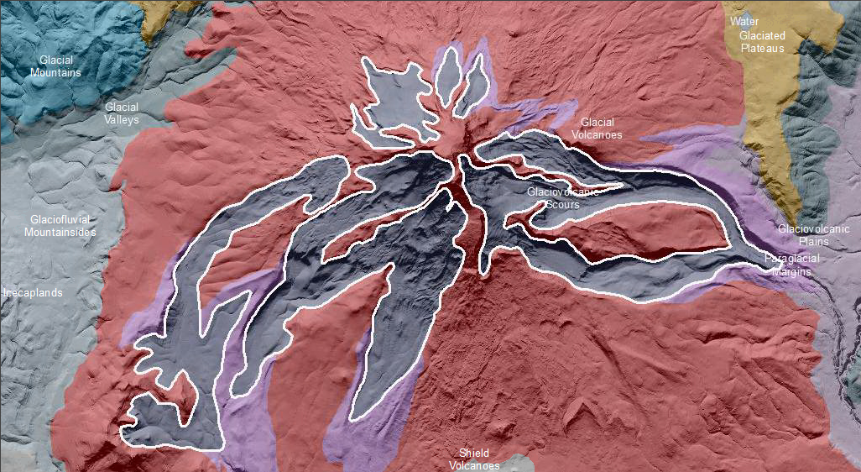

Glaciovolcanic Scours occur on the upper slopes of glacial volcanoes. They are deposits and/or landforms derived from mixed sources of glacial and volcanic processes, including ash-on-ice sourced deposits and subglacial eruptive vents and flows that result in lahars. Scours are the powerful and concentrated clearing and digging action of flowing air, water, or ice, esp. the downward erosion by stream water in sweeping away mud and silt on the outside curve of a bend, or during time of flood.

This Landform Association is rare on National Forest System Lands.

Landtype Associations: Landtype Associations are formed by intersecting vegetation series or groups of vegetation series with Landform Associations.

Topography:
The following tables represent the average conditions for the Landform Association. Only lands within and adjacent to National Forest System Lands were mapped by this project. The entire EPA Level III Ecoregion is not covered by this mapping.

The percent of Landform Association (% of LfA) in bold in the table below refers to the percent of the Ecoregion represented by that Landform Association. The (% of LfA) numbers not in bold in the table below refer to the percent of each Landtype Association within the Landform Association.
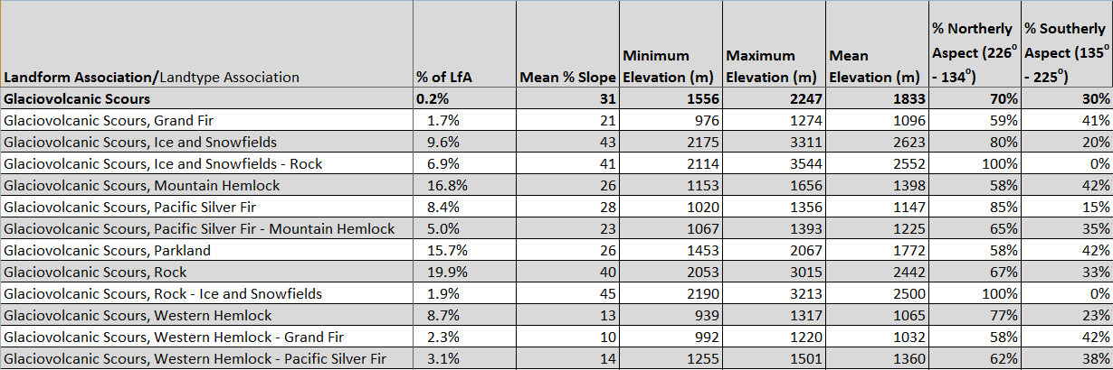

Climate:
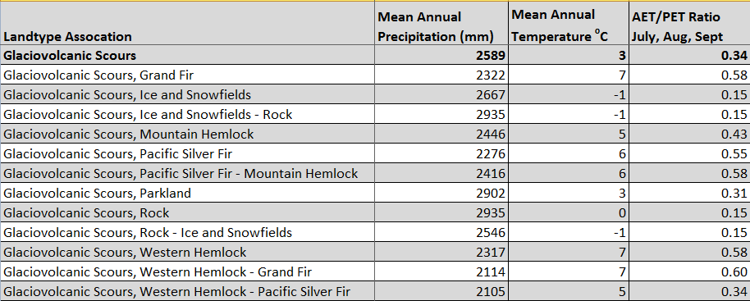
The ratio of Actual Evapotranspiration to Potential Evapotranspiration (AET/PET) is used as a broad-scale indicator of potential drought stress. We obtained modeled actual and potential evapotranspiration datasets from the Numerical Terradynamic Simulation Group at the University of Montana (http://www.ntsg.umt.edu/project/mod16) for a 30 year climate average. AET/PET ratio in the table above is based on a scale of zero to one. A value closer to 1 means the vegetation is transpiring close to its potential. A value farther from 1means that the Actual Evapotranspiration is below potential based on this climatic zone (Ringo, et. al. 2016 in draft).

