Cascades Collapsed Volcanoes
Volcanoes are edifies, typically conical in shape, with a central summit vent that erupts effusive magmatic material as ash, cinder, blocks and or lava that accumulates and build up the landform.
Landform Association – Collapsed Volcanoes:
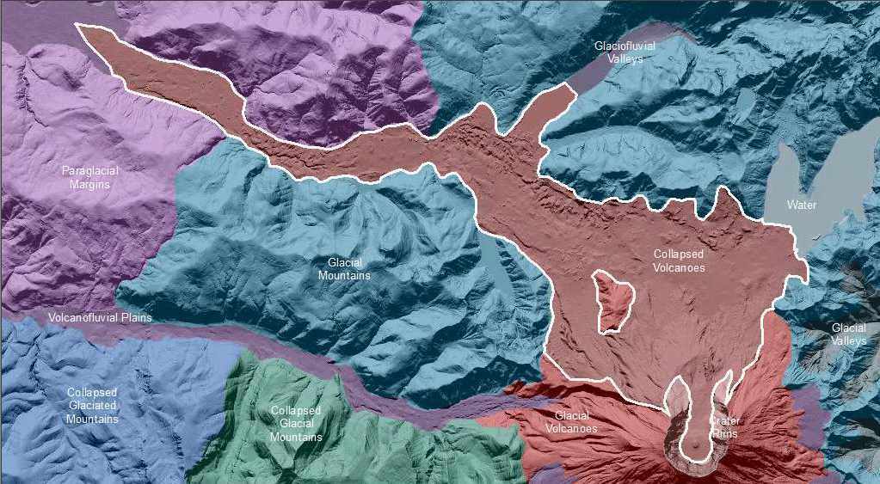

Collapsed Volcanoes outline the collapse debris of Mt. St. Helens. The failure covers many miles from the summit crater. The debris consists of large fragments of the Glacial Volcano as evident by large hills of exogenous bedrock in the former locations of Spirit Lake and Toutle River headwater valleys. These blocks are immersed in lahar deposits resulting from the admixture of eruptive tephra, bedrock and melted glaciers. If soil is present, the soils are in the taxa Entisols and Andisols are present in this map unit.
This Landform Association is rare on National Forest System Lands.

Landtype Associations: Landtype Associations are formed by intersecting vegetation series or groups of vegetation series with Landform Associations.

Topography:
The following tables represent the average conditions for the Landform Association. Only lands within and adjacent to National Forest System Lands were mapped by this project. The entire EPA Level III Ecoregion is not covered by this mapping.

The percent of Landform Association (% of LfA) in bold in the table below refers to the percent of the Ecoregion represented by that Landform Association. The (% of LfA) numbers not in bold in the table below refer to the percent of each Landtype Association within the Landform Associations.

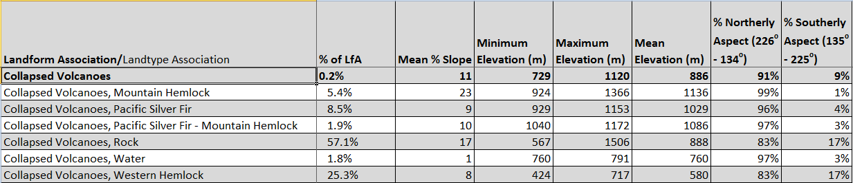

Climate:
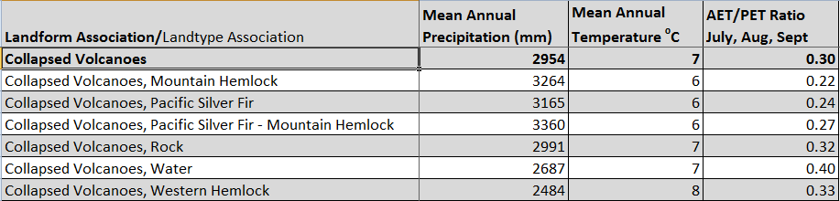

The ratio of Actual Evapotranspiration to Potential Evapotranspiration (AET/PET) is used as a broad-scale indicator of potential drought stress. We obtained modeled actual and potential evapotranspiration datasets from the Numerical Terradynamic Simulation Group at the University of Montana (http://www.ntsg.umt.edu/project/mod16) for a 30 year climate average. AET/PET ratio in the table above is based on a scale of zero to one. A value closer to 1 means the vegetation is transpiring close to its potential. A value farther from 1means that the Actual Evapotranspiration is below potential based on this climatic zone (Ringo, et. al. 2016 in draft).

