Cascades Crater Rims
Volcanoes are edifies, typically conical in shape, with a central summit vent that erupts effusive magmatic material as ash, cinder, blocks and or lava that accumulates and build up the landform.
Landform Association – Crater Rims:
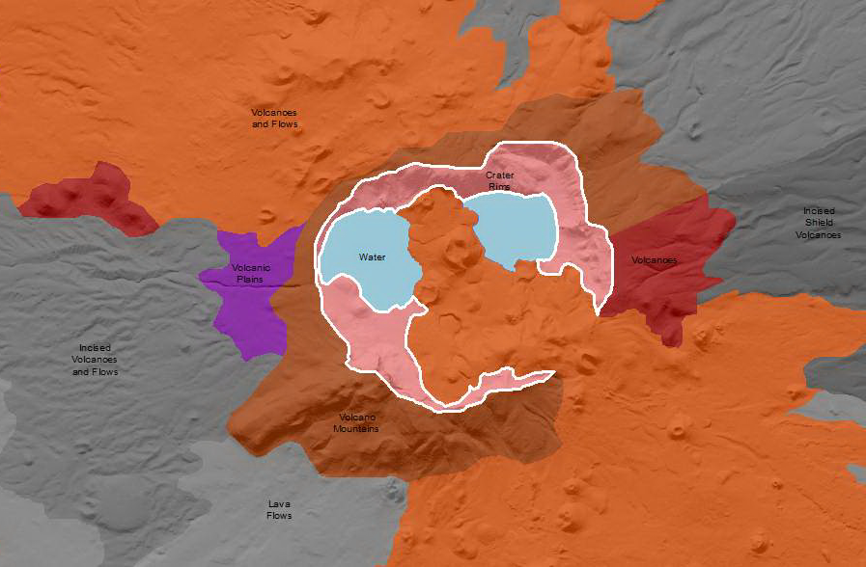

Crater Rims are basin-like, rimmed structure that is usually at the summit of a volcanic cone. It may be formed by collapse, by an explosive eruption, or by the gradual accumulation of pyroclastic material around a vent. Crater Rims are dominantly rock slopes well exceeding the angle of repose. Rock debris clings to these steep slopes in places and along the base of the rim in the form of blockfieds. Crater Rims may be submerged at their base by a crater filling lake (e.g. Crater Lake). Soils are thin and rocky when present.
This Landform Association is rare on National Forest System Lands.

Landtype Associations: Landtype Associations are formed by intersecting vegetation series or groups of vegetation series with Landform Associations.

Topography:
The following tables represent the average conditions for the Landform Association. Only lands within and adjacent to National Forest System Lands were mapped by this project. The entire EPA Level III Ecoregion is not covered by this mapping.

The percent of Landform Association (% of LfA) in bold in the table below refers to the percent of the Ecoregion represented by that Landform Association. The (% of LfA) numbers not in bold in the table below refer to the percent of each Landtype Association within the Landform Associations.
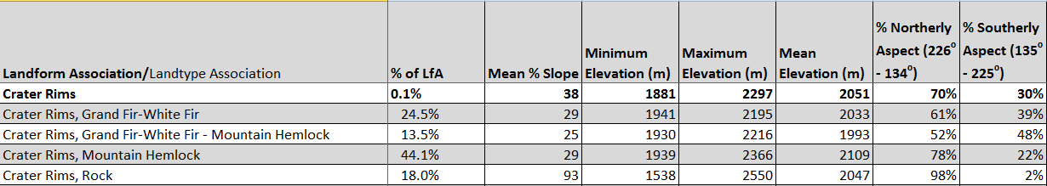

Climate:
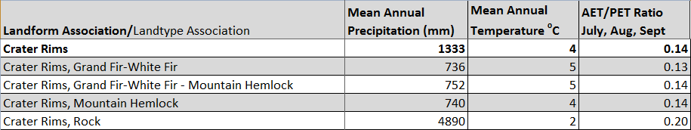

The ratio of Actual Evapotranspiration to Potential Evapotranspiration (AET/PET) is used as a broad-scale indicator of potential drought stress. We obtained modeled actual and potential evapotranspiration datasets from the Numerical Terradynamic Simulation Group at the University of Montana (http://www.ntsg.umt.edu/project/mod16) for a 30 year climate average. AET/PET ratio in the table above is based on a scale of zero to one. A value closer to 1 means the vegetation is transpiring close to its potential. A value farther from 1means that the Actual Evapotranspiration is below potential based on this climatic zone (Ringo, et. al. 2016 in draft).

