Cascades Incised Volcanoes and Flows
Volcanoes are edifies, typically conical in shape, with a central summit vent that erupts effusive magmatic material as ash, cinder, blocks and or lava that accumulates and build up the landform.
Landform Association – Incised Volcanoes and Flows:
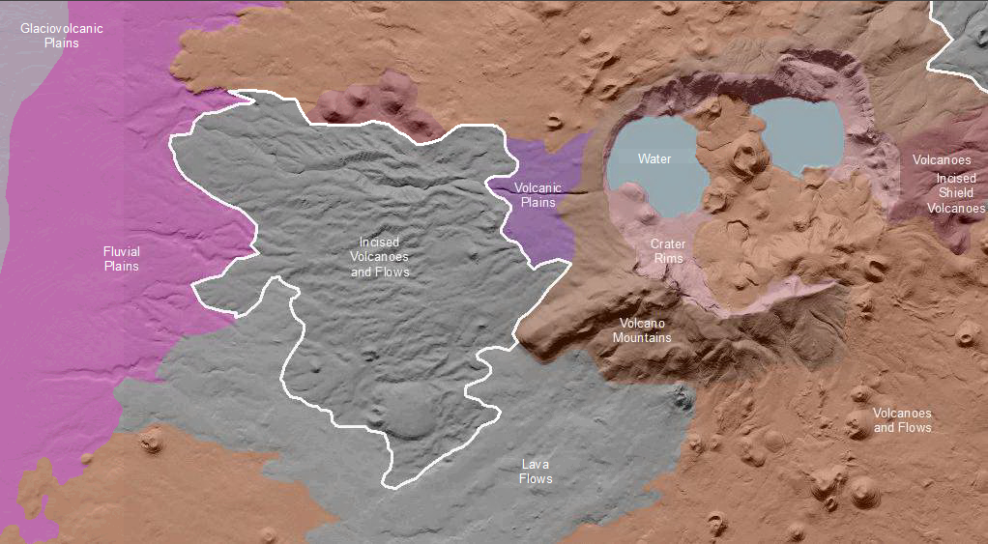

Incised Volcanoes and Flows are landscapes created by volcanoes and their associated lava flows and that have undergone weathering and fluvial erosion to the extent that their original landforms are degraded yet still recognizable. This landscape may locally have been covered by fluvial deposits, such as in intraflow depressions, which have been eroded as well. The appearance of distinct V-shaped channels throughout is the key difference from the younger or less degraded Volcanoes and Flows. The volcanoes are typically of the cinder cone type and these have a near summit depression that sometimes open out onto the landscape and become part of the integrated drainage system. Volcano summits are typically rounded off and side slopes may have gullies indicating soil profile development and the consequent decrease in transmissivity. Stream incision styles range from a sinuous, single threaded mainstem channel with limited tributaries, to dense and equally distributed networks of branching V-shaped channels.
Differential erosion along the margins of volcanoes and their associated lava flows yields mesa or low-relief plateau types of landforms. The volcanic rock shields this landscape from erosional land lowering as fast as adjacent landscapes.

Soils on this landscape are mature and have developed horizons that impede transmission of soil water, thence leading to the development of drainage networks. Soil taxa range from Mollisols with duripans (in dry climates) to Andisols (in humid climates).
This Landform Association has a limited spatial extent on National Forest System Lands.

Landtype Associations: Landtype Associations are formed by intersecting vegetation series or groups of vegetation series with Landform Associations.

Topography:
The following tables represent the average conditions for the Landform Association. Only lands within and adjacent to National Forest System Lands were mapped by this project. The entire EPA Level III Ecoregion is not covered by this mapping.

The percent of Landform Association (% of LfA) in bold in the table below refers to the percent of the Ecoregion represented by that Landform Association. The (% of LfA) numbers not in bold in the table below refer to the percent of each Landtype Association within the Landform Associations.
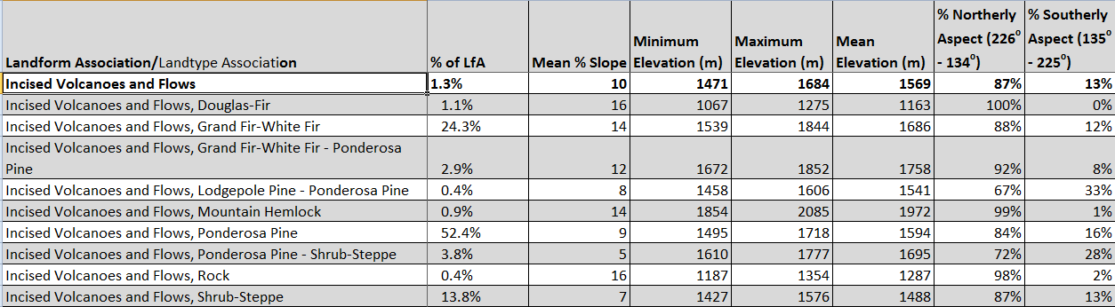

Climate:
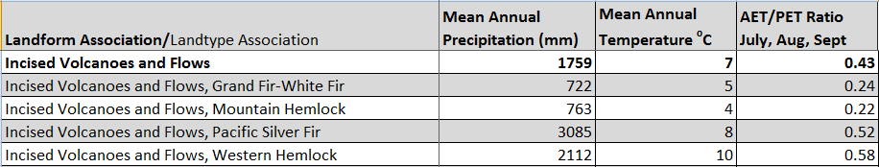

The ratio of Actual Evapotranspiration to Potential Evapotranspiration (AET/PET) is used as a broad-scale indicator of potential drought stress. We obtained modeled actual and potential evapotranspiration datasets from the Numerical Terradynamic Simulation Group at the University of Montana (http://www.ntsg.umt.edu/project/mod16) for a 30 year climate average. AET/PET ratio in the table above is based on a scale of zero to one. A value closer to 1 means the vegetation is transpiring close to its potential. A value farther from 1means that the Actual Evapotranspiration is below potential based on this climatic zone (Ringo, et. al. 2016 in draft).

