Cascades Shield Volcanoes
Terrain Class - Volcanoes: Volcanoes are edifies, typically conical in shape, with a central summit vent that erupts effusive magmatic material as ash, cinder, blocks and or lava that accumulates and build up the landform.
Landform Association – Shield Volcanoes:
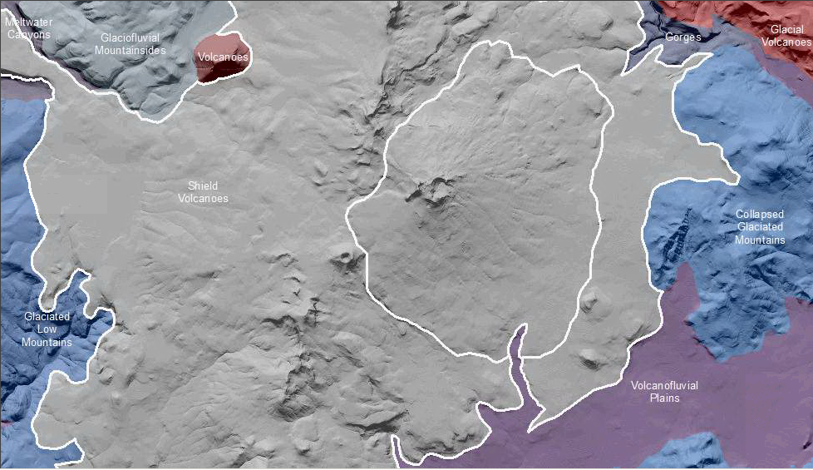

Shield Volcanoes are volcanoes formed by the accumulation of fluid basalt from a central vent area yields a convex shield-like landform. The accumulation of fluid basalt from a central vent area yields a convex shield-like landform. The vent area may have developed a late-stage eruptive edifice with steep, rocky slopes. The shield may have locally accumulated tephra that issued from the vent, particularly late in the volcano’s development.

Soils developed on this map unit vary from residual, thin rocky soils on the flows, to ashy horizons over this residual soil, to thicker, less-rocky soils in depressions and lower slope positions along fault zones.

This Landform Association has limited spatial extent on National Forest System Lands.

Landtype Associations: Landtype Associations are formed by intersecting vegetation series or groups of vegetation series with Landform Associations.

Topography:
The following tables represent the average conditions for the Landform Association. Only lands within and adjacent to National Forest System Lands were mapped by this project. The entire EPA Level III Ecoregion is not covered by this mapping.

The percent of Landform Association (% of LfA) in bold in the table below refers to the percent of the Ecoregion represented by that Landform Association. The (% of LfA) numbers not in bold in the table below refer to the percent of each Landtype Association within the Landform Associations.
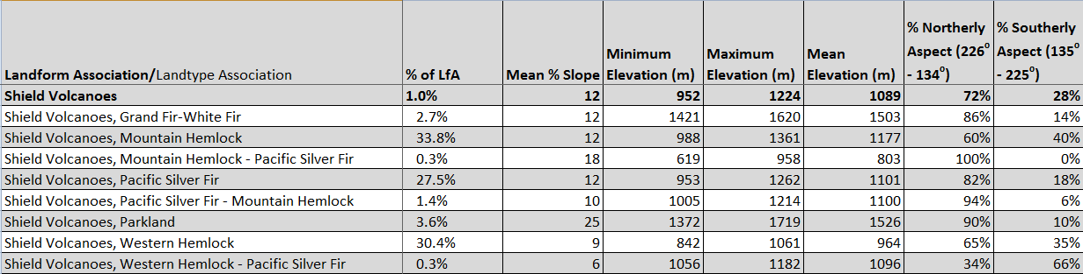

Climate:
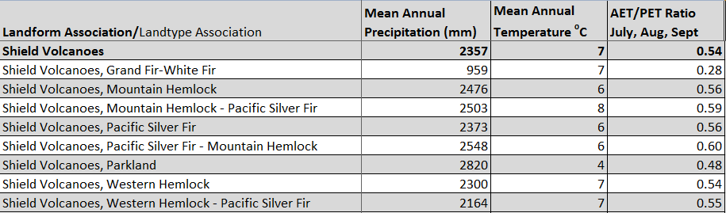

The ratio of Actual Evapotranspiration to Potential Evapotranspiration (AET/PET) is used as a broad-scale indicator of potential drought stress. We obtained modeled actual and potential evapotranspiration datasets from the Numerical Terradynamic Simulation Group at the University of Montana (http://www.ntsg.umt.edu/project/mod16) for a 30 year climate average. AET/PET ratio in the table above is based on a scale of zero to one. A value closer to 1 means the vegetation is transpiring close to its potential. A value farther from 1 means that the Actual Evapotranspiration is below potential based on this climatic zone (Ringo, et. al. 2016 in draft).

