Coast Range Marine Terraces

Lowland [Common Landform and Landscape Term] (a) A general term for low-lying land or an extensive region of low land, esp. near the coast and including the extended plains or country lying not far above tide level. (b) The low and relatively level ground of a region, in contrast with the adjacent, higher country; e.g. a vale between two cuestas. (c) A low or level tract of land along a watercourse; a bottom. (Bates and Jackson, 1995)

Landform Association:
Marine Terraces
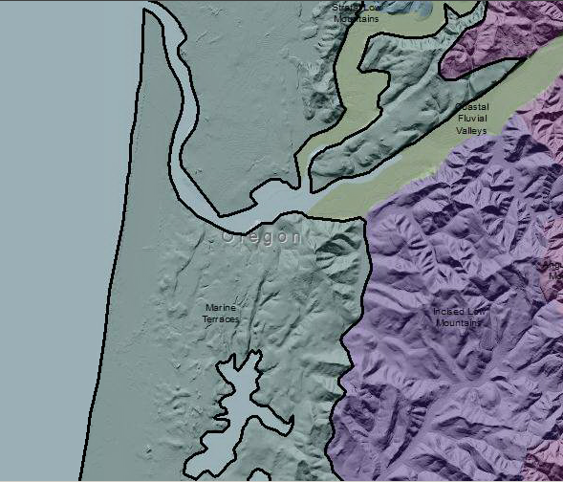

Marine Terraces
Marine Terraces are wave cut benches on the seaward side of adjoining coastal foothills and mountains. They can be a single terrace or a series of treads (gentle slopes) and risers (steep slopes) stacked up away from the coastline. Some marine terraces can be traced as a series parallel to the coast for miles. The uplift of beveled bedrock with marine cover sediments characterizes a terrace. The planar unconformity between sediments and bedrock has a shallow dip to the sea called an abrasion platform and represents and ancient beach . Older, higher terraces have thicker mature Ultisols, richer in clay, whilst closer to the shore Inceptisols, Andisols, and Spodosols are more prevalent. The oldest terraces are higher up with the marine terraces closest to modern sea level being younger.
The lower terraces that have encroaching dunes covering them which alter water flows, resulting in streams or rivers that run parallel to the beach before entering the ocean. The encroaching dunes also create lakes perched on the bedrock of the terraces. The habitats in these areas are unique with a diversity of food sources and water availability.
This Landform Association is rare on National Forest System Lands.

Landtype Associations: Landtype Associations are formed by intersecting vegetation series or groups of vegetation series with Landform Associations.

Topography:
The following tables represent the average conditions for the Landform Association. Only lands within and adjacent to National Forest System Lands were mapped by this project. The entire EPA Level III Ecoregion is not covered by this mapping.

The percent of Landform Association (% of LfA) in bold in the table below refers to the percent of the Ecoregion represented by that Landform Association. The (% of LfA) numbers not in bold in the table below refer to the percent of each Landtype Association within the Landform Association.
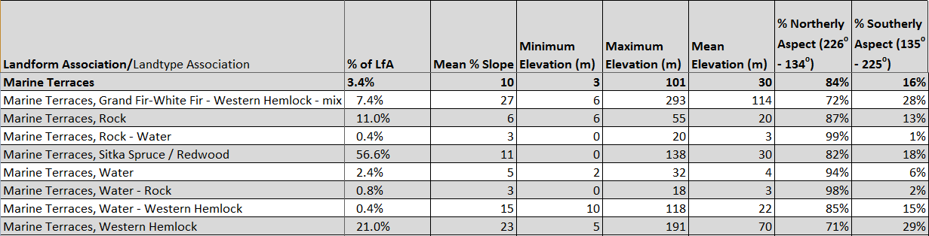

Climate:
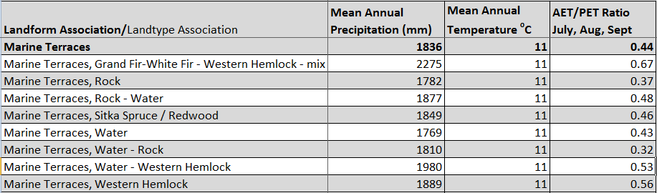

The ratio of Actual Evapotranspiration to Potential Evapotranspiration (AET/PET) is used as a broad-scale indicator of potential drought stress. We obtained modeled actual and potential evapotranspiration datasets from the Numerical Terradynamic Simulation Group at the University of Montana (http://www.ntsg.umt.edu/project/mod16) for a 30 year climate average. AET/PET ratio in the table above is based on a scale of zero to one. A value closer to 1 means the vegetation is transpiring close to its potential. A value farther from 1means that the Actual Evapotranspiration is below potential based on this climatic zone (Ringo, et. al. 2016 in draft).

