Columbia Plateau Canyonlands
Valley [Landscape Term] (a) Any low-lying land bordered by higher ground; esp. an elongate, relatively large, gently sloping depression of the Earth's surface, commonly situated between two mountains or between ranges of hills or mountains, and often containing a stream with an outlet. It is usually developed by stream erosion, but may be formed by faulting. (b) A broad area of generally flat land extending inland for a considerable distance, drained or watered by a large river and its tributaries; a river basin. (Bates and Jackson, 1995)

Landform Association:
Canyonlands
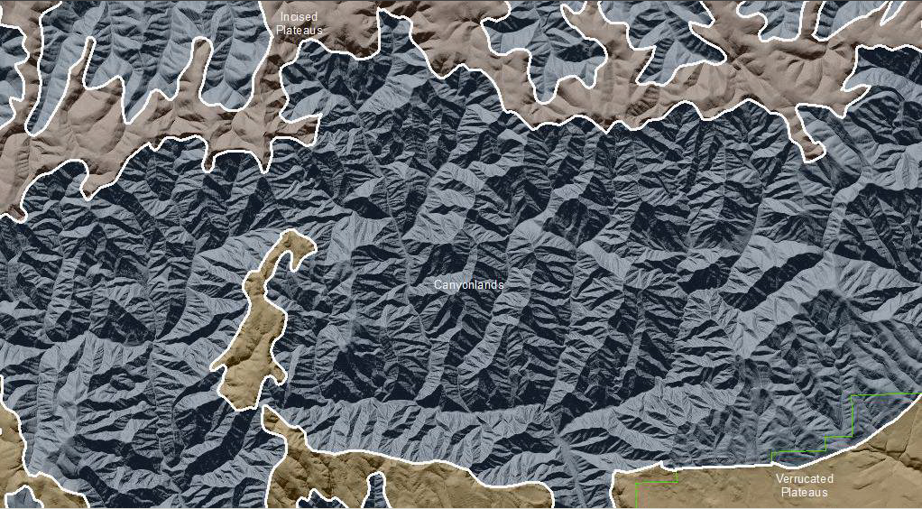

Canyonlands are an extensive landform north of the Wallowa Mountains. They are low linear concave features that at the base have a fluvial channel that may or may not be active. The active channel processes that is visible may not be the original process that formed this landscape. Conversely, the magnitude of the process at present may not be representative of its magnitude in the past. A central active channel is cutting a narrow slot that erodes or causes the collapse and mass movement of material to the channel where water flow removes it. Rock removal occurs because of slope mass collapse or movement. Recognition of the different processes occurring along the walls of the feature parallel to the current river or stream is what differentiates these features from one another.

Canyonlands have repeating elements from river to terraces to hill-slopes up to a ridge and then downslope in reverse in the next catchment. These repeating elements continue across the landscape for hundreds and sometimes thousands of acres. The thin-bedded Columbia River Basalts give a horizontal to sub-horizontal ridge swale going down a steep rocky slope. The benched landscape is cut by small drainages or gullies so that much of the Canyonlands are dominated by right angles in the drainages. Limited by the rate the resistant basalt bedrock is decomposed, very thin soil (if any) profiles build up, as a result, sediment supply is limited from this LfA. The horizontal strata intercepts what sediments and thin soils form in wedges on some of the benches. These accumulations and soils increase in thickness as you move downslope. Canyonlands have predominantly droughty conditions. However, the colluvial soil in lower landscape positions trap water and sediments. This can result in well-developed soils that hold moisture and facilitate better vegetation, timber and habitat. In this colluvial terrain positive landforms have developed overtime changing from concave to convex. This colluvial terrain is often neglected and is a source of excellent habitat. Soils found on hilltops are deep and those by depressions or ponds are thin, counter to expectation. On the project scale these are areas with great heterogeneity so planning and review needs to be site specific and site verified.

This Landform Association has a common spatial extent on National Forest System Lands.

Landtype Associations: Landtype Associations are formed by intersecting vegetation series or groups of vegetation series with Landform Associations.

Topography:
The following tables represent the average conditions for the Landform Association. Only lands within and adjacent to National Forest System Lands were mapped by this project. The entire EPA Level III Ecoregion is not covered by this mapping.

The percent of Landform Association (% of LfA) in bold in the table below refers to the percent of the Ecoregion represented by that Landform Association. The (% of LfA) numbers not in bold in the table below refer to the percent of each Landtype Association within the Landform Association.
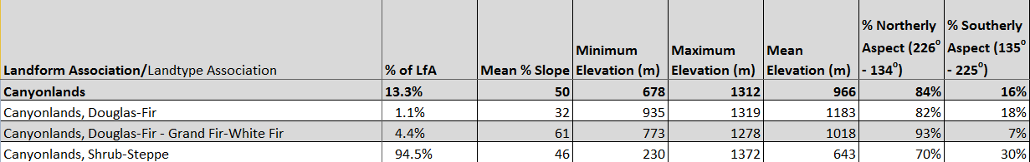

Climate:
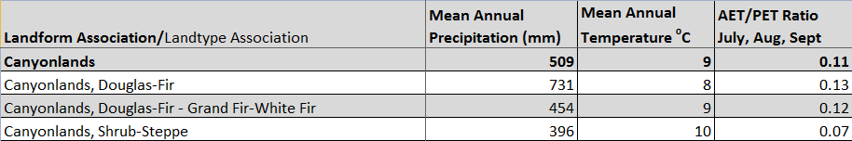
The ratio of Actual Evapotranspiration to Potential Evapotranspiration (AET/PET) is used as a broad-scale indicator of potential drought stress. We obtained modeled actual and potential evapotranspiration datasets from the Numerical Terradynamic Simulation Group at the University of Montana (http://www.ntsg.umt.edu/project/mod16) for a 30 year climate average. AET/PET ratio in the table above is based on a scale of zero to one. A value closer to 1 means the vegetation is transpiring close to its potential. A value farther from 1means that the Actual Evapotranspiration is below potential based on this climatic zone (Ringo, et. al. 2016 in draft).

