Columbia Plateau Collapsed Gorges
Terrain Class: Valley [Landscape Term] (a) Any low-lying land bordered by higher ground; esp. an elongate, relatively large, gently sloping depression of the Earth's surface, commonly situated between two mountains or between ranges of hills or mountains, and often containing a stream with an outlet. It is usually developed by stream erosion, but may be formed by faulting. (b) A broad area of generally flat land extending inland for a considerable distance, drained or watered by a large river and its tributaries; a river basin. (Bates and Jackson, 1995)

Landform Association: Collapsed Gorges
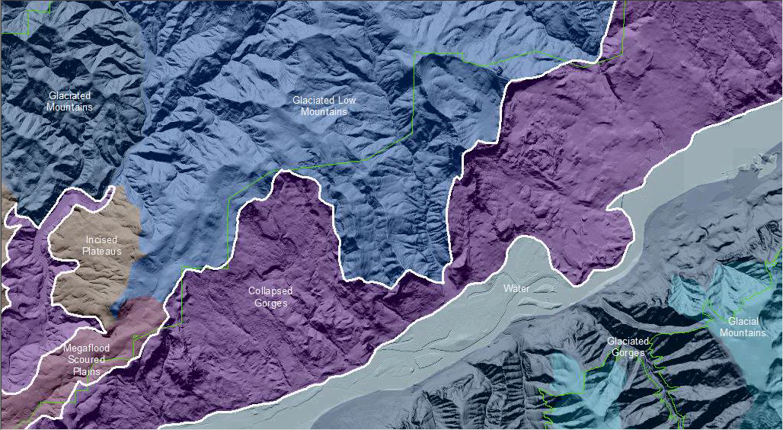

Collapsed Gorges consist of gorges whose sidewalls are dominated by landslides, with hummocky poorly-drained, chaotic fallen bedrock blocks that divert the main-axis river channel. A gorge is identified by its vertical or overhanging walls, narrow slotted shape and higher relief slopes than the canyon or valley adjoining or bounding it. Collapse of sidewalls lowers their overall slope from an original deep, box-shape. Gorges are deep, box-shaped valleys created by higher than normal discharges. These gorge-forming discharges are the result of a restriction or stoppage of normal flows upstream of this landform that upon release create a catastrophic flood. The gorge-forming flows originate from a landslide formed lake, which was catastrophically breached, or a glacier dammed lake breaching the restricting ice, as in the Missoula Floods.

Collapsed Gorges have formed differently shaped hillslopes and contra shaped elements that trap water and sediments. This can result in well-developed soils that hold moisture and facilitate better vegetation, timber and habitat. This collapse terrain can be a source of excellent habitat. In this collapsed terrain positive landforms have developed overtime changing from concave to convex as a result of erosion processes. As a result, soils found on hilltops are deep and those by depressions or ponds are thin, counter to expectation.

This Landform Association is rare on National Forest System Lands.

Landtype Associations: Landtype Associations are formed by intersecting vegetation series or groups of vegetation series with Landform Associations.

Topography:
The following tables represent the average conditions for the Landform Association. Only lands within and adjacent to National Forest System Lands were mapped by this project. The entire EPA Level III Ecoregion is not covered by this mapping.

The percent of Landform Association (% of LfA) in bold in the table below refers to the percent of the Ecoregion represented by that Landform Association. The (% of LfA) numbers not in bold in the table below refer to the percent of each Landtype Association within the Landform Association.

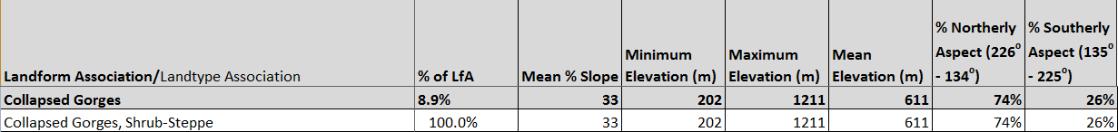

Climate:

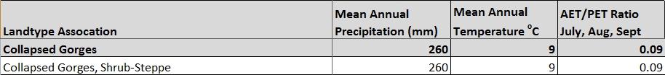

The ratio of Actual Evapotranspiration to Potential Evapotranspiration (AET/PET) is used as a broad-scale indicator of potential drought stress. We obtained modeled actual and potential evapotranspiration datasets from the Numerical Terradynamic Simulation Group at the University of Montana (http://www.ntsg.umt.edu/project/mod16) for a 30 year climate average. AET/PET ratio in the table above is based on a scale of zero to one. A value closer to 1 means the vegetation is transpiring close to its potential. A value farther from 1means that the Actual Evapotranspiration is below potential based on this climatic zone (Ringo, et. al. 2016 in draft).

