Columbia Plateau Fluvial Valleys
Valley [Landscape Term] (a) Any low-lying land bordered by higher ground; esp. an elongate, relatively large, gently sloping depression of the Earth's surface, commonly situated between two mountains or between ranges of hills or mountains, and often containing a stream with an outlet. It is usually developed by stream erosion, but may be formed by faulting. (b) A broad area of generally flat land extending inland for a considerable distance, drained or watered by a large river and its tributaries; a river basin. (Bates and Jackson, 1995)

Landform Association:
Fluvial Valleys
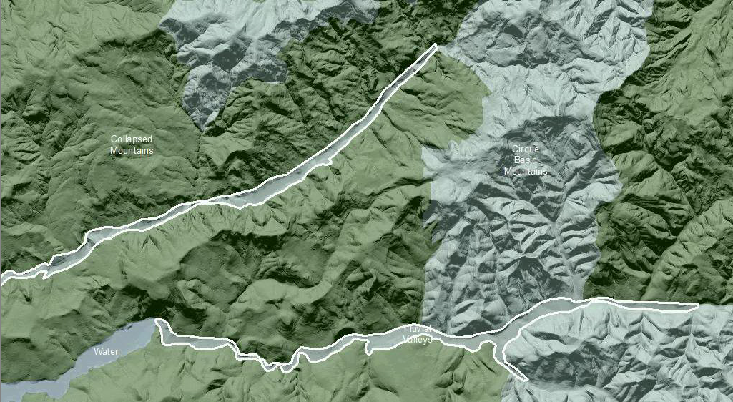

Fluvial Valleys are characterized by a broad valley floor, a plain related to a watercourse with broad terraces and parallel or sub-parallel boundaries. The valley is mostly contiguous with a direct relation between the flowing water and its surrounding floodplain. Soils will have redox features from numerous wet/dry cycles, high primary productivity is found due to low slope angles, sufficient moisture, and well-developed soil horizons with generous amounts of organic matter. In and near the channels, sandy to boulder, well-drained soil expedites hyporheic flow. The dynamic nature of the channel and water level fluctuation creates lakes and sloughs as well as seasonal and permanent wetlands adjacent to the stream and in currently abandoned streambeds. Mollisols, Inceptisols, and Alfisols are common depending on parent material and elevation above the valley floor.

This Landform Association is rare on National Forest System Lands.

Landtype Associations: Landtype Associations are formed by intersecting vegetation series or groups of vegetation series with Landform Associations.

Topography:
The following tables represent the average conditions for the Landform Association. Only lands within and adjacent to National Forest System Lands were mapped by this project. The entire EPA Level III Ecoregion is not covered by this mapping.

The percent of Landform Association (% of LfA) in bold in the table below refers to the percent of the Ecoregion represented by that Landform Association. The (% of LfA) numbers not in bold in the table below refer to the percent of each Landtype Association within the Landform Association.
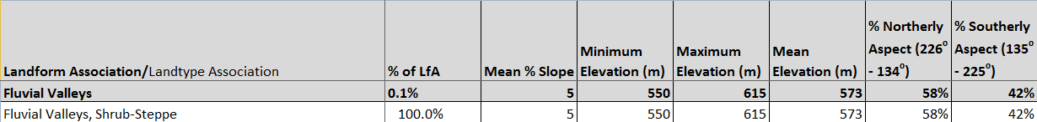

Climate:
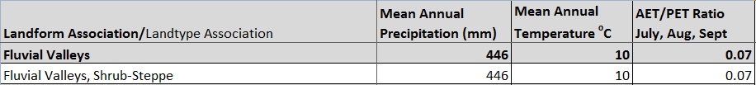

The ratio of Actual Evapotranspiration to Potential Evapotranspiration (AET/PET) is used as a broad-scale indicator of potential drought stress. We obtained modeled actual and potential evapotranspiration datasets from the Numerical Terradynamic Simulation Group at the University of Montana (http://www.ntsg.umt.edu/project/mod16) for a 30 year climate average. AET/PET ratio in the table above is based on a scale of zero to one. A value closer to 1 means the vegetation is transpiring close to its potential. A value farther from 1means that the Actual Evapotranspiration is below potential based on this climatic zone (Ringo, et. al. 2016 in draft).

