Overall Relief Class (Lowlands, Mountains, Plateaus, ect.)
Plateau:
Plateau [Landscape Term] Any comparatively flat area of great extent and elevation; specifically an extensive land region considerably elevated (more than 150-300 m in altitude) above the adjacent country or above sea level; it is commonly limited on at least one side by an abrupt descent, has a flat or nearly smooth surface but is often dissected by deep valleys and surmounted by high hills or mountains, and has a large part of its total surface at or near the summit level. A plateau is usually higher and has more noticeable relief than a plain (it often represents an elevated plain), and is usually higher and more extensive than a mesa; it may be tectonic, residual, or volcanic in origin. (Bates and Jackson, 1995)

Landform Association:
Megaflood Scoured Uplands are low mountains areas adjacent to the Columbia River where soil and unconsolidated geologic sediments removed/swept away by Missoula Floods floodwaters. Soils are generally shallow, some deeper pocket remain downstream of prominent topographic features that protected them from the flood waters or caused eddy deposits.
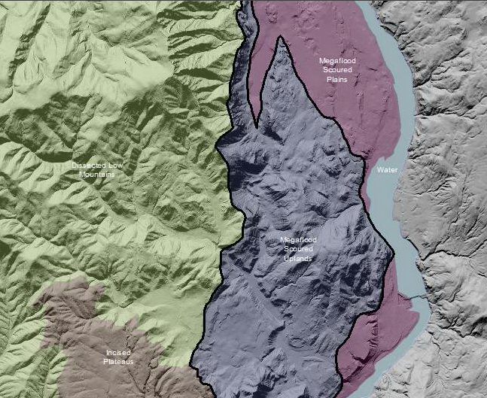

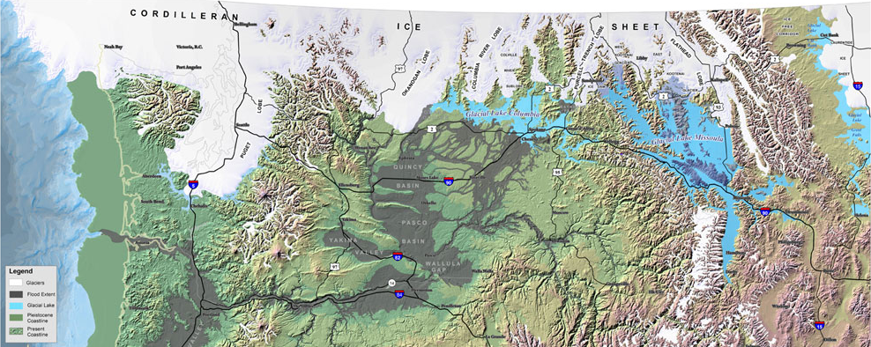
Figure xx: Map of Continental Glaciation (Map Source: USFS modified by IAFI and EWU 2010.
Landtype Associations: Landtypes are formed by intersecting vegetation series or group of vegetation series with landform associations.
Vegetation Zones | Percent of Landform Association | Mean Elevation | Min Elevation | Max Elevation | General Aspect
Entire Landform Association
VegZone name 1
VegZone name 2

Climate: Display this by vegzone as it varies with each veg zone (LTA) more than with LfA as a whole

Vegetation Zone | Mean Annual Precipitation | Mean Annual Temperature | June/July/August  AET/PET Ratio
Entire Landform Association
VegZone name 1
VegZone name 2

Geology:
- Bedrock Group
- RockType
Soils:
- Surface and subsurface soil texture
- Rock Fragments
- Soil depth
- Depth To Bedrock
- Drainage Class
- Slope
- Hydrologic Class
- Stability
  - Mass Wasting Potential
  - Shallow Rapid landslide potential
  - Surface soil erosion potential
Fire History:
- There must be some layer we could mine here
Unique Habitats
- Seeps, springs
- Wetlands
- Lakes/ponds
- Scarps
- Debris Slides

Hydro/Water Quality:
- Source/Transport Deposition
- Avg Sinuosity
- Bankfull Width (the survey data has an average bankfull width (ft) per surveyed stream length)
- Floodprone width (same here, this is an average value in ft)
- BF_W/D_ratio (same here, average value)
- Stream Temperature

Fish Habitat:
- Stream substrates
- Pools per mile
- Bull Trout
- Coho
- Reach Class

