Overall Relief Class (Lowlands, Mountains, Plateaus, ect.)
Plateau:
Plateau [Landscape Term] Any comparatively flat area of great extent and elevation; specifically an extensive land region considerably elevated (more than 150-300 m in altitude) above the adjacent country or above sea level; it is commonly limited on at least one side by an abrupt descent, has a flat or nearly smooth surface but is often dissected by deep valleys and surmounted by high hills or mountains, and has a large part of its total surface at or near the summit level. A plateau is usually higher and has more noticeable relief than a plain (it often represents an elevated plain), and is usually higher and more extensive than a mesa; it may be tectonic, residual, or volcanic in origin. (Bates and Jackson, 1995)

Landform Association:
Megaflood Scours and Deposits are
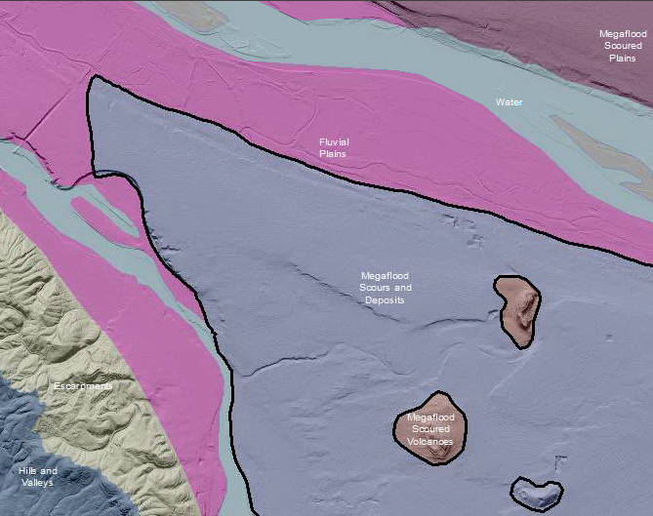

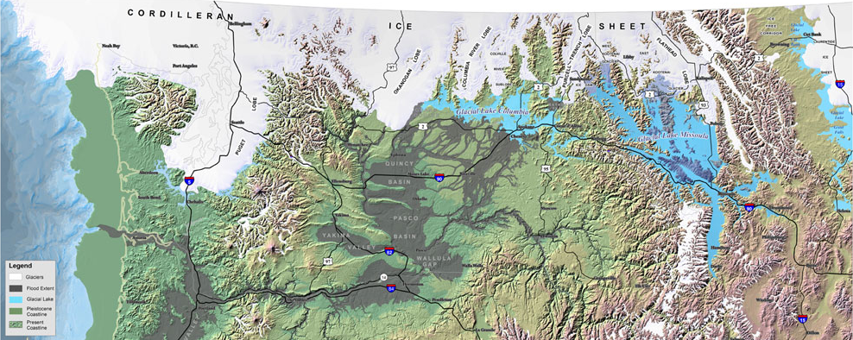
Figure xx: Map of Continental Glaciation (Map Source: USFS modified by IAFI and EWU 2010.
Landtype Associations: Landtypes are formed by intersecting vegetation series or group of vegetation series with landform associations.
Vegetation Zones | Percent of Landform Association | Mean Elevation | Min Elevation | Max Elevation | General Aspect
Entire Landform Association
VegZone name 1
VegZone name 2

Climate: Display this by vegzone as it varies with each veg zone (LTA) more than with LfA as a whole

Vegetation Zone | Mean Annual Precipitation | Mean Annual Temperature | June/July/August  AET/PET Ratio
Entire Landform Association
VegZone name 1
VegZone name 2

Geology:
- Bedrock Group
- RockType
Soils:
- Surface and subsurface soil texture
- Rock Fragments
- Soil depth
- Depth To Bedrock
- Drainage Class
- Slope
- Hydrologic Class
- Stability
  - Mass Wasting Potential
  - Shallow Rapid landslide potential
  - Surface soil erosion potential
Fire History:
- There must be some layer we could mine here
Unique Habitats
- Seeps, springs
- Wetlands
- Lakes/ponds
- Scarps
- Debris Slides

Hydro/Water Quality:
- Source/Transport Deposition
- Avg Sinuosity
- Bankfull Width (the survey data has an average bankfull width (ft) per surveyed stream length)
- Floodprone width (same here, this is an average value in ft)
- BF_W/D_ratio (same here, average value)
- Stream Temperature

Fish Habitat:
- Stream substrates
- Pools per mile
- Bull Trout
- Coho
- Reach Class

