Eastern Cascade Dune Fields

Lowland [Common Landform and Landscape Term] (a) A general term for low-lying land or an extensive region of low land, esp. near the coast and including the extended plains or country lying not far above tide level. (b) The low and relatively level ground of a region, in contrast with the adjacent, higher country; e.g. a vale between two cuestas. (c) A low or level tract of land along a watercourse; a bottom. (Bates and Jackson, 1995)

Landform Association:
Dune Fields

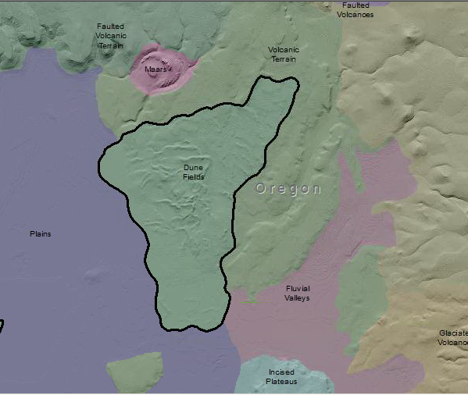

Dune Fields on National Forest lands are found adjacent to the Klamath Marsh. The dune sediments are uniformly sand texture and are sourced from fluvial montane erosion as well as the pluvial and lacustrine deposits of Pleistocene lakes. This phenomenon is not uncommon in intermountain basins in the western United States. The dunes will range from a meter to tens of meters in height. The well-drained soils may be droughty yet produce well when irrigated. Soils on dunes vary from Entisols, Inceptisols to Mollisols in xeric moisture regimes.

This Landform Association is rare on National Forest System Lands.

Landtype Associations: Landtype Associations are formed by intersecting vegetation series or groups of vegetation series with Landform Associations.

Topography:
The following tables represent the average conditions for the Landform Association. Only lands within and adjacent to National Forest System Lands were mapped by this project. The entire EPA Level III Ecoregion is not covered by this mapping.

The percent of Landform Association (% of LfA) in bold in the table below refers to the percent of the Ecoregion represented by that Landform Association. The (% of LfA) numbers not in bold in the table below refer to the percent of each Landtype Association within the Landform Association.
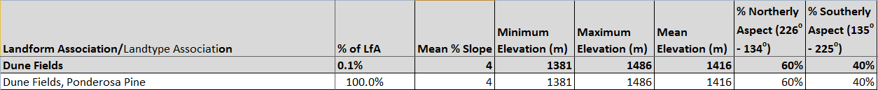

Climate:

The ratio of Actual Evapotranspiration to Potential Evapotranspiration (AET/PET) is used as a broad-scale indicator of potential drought stress. We obtained modeled actual and potential evapotranspiration datasets from the Numerical Terradynamic Simulation Group at the University of Montana (http://www.ntsg.umt.edu/project/mod16) for a 30 year climate average. AET/PET ratio in the table above is based on a scale of zero to one. A value closer to 1 means the vegetation is transpiring close to its potential. A value farther from 1means that the Actual Evapotranspiration is below potential based on this climatic zone (Ringo, et. al. 2016 in draft).

