Eastern Cascades Faulted Outwash Plains
Overall Terrain:
Plains [Landscape Term] A general term referring to an extensive, lowland area that ranges from level to gently sloping or undulating. A plain has few or no prominent hills or valleys, and usually occurs at low elevation relative to surrounding areas. (Bates and Jackson, 1980)

Landform Association:
Faulted Outwash Plains:

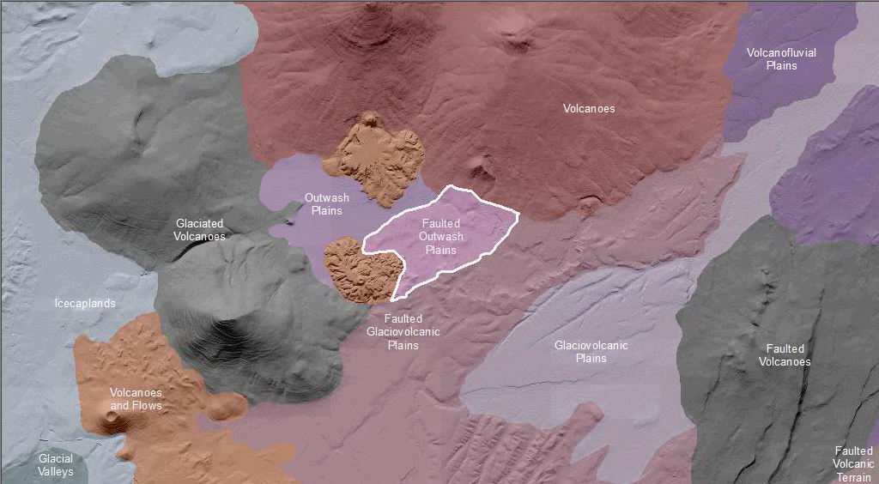

Faulted Outwash Plains are plains downstream of and connected to glacial valleys and moraines that have been faulted. Upstream past or present glacial action continues to influence processes in this domain. Previously channelized flow was the source providing the sediments that form the now very low relief plains. This landform fronts a much larger valley and is commonly the site of urbanization or farming. Productive thick soils and topography that focused travel and migration to and past these landforms contributed to human settlement. In active outwash landforms channelized and braided water courses are found moving over the fan shaped deposits. Faulted Outwash Plains are disrupted by fault displacement of the surface. Potentially active, these areas are cut by faults or fault scarps. Streams in this area are rerouted or blocked by the fault scarps.
This Landform Association is rare on National Forest System Lands.
.

Landtype Associations: Landtype Associations are formed by intersecting vegetation series or groups of vegetation series with Landform Associations.

Topography:
The following tables represent the average conditions for the Landform Association. Only lands within and adjacent to National Forest System Lands were mapped by this project. The entire EPA Level III Ecoregion is not covered by this mapping.

The percent of Landform Association (% of LfA) in bold in the table below refers to the percent of the Ecoregion represented by that Landform Association. The (% of LfA) numbers not in bold in the table below refer to the percent of each Landtype Association within the Landform Association.

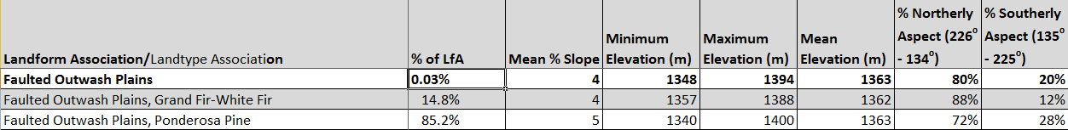

Climate:
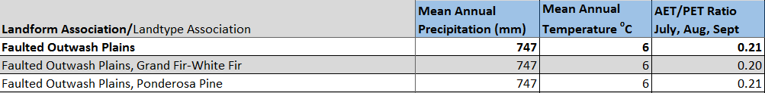

The ratio of Actual Evapotranspiration to Potential Evapotranspiration (AET/PET) is used as a broad-scale indicator of potential drought stress. We obtained modeled actual and potential evapotranspiration datasets from the Numerical Terradynamic Simulation Group at the University of Montana (http://www.ntsg.umt.edu/project/mod16) for a 30 year climate average. AET/PET ratio in the table above is based on a scale of zero to one. A value closer to 1 means the vegetation is transpiring close to its potential. A value farther from 1means that the Actual Evapotranspiration is below potential based on this climatic zone (Ringo, et. al. 2016 in draft).

