Eastern Cascades Glaciated Remnant Volcanoes
Volcanoes are edifies, typically conical in shape, with a central summit vent that erupts effusive magmatic material as ash, cinder, blocks and or lava that accumulates and build up the landform.
Landform Association – Glaciated Remnant Volcanoes:
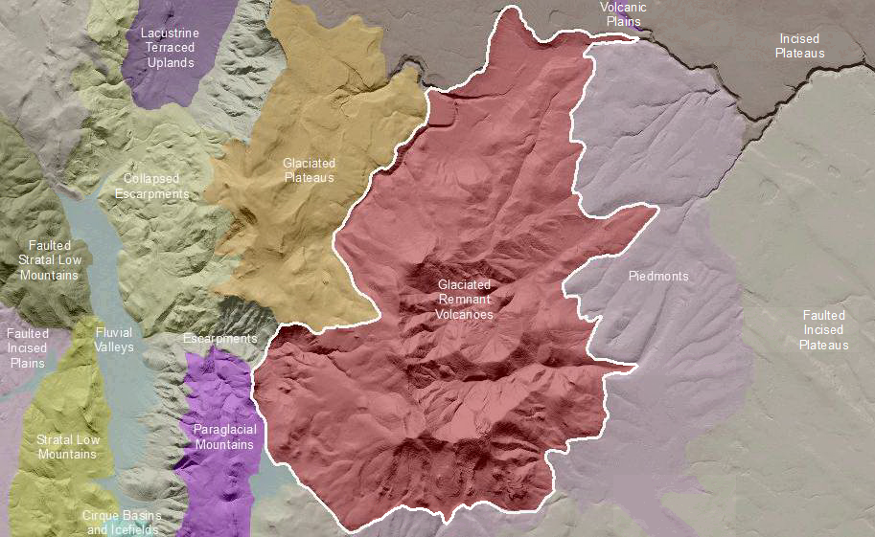

Glaciated Remnant Volcanoes are deeply eroded Quarternary volcanoes that also have a history of glaciation. This map unit has a radial to annular stream pattern that is superposed on the underlying bedrock. Some massifs are more than half eroded away. The flanks of these volcanoes maintain the original conical base shape. The north and or east summit areas have cirque or cuirque-like landforms, as well as nivation features, talus slopes and block fields. In the core of the map unit, roots of the volcano include igneous hypabyssal intrusive rocks which form towering rock outcrops. Soils on this map unit are typically gravelly, shallow to bedrock and likely taxa are Andisols, Alfisols and Mollisols.
This Landform Association is of limited spatial extent on National Forest System Lands.

Landtype Associations: Landtype Associations are formed by intersecting vegetation series or groups of vegetation series with Landform Associations.

Topography:
The following tables represent the average conditions for the Landform Association. Only lands within and adjacent to National Forest System Lands were mapped by this project. The entire EPA Level III Ecoregion is not covered by this mapping.

The percent of Landform Association (% of LfA) in bold in the table below refers to the percent of the Ecoregion represented by that Landform Association. The (% of LfA) numbers not in bold in the table below refer to the percent of each Landtype Association within the Landform Associations.
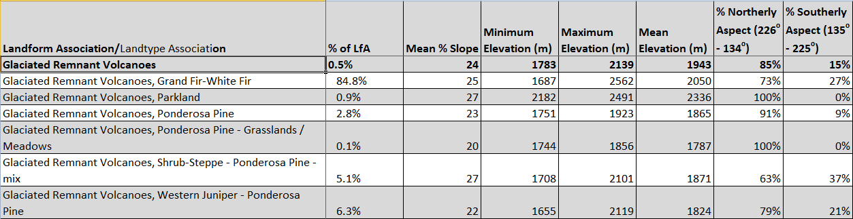

Climate:
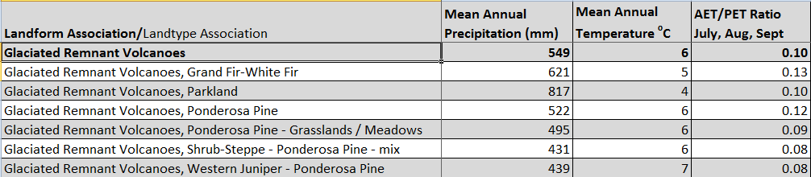

The ratio of Actual Evapotranspiration to Potential Evapotranspiration (AET/PET) is used as a broad-scale indicator of potential drought stress. We obtained modeled actual and potential evapotranspiration datasets from the Numerical Terradynamic Simulation Group at the University of Montana (http://www.ntsg.umt.edu/project/mod16) for a 30 year climate average. AET/PET ratio in the table above is based on a scale of zero to one. A value closer to 1 means the vegetation is transpiring close to its potential. A value farther from 1means that the Actual Evapotranspiration is below potential based on this climatic zone (Ringo, et. al. 2016 in draft).

