Eastern Cascades Glaciated Volcanoes
Volcanoes are edifies, typically conical in shape, with a central summit vent that erupts effusive magmatic material as ash, cinder, blocks and or lava that accumulates and build up the landform.
Landform Association – Glaciated Volcanoes:
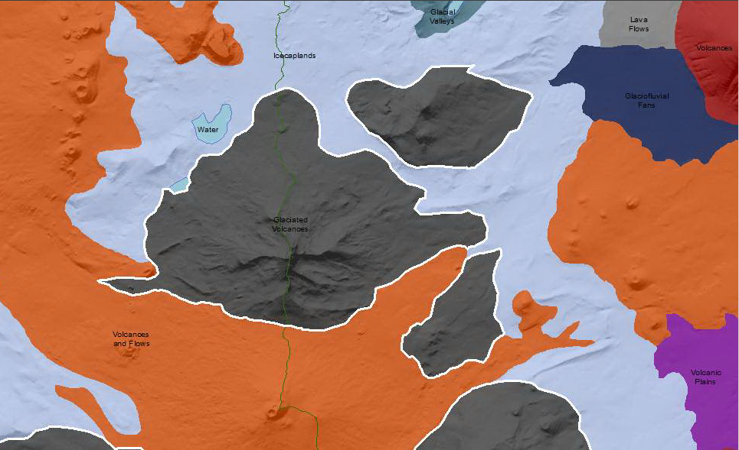

Glaciated Volcanoes are volcano cones shaped by both past glaciers and more recent geomorphic processes. Volcanoes are edifies, typically conical in shape, with a central summit vent that erupts effusive magmatic material as ash, cinder, blocks and or lava that accumulates and build up the landform.
Along peaks and ridges there are indicators of past glacial action. The terrain is glacially scoured with cirque basins, icefields, and U-shaped valleys. Cirque valley bottoms and small valley areas may be included in this map unit where unmappable as Glacial Valleys Landform Association. Since the cessation of glaciation in these areas, however, surface, mass wasting (shallow rapid or deepseated earthflow, rockfall, etc.) or fluvial erosion processes have dominated and masked much of the glacial signature of the mid to lower slopes.
This Landform Association has an abundant spatial extent on National Forest System Lands.

Landtype Associations: Landtype Associations are formed by intersecting vegetation series or groups of vegetation series with Landform Associations.

Topography:
The following tables represent the average conditions for the Landform Association. Only lands within and adjacent to National Forest System Lands were mapped by this project. The entire EPA Level III Ecoregion is not covered by this mapping.

The percent of Landform Association (% of LfA) in bold in the table below refers to the percent of the Ecoregion represented by that Landform Association. The (% of LfA) numbers not in bold in the table below refer to the percent of each Landtype Association within the Landform Associations.

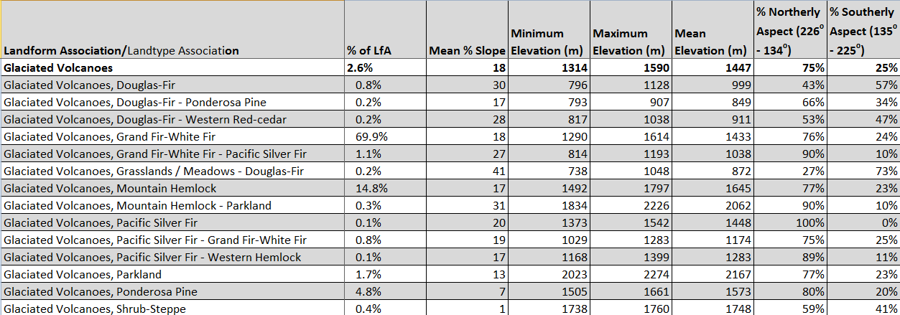
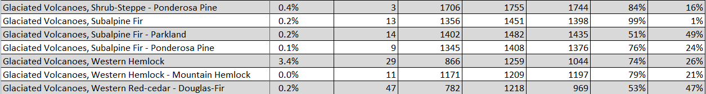

Climate:
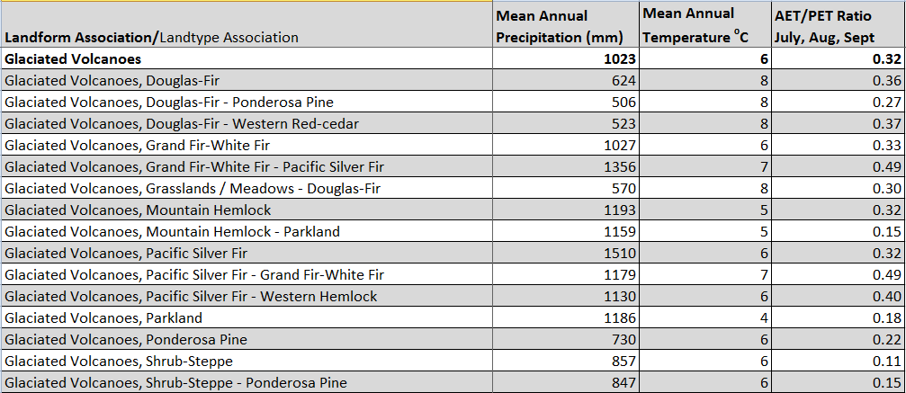
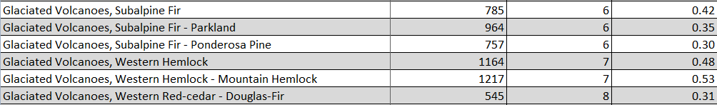

The ratio of Actual Evapotranspiration to Potential Evapotranspiration (AET/PET) is used as a broad-scale indicator of potential drought stress. We obtained modeled actual and potential evapotranspiration datasets from the Numerical Terradynamic Simulation Group at the University of Montana (http://www.ntsg.umt.edu/project/mod16) for a 30 year climate average. AET/PET ratio in the table above is based on a scale of zero to one. A value closer to 1 means the vegetation is transpiring close to its potential. A value farther from 1means that the Actual Evapotranspiration is below potential based on this climatic zone (Ringo, et. al. 2016 in draft).

