Eastern Cascades Maars
Terrain Class - Volcanoes: Volcanoes are edifies, typically conical in shape, with a central summit vent that erupts effusive magmatic material as ash, cinder, blocks and or lava that accumulates and build up the landform.
Landform Association – Maars:
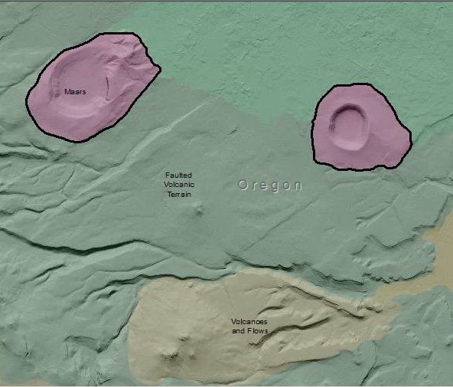

Maars are a low-relief, broad volcanic crater formed by multiple shallow explosive eruptions. It is surrounded by a crater ring, and may be filled by water during wet seasons. The top of the crater wall transitions to an asymmetric berm that encircles the crater. The berm represents the ejected ballistic debris. The greatest accumulation and relief is nearest the crater wall. Talus to debris cones accumulate along the lower portions of the crater wall.

Soils tend to be coarse, gravelly to rocky nearest the crater wall and become finer texture towards the crater center and out, away from the berm crest. Soil taxa are typically Mollisols and Andisols, the latter most likely where ash has accumulated.

This Landform Association is rare on National Forest System Lands.

Landtype Associations: Landtype Associations are formed by intersecting vegetation series or groups of vegetation series with Landform Associations.

Topography:
The following tables represent the average conditions for the Landform Association. Only lands within and adjacent to National Forest System Lands were mapped by this project. The entire EPA Level III Ecoregion is not covered by this mapping.

The percent of Landform Association (% of LfA) in bold in the table below refers to the percent of the Ecoregion represented by that Landform Association. The (% of LfA) numbers not in bold in the table below refer to the percent of each Landtype Association within the Landform Associations.
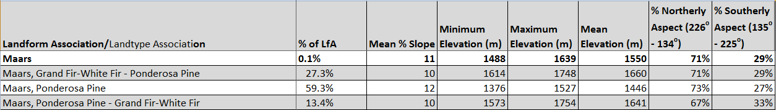

Climate:

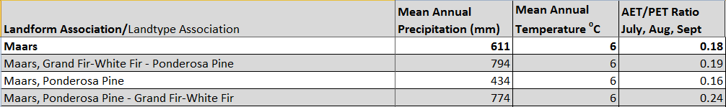

The ratio of Actual Evapotranspiration to Potential Evapotranspiration (AET/PET) is used as a broad-scale indicator of potential drought stress. We obtained modeled actual and potential evapotranspiration datasets from the Numerical Terradynamic Simulation Group at the University of Montana (http://www.ntsg.umt.edu/project/mod16) for a 30 year climate average. AET/PET ratio in the table above is based on a scale of zero to one. A value closer to 1 means the vegetation is transpiring close to its potential. A value farther from 1means that the Actual Evapotranspiration is below potential based on this climatic zone (Ringo, et. al. 2016 in draft).

