Eastern Cascades Volcanic Terrain
Terrain Class - Volcanoes: Volcanoes are edifies, typically conical in shape, with a central summit vent that erupts effusive magmatic material as ash, cinder, blocks and or lava that accumulates and build up the landform.
Landform Association – Shield Volcanoes:
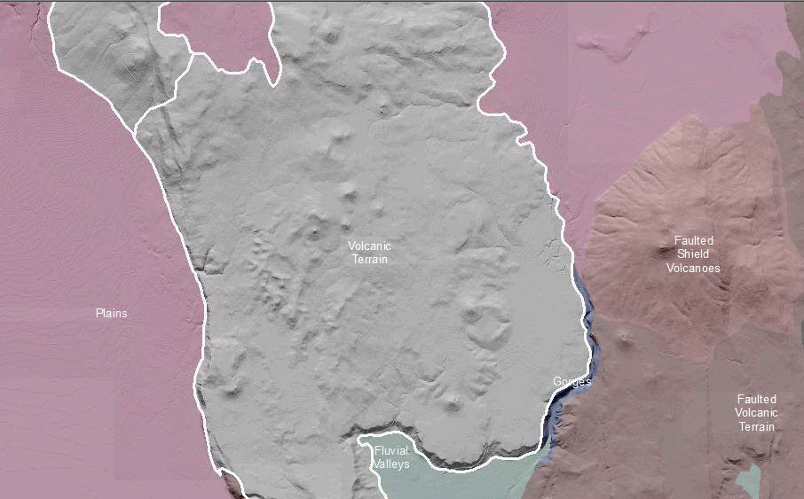

Volcanic Terrain is a miscellaneous map unit that includes diverse landform elements associated with the numerous volcanoes in the volcanic fields of central and eastern Oregon. This is a diverse terrain all with a volcanic origin including volcanoes, flows, lava tubes and caves, parasitic volcanoes superimposed on a volcano or a flow. This terrain is dominantly constructive topography associated with basaltic volcanoes, including cinder cones, conical volcanoes, shield volcanoes and maars. The extensive lava flows of these volcanoes are not differentiated. Tephra from local volcanic sources, pumiceous tephra from Mt. Mazama, and or andesitic tephra form the Cascade Range volcanoes blanket some or this entire map unit.

Weathering, fluvial erosion and, to a large degree, mass wasting have degraded these constructional landforms. Shed sediments are deposited in fluvial fans, plains and terraces which can represent significant extents within this map unit. Soils are thin to absent om the rocky slopes and thick and rocky along lower (footslope, toeslope) slope positions. Soil taxa are typically Andisols, Alfisos and Mollisols.

This Landform Association is rare on National Forest System Lands.
Landtype Associations: Landtype Associations are formed by intersecting vegetation series or groups of vegetation series with Landform Associations.

Topography:
The following tables represent the average conditions for the Landform Association. Only lands within and adjacent to National Forest System Lands were mapped by this project. The entire EPA Level III Ecoregion is not covered by this mapping.

The percent of Landform Association (% of LfA) in bold in the table below refers to the percent of the Ecoregion represented by that Landform Association. The (% of LfA) numbers not in bold in the table below refer to the percent of each Landtype Association within the Landform Associations.
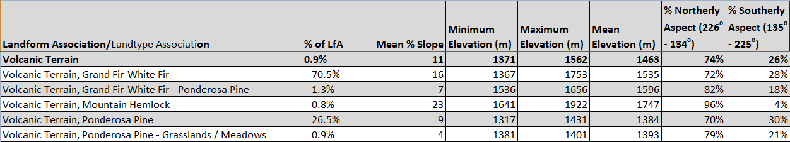

Climate:
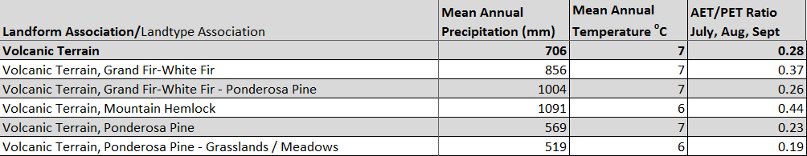

The ratio of Actual Evapotranspiration to Potential Evapotranspiration (AET/PET) is used as a broad-scale indicator of potential drought stress. We obtained modeled actual and potential evapotranspiration datasets from the Numerical Terradynamic Simulation Group at the University of Montana (http://www.ntsg.umt.edu/project/mod16) for a 30 year climate average. AET/PET ratio in the table above is based on a scale of zero to one. A value closer to 1 means the vegetation is transpiring close to its potential. A value farther from 1 means that the Actual Evapotranspiration is below potential based on this climatic zone (Ringo, et. al. 2016 in draft).

