Klamath Mountains Fluvial Plains
Overall Terrain:
Plains [Landscape Term] A general term referring to an extensive, lowland area that ranges from level to gently sloping or undulating. A plain has few or no prominent hills or valleys, and usually occurs at low elevation relative to surrounding areas. (Bates and Jackson, 1980)

Landform Association:
Fluvial Plains:
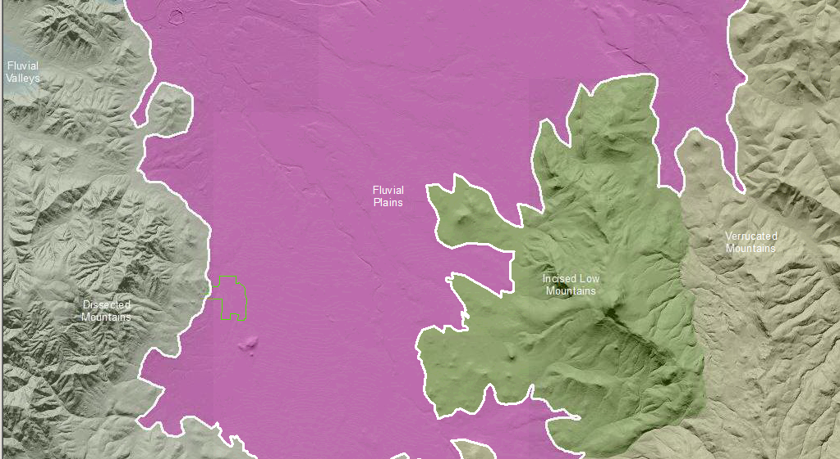

Fluvial Plains are an extensive, lowland area that ranges from level to gently sloping or undulating. Fluvial Plains are produced by migrating channels and floodplains of non-glacial streams. Locally, older deposits identified as terraces are included in this map unit. The bounds of fluvial plains conform to the surrounding uplands as they confine the streams.

Fluvial Plains have relict and abandoned stream landforms. Relict landforms in this map unit are those formed during a prior hydrologic regime of the glacial or pluvial epochs. As such, they consist of generally higher energy stream deposits – sandy to boulder gravel beds upwards of several meters in thickness. Relict landforms are generally present at the margins of fluvial plains where confined in mountain valleys. Channel, bar and terrace landforms are muted in morphology due to weathering and surface degradation over the thousands of year since their formation. Soil profiles are typically deep and high differentiated in horizon properties from the parent material. Soil taxa vary according to age and climatic regime, though Alfisols and Mollisols are common.

Abandoned stream landforms are generally younger in age and formed under a hydrologic regime similar to that of the present stream. These generally consist of variable energy (except in modern glacial watershed) stream deposits, including lower energy silt to sandy beds and flashy, high-energy debris flow deposits. Thicknness of deposits is consequently variable between as well as within watersheds. These are relatively young landforms and deposits, located adjacent to the modern stream channel, and soil profile development is immature – Entisols, Inceptisols and Mollisols are typical.

This Landform Association has a limited spatial extent on National Forest System Lands.

Landtype Associations: Landtype Associations are formed by intersecting vegetation series or groups of vegetation series with Landform Associations.
Topography:
The following tables represent the average conditions for the Landform Association. Only lands within and adjacent to National Forest System Lands were mapped by this project. The entire EPA Level III Ecoregion is not covered by this mapping.

The percent of Landform Association (% of LfA) in bold in the table below refers to the percent of the Ecoregion represented by that Landform Association. The (% of LfA) numbers not in bold in the table below refer to the percent of each Landtype Association within the Landform Association.
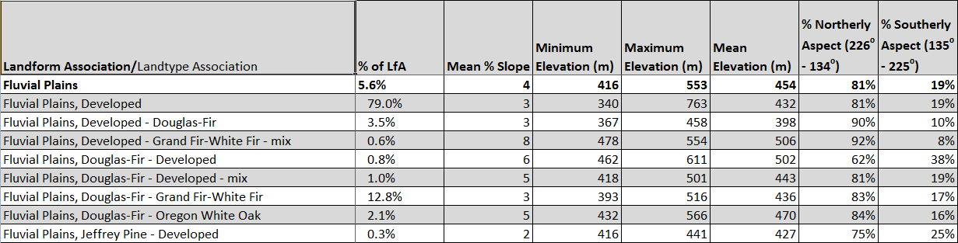
Climate:
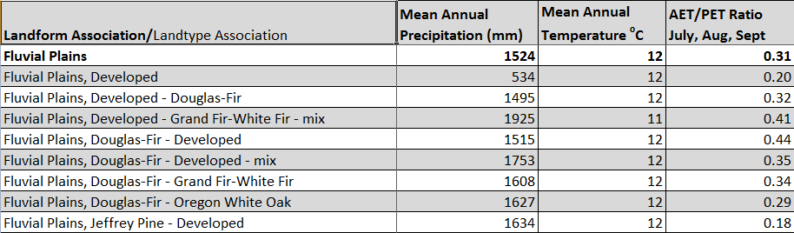
The ratio of Actual Evapotranspiration to Potential Evapotranspiration (AET/PET) is used as a broad-scale indicator of potential drought stress. We obtained modeled actual and potential evapotranspiration datasets from the Numerical Terradynamic Simulation Group at the University of Montana (http://www.ntsg.umt.edu/project/mod16) for a 30 year climate average. AET/PET ratio in the table above is based on a scale of zero to one. A value closer to 1 means the vegetation is transpiring close to its potential. A value farther from 1means that the Actual Evapotranspiration is below potential based on this climatic zone (Ringo, et. al. 2016 in draft).

