North Cascade Incised Plateaus
Plateaus in the Pacific Northwest are predominantly underlain by stacked flows of the Columbia River Basalts and form extensive elevated plains bounded on one or more sides by steep slopes hundreds of feet above adjoining areas. Plateaus are differentiated from each other by the most-evident surficial processes of alteration.

Landform Association: Incised Plateaus:
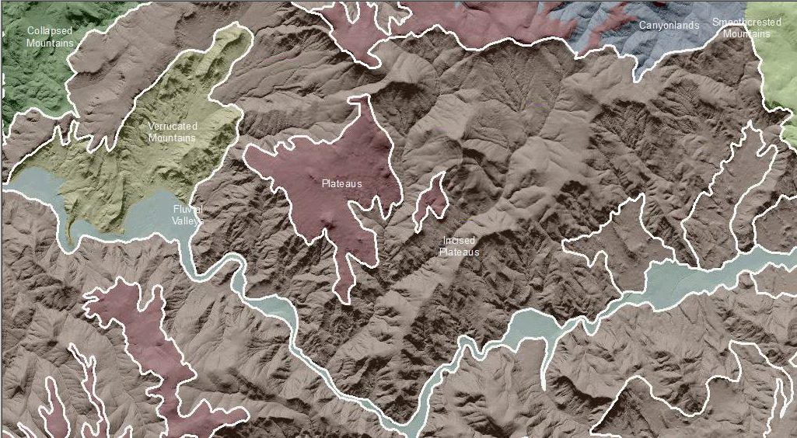

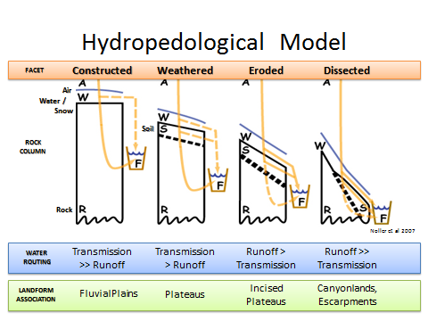
Incised refers to landscapes and landforms that retain their outlines and the majority of their mass but are experiencing an initial alteration of form due to weathering. Depending on stage of erosion, plateaus will manifest varying degrees of incision (Figure 1). Initially water is transmitted directly below ground through a series of fractures in the flow. As the original basalt flow weathers, surface runoff increases. Fluvial erosion processes initiate incision and ephemeral stream channel formation. With increased weathering and erosion, runoff of snowment and precipitation dominates and deep incisions occur at weak points in the basalt flows. The plateau becomes highly incised, eventually giving way to deep incision of canyons which headcut back into the plateaus over time.
Figure 1: Noller depiction of landform relationships based on degree of weathering and erosion and runoff from the landscape.

This Landform Association has an abundant spatial extent on National Forest System Lands.

Landtype Associations: Landtype Associations are formed by intersecting vegetation series or groups of vegetation series with Landform Associations.

Topography:
The following tables represent the average conditions for the Landform Association. Only lands within and adjacent to National Forest System Lands were mapped by this project. The entire EPA Level III Ecoregion is not covered by this mapping.

The percent of Landform Association (% of LfA) in bold in the table below refers to the percent of the Ecoregion represented by that Landform Association. The (% of LfA) numbers not in bold in the table below refer to the percent of each Landtype Association within the Landform Association.
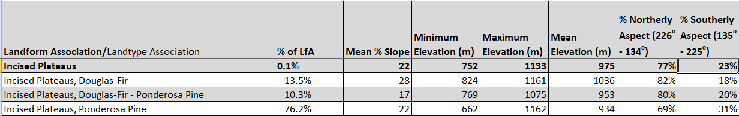

Climate:
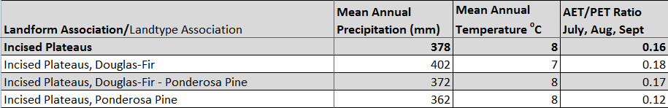

The ratio of Actual Evapotranspiration to Potential Evapotranspiration (AET/PET) is used as a broad-scale indicator of potential drought stress. We obtained modeled actual and potential evapotranspiration datasets from the Numerical Terradynamic Simulation Group at the University of Montana (http://www.ntsg.umt.edu/project/mod16) for a 30 year climate average. AET/PET ratio in the table above is based on a scale of zero to one. A value closer to 1 means the vegetation is transpiring close to its potential. A value farther from 1means that the Actual Evapotranspiration is below potential based on this climatic zone (Ringo, et. al. 2016 in draft).

