North Cascades Glacial Remnant Volcanoes
Volcanoes are edifies, typically conical in shape, with a central summit vent that erupts effusive magmatic material as ash, cinder, blocks and or lava that accumulates and build up the landform.
Landform Association - Glacial Remnant Volcanoes:
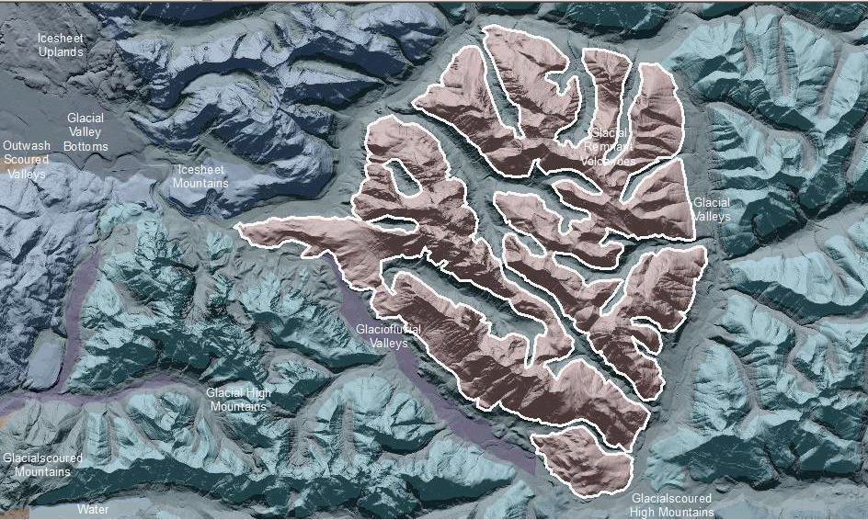

Glacial Remnant Volcanoes are the eroded roots of Tertiary volcanic mountains and which have clear geomorphic evidence of late glacial scour. This map unit has a radial stream pattern that drains to an encircling set of mainstem rivers. This drainage pattern is superposed on the underlying bedrock. Most or the entire volcanic massif is eroded away. In the core of the map unit roots of the volcano, include igneous stocks and hypabyssal intrusive rocks. Glacial scoured landforms include U-sped valleys with vertical to near-vertical walls and bedrock throughout, hanging valleys, cirques and arêtes. Glacial valleys may be differentiated where mappable at this scale.
This Landform Association is rare on National Forest System Lands.

Landtype Associations: Landtype Associations are formed by intersecting vegetation series or groups of vegetation series with Landform Associations.

Topography:
The following tables represent the average conditions for the Landform Association. Only lands within and adjacent to National Forest System Lands were mapped by this project. The entire EPA Level III Ecoregion is not covered by this mapping.

The percent of Landform Association (% of LfA) in bold in the table below refers to the percent of the Ecoregion represented by that Landform Association. The (% of LfA) numbers not in bold in the table below refer to the percent of each Landtype Association within the Landform Association.

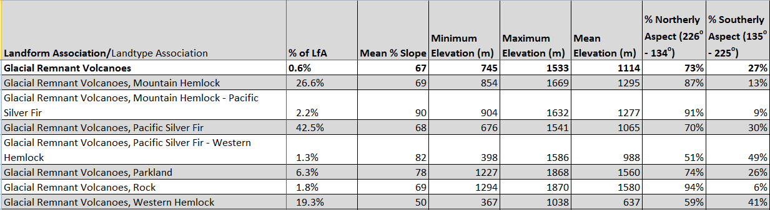

Climate:
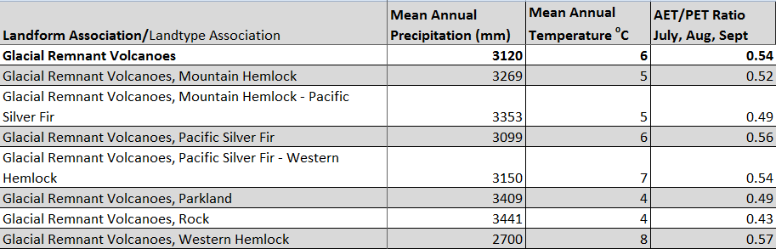

The ratio of Actual Evapotranspiration to Potential Evapotranspiration (AET/PET) is used as a broad-scale indicator of potential drought stress. We obtained modeled actual and potential evapotranspiration datasets from the Numerical Terradynamic Simulation Group at the University of Montana (http://www.ntsg.umt.edu/project/mod16) for a 30 year climate average. AET/PET ratio in the table above is based on a scale of zero to one. A value closer to 1 means the vegetation is transpiring close to its potential. A value farther from 1means that the Actual Evapotranspiration is below potential based on this climatic zone (Ringo, et. al. 2016 in draft).

