Northern Basin and Range Lava Flows
Terrain Class - Volcanoes:
Landform Association – Lava Flows:
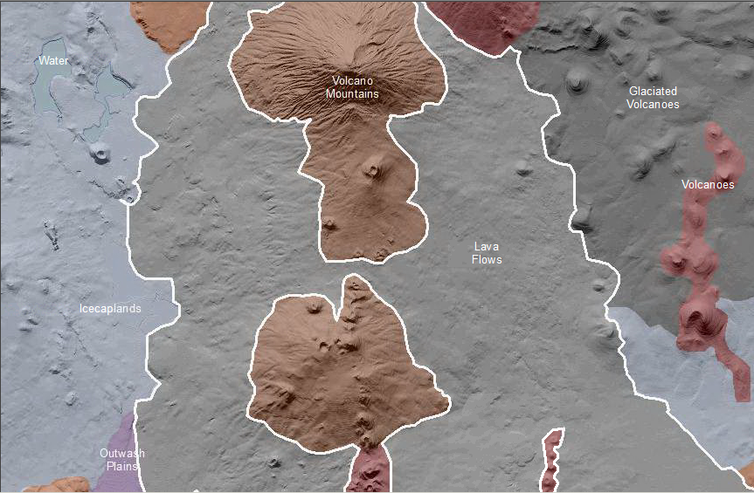

Lava Flows are areas covered by volcanic lava rock and for which a source ventis not mappable at this scale or is no longer directly contiguous. This map unit locally includes lava units that flowed down river valleus and through differential erosion of the bedrock along the valley walls, the lava flow is now a mesa, an example of “inverted topography.”
Soils on lava flows are age and climate dependent. Young lava flows may have little or no soil development, unless in humid areas where Histosols may develop. Older lava flows have Andisols where humid to Mollisols (commonly with duripans) where dry.
This Landform Association has limited spatial extent on National Forest System Lands.

Landtype Associations: Landtype Associations are formed by intersecting vegetation series or groups of vegetation series with Landform Associations.

Topography:
The following tables represent the average conditions for the Landform Association. Only lands within and adjacent to National Forest System Lands were mapped by this project. The entire EPA Level III Ecoregion is not covered by this mapping.

The percent of Landform Association (% of LfA) in bold in the table below refers to the percent of the Ecoregion represented by that Landform Association. The (% of LfA) numbers not in bold in the table below refer to the percent of each Landtype Association within the Landform Associations.
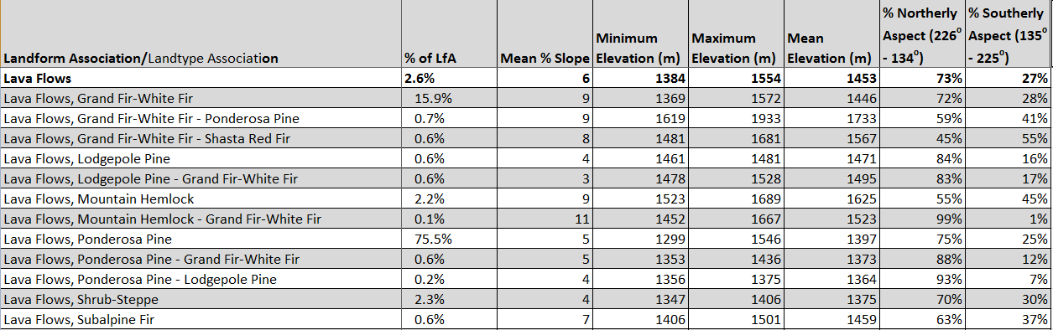

Climate:
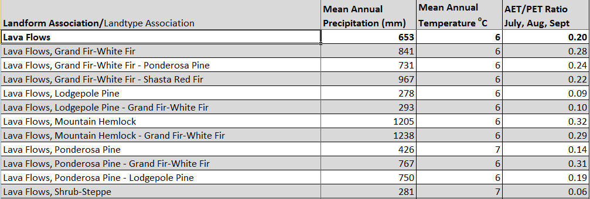

The ratio of Actual Evapotranspiration to Potential Evapotranspiration (AET/PET) is used as a broad-scale indicator of potential drought stress. We obtained modeled actual and potential evapotranspiration datasets from the Numerical Terradynamic Simulation Group at the University of Montana (http://www.ntsg.umt.edu/project/mod16) for a 30 year climate average. AET/PET ratio in the table above is based on a scale of zero to one. A value closer to 1 means the vegetation is transpiring close to its potential. A value farther from 1means that the Actual Evapotranspiration is below potential based on this climatic zone (Ringo, et. al. 2016 in draft).

