Northern Rockies Glaciofluvial Plains
Overall Terrain:
Plains [Landscape Term] A general term referring to an extensive, lowland area that ranges from level to gently sloping or undulating. A plain has few or no prominent hills or valleys, and usually occurs at low elevation relative to surrounding areas. (Bates and Jackson, 1980)

Landform Association:
Glaciofluvial Plains:

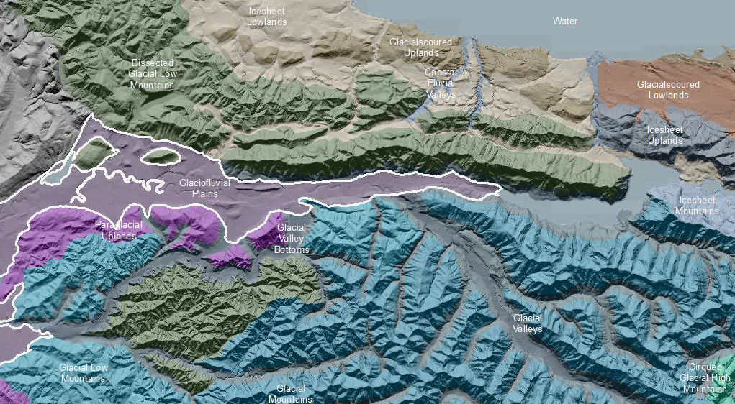

Glaciofluvial Plains are an extensive, lowland area that ranges from level to gently sloping or undulating. Glaciofluvial Plains are produced by shifting sedimentation by glacial outwash or glacial meltwater streams. Parent streams were typically multi-threaded and carried heavy sediment loads. As a consequence, thick, sandy to gravelly deposits are the norm. It may be difficult to distinguish the two originsbut fluvial processes are commonly more recent and overly or are inset to glacially derived sediments in the plain. The modern hydrologic and sediment regime supports a meandering stream course as a general rule. Migration of meanders leads to undercutting of bedrock valley walls or moraines, setting up reaches with considerable bedrock or glacial gravel recruitment. The bounds of fluvial plains deposits identifiable as terraces are included in this map unit. The plains originate within glacial ice-contact areas of mountain valleys or adjacent lowlands; typically within the rech of recessional terminal moraines. Soil profiles are deep and well developed on older deposits and are classified as Andisols and Alfisols. Younger deposits and the soils developed thereon are locally organic rich and are classified as Fluvents, Inceptisols and Mollisols.

This Landform Association is rare on National Forest System Lands.
Landtype Associations: Landtype Associations are formed by intersecting vegetation series or groups of vegetation series with Landform Associations.

Topography:
The following tables represent the average conditions for the Landform Association. Only lands within and adjacent to National Forest System Lands were mapped by this project. The entire EPA Level III Ecoregion is not covered by this mapping.

The percent of Landform Association (% of LfA) in bold in the table below refers to the percent of the Ecoregion represented by that Landform Association. The (% of LfA) numbers not in bold in the table below refer to the percent of each Landtype Association within the Landform Association.
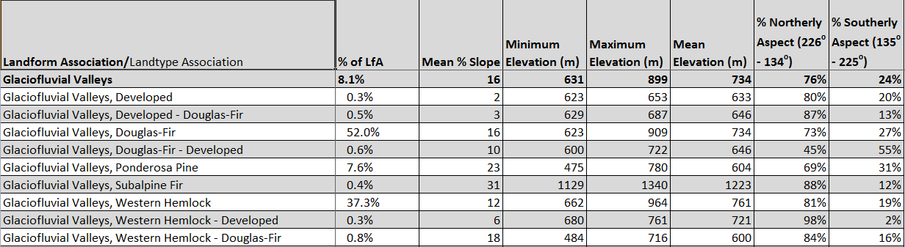

Climate:
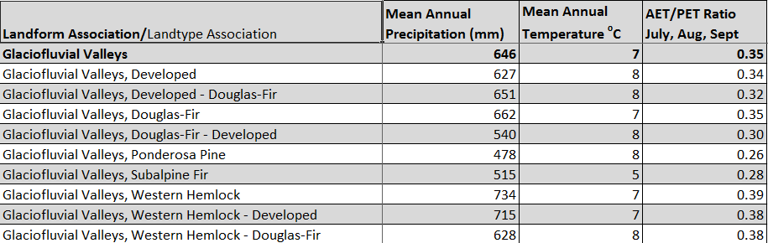

The ratio of Actual Evapotranspiration to Potential Evapotranspiration (AET/PET) is used as a broad-scale indicator of potential drought stress. We obtained modeled actual and potential evapotranspiration datasets from the Numerical Terradynamic Simulation Group at the University of Montana (http://www.ntsg.umt.edu/project/mod16) for a 30 year climate average. AET/PET ratio in the table above is based on a scale of zero to one. A value closer to 1 means the vegetation is transpiring close to its potential. A value farther from 1means that the Actual Evapotranspiration is below potential based on this climatic zone (Ringo, et. al. 2016 in draft).

