Northern Rockies Glacial Valley Bottoms
Valley [Landscape Term] (a) Any low-lying land bordered by higher ground; esp. an elongate, relatively large, gently sloping depression of the Earth's surface, commonly situated between two mountains or between ranges of hills or mountains, and often containing a stream with an outlet. It is usually developed by stream erosion, but may be formed by faulting. (b) A broad area of generally flat land extending inland for a considerable distance, drained or watered by a large river and its tributaries; a river basin. (Bates and Jackson, 1995)

Landform Association:
Glacial Valley Bottoms
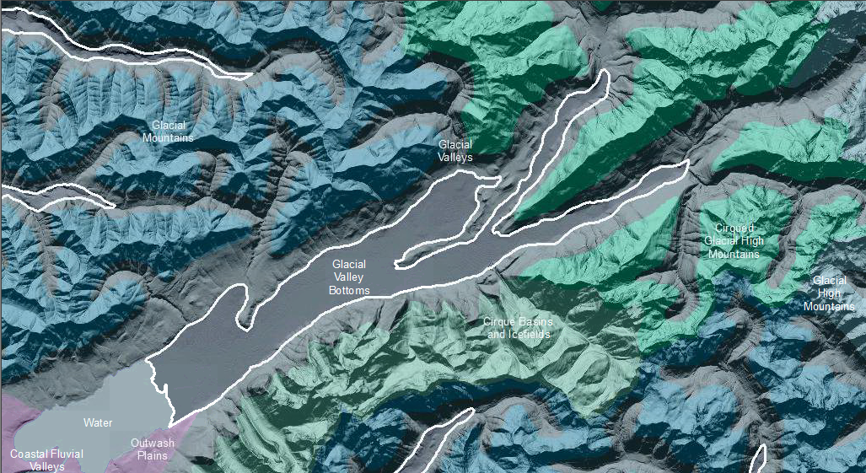

Glacial Valley Bottoms are those fluvial valleys that are found upstream of paleo-glacial moraines. Glacial Valley Bottoms are fluvial valleys with areas of glacially deposited sediments and scours mixed in with fluvial aggradation and erosion. This mélange makes discerning what is fluvial and what is glacial difficult. The glacial influence predates that fluvial in most locales. A meander plain that varies with watercourse sinuosity dominates the landform. Remnant moraines can detour or dam the stream channel creating valley lakes. In a Glacial Valley Bottoms where drainages meet, stream confluence is often downstream of what topography would indicate due to the presence of ancient medial moraines acting as a barrier. The confluence of waters is delayed for yards or sometimes miles. Heterogeneity of sedimentation is common rather than unusual with the glacial scouring and deposition intermingled with fluvial aggradation and degradation along the valley floor. These are droughty soils, quickly draining; in a climate with sufficient moisture they can be relatively productive.

This Landform Association has a limited spatial extent on National Forest System Lands.

Landtype Associations: Landtype Associations are formed by intersecting vegetation series or groups of vegetation series with Landform Associations.

Topography:
The following tables represent the average conditions for the Landform Association. Only lands within and adjacent to National Forest System Lands were mapped by this project. The entire EPA Level III Ecoregion is not covered by this mapping.

The percent of Landform Association (% of LfA) in bold in the table below refers to the percent of the Ecoregion represented by that Landform Association. The (% of LfA) numbers not in bold in the table below refer to the percent of each Landtype Association within the Landform Association.
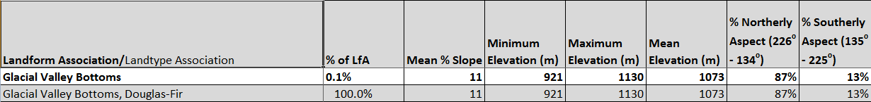

Climate:
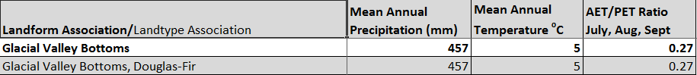

The ratio of Actual Evapotranspiration to Potential Evapotranspiration (AET/PET) is used as a broad-scale indicator of potential drought stress. We obtained modeled actual and potential evapotranspiration datasets from the Numerical Terradynamic Simulation Group at the University of Montana (http://www.ntsg.umt.edu/project/mod16) for a 30 year climate average. AET/PET ratio in the table above is based on a scale of zero to one. A value closer to 1 means the vegetation is transpiring close to its potential. A value farther from 1means that the Actual Evapotranspiration is below potential based on this climatic zone (Ringo, et. al. 2016 in draft).

