Puget Lowlands Puget Fluvial Valleys
Terrain Class: Valley [Landscape Term] (a) Any low-lying land bordered by higher ground; esp. an elongate, relatively large, gently sloping depression of the Earth's surface, commonly situated between two mountains or between ranges of hills or mountains, and often containing a stream with an outlet. It is usually developed by stream erosion, but may be formed by faulting. (b) A broad area of generally flat land extending inland for a considerable distance, drained or watered by a large river and its tributaries; a river basin. (Bates and Jackson, 1995)

Landform Association: Puget Fluvial Valleys
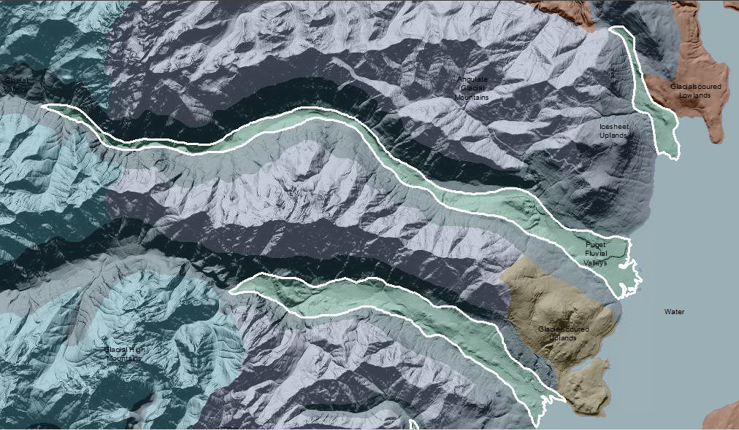

Puget Fluvial Valleys are valleys that flow into the Puget Sound. They are similar to Coastal Fluvial Valleys but have undergone post glacial uplift due to crustal rebound. Tides may have no influence or may affect the fluvial processes for many miles upstream depending on stream gradient in relation to sea level. In areas of tidal influence Puget Fluvial valleys within the diurnal tide cycles have attenuated hypoheriec flow and the daily ingress and egress of the tide intensify the moisture effect in soils and soil development. The Puget Fluvial Valleys fade or die as they merge with the bay or estuary. Within the Puget Fluvial Valleys landform association, the streams have a distinctly different gradient than the terraces. There is a random mix of sediment sizes due to unsorted mix of continental glacial deposits. The streams are reworking the glacial sediments. The river surfaces develop an armored channel due to the current river power not being able to move the particles sizes available. Streams migrate to the margins to capture new sediments, constantly reworking the channel shape.

This Landform Association is rare on National Forest System Lands.
Landtype Associations: Landtype Associations are formed by intersecting vegetation series or groups of vegetation series with Landform Associations.

Topography:
The following tables represent the average conditions for the Landform Association. Only lands within and adjacent to National Forest System Lands were mapped by this project. The entire EPA Level III Ecoregion is not covered by this mapping.

The percent of Landform Association (% of LfA) in bold in the table below refers to the percent of the Ecoregion represented by that Landform Association. The (% of LfA) numbers not in bold in the table below refer to the percent of each Landtype Association within the Landform Association.
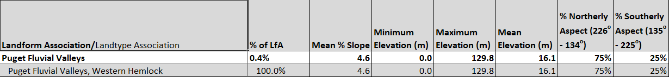

Climate:
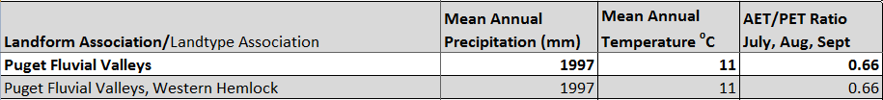

The ratio of Actual Evapotranspiration to Potential Evapotranspiration (AET/PET) is used as a broad-scale indicator of potential drought stress. We obtained modeled actual and potential evapotranspiration datasets from the Numerical Terradynamic Simulation Group at the University of Montana (http://www.ntsg.umt.edu/project/mod16) for a 30 year climate average. AET/PET ratio in the table above is based on a scale of zero to one. A value closer to 1 means the vegetation is transpiring close to its potential. A value farther from 1means that the Actual Evapotranspiration is below potential based on this climatic zone (Ringo, et. al. 2016 in draft).

