The ‘Lost’ Gardens: First Nations’ berry cultivation on British Columbia’s Central Coast

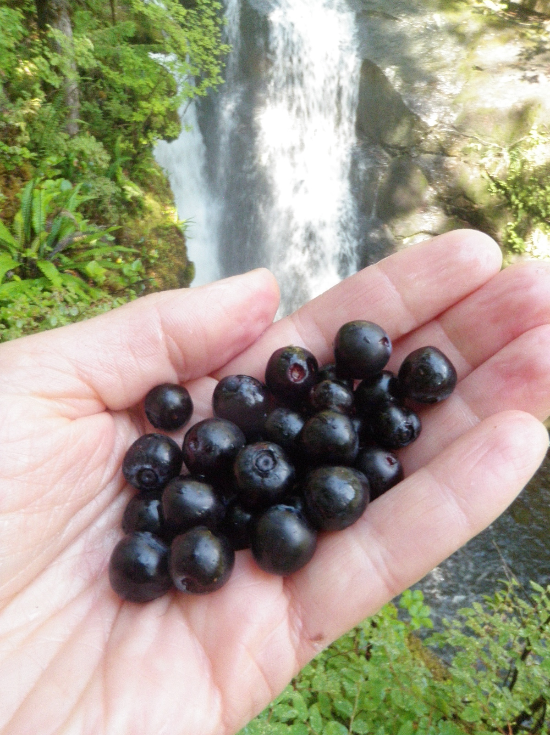

Alaska blueberries, possibly from Bessie Brown’s ‘berry garden’, as described by her grandson Cyril Carpenter. The patch where these were picked was located alongside a waterfall in Ripley Bay, Heiltsuk territory, on British Columbia’s Central Coast.

“A lot of people think we never touched the wild…berries. But we did. We cultivated it. We pruned it…. Especially that gwadems (Vaccinium parvifolium, red huckleberry), when they finished picking the gwadems, they pruned them. They break the tops off. Salmonberries (Rubus spectabilis) too….”

(Clan Chief Adam Dick, ‘Kwaxsistalla’, quoted in The Earth’s Blanket, p.165)
Summary
Recent research has highlighted how First Peoples on British Columbia’s Northwest coast managed their territories to enhance productivity of key resources such as estuary root crops, crabapple orchards and clam gardens. Today, however, few of these traditional management practices are followed, and First Peoples are continuing a nutrition transition as they move away from nutrient dense traditional foods to a modern diet high in processed foods, saturated fats and sugars. Concerns arising from this trend include a lack of community food security/sovereignty, epidemic rates of chronic diseases such as diabetes and stroke, and the loss of biological and cultural diversity as traditional management practices decline and traditionally managed plant communities are replaced with later successional stages of vegetation. This proposed research will study ‘berry gardens’, areas where key species such as red huckleberry (Vaccinium parvifolium) were likely cultivated, and that remain relatively unknown and unstudied today. Working with the Heiltsuk First Nation, this research seeks to understand to what extent and in what ways berries were managed in the past and to describe the spectrum of how a ‘cultivated’ garden differs from a ‘wild’ berry patch. A survey of ethnographic and published literature will be followed by key knowledge holder interviews as well as scientific testing of the traditional fertilizing methods of salmon remains and wood ashes on red huckleberry (Vaccinium parvifolium) in a controlled experiment. The results will be applied collaboratively with the Heiltsuk community to address issues of food security/sovereignty, Elder/youth knowledge transfer and ethnoecological restoration. A number of potential historic berry gardens within Heiltsuk territory will be identified and described. A participatory research and decolonizing methodology will be followed in a mixed methods approach. Key qualitative methods include semi-structured and open-ended interviews, snowball sampling, elicitation and a focus group. Quantitative methods used include soil sampling, random block design, and measurement of red huckleberry growth rate and fruit quality. It is anticipated that this research will contribute to the evolving understanding of how Northwest Coast First Nations enhanced plant productivity through cultivation methods. Berry gardens and their associated management and cultural practices may help communities to address food security/sovereignty as well as contribute to the national and global discussion of the nutrition transition.

Introduction
The past decade has seen a dramatic shift in the understanding of how British Columbia (BC) First Nations historically managed landscapes and key resources. No longer are these First Peoples portrayed as passive hunter-gatherers surviving in ‘pristine’ natural environments and opportunistically foraging that nature provided. Rather, they are increasingly recognized as active and sophisticated agents, responsible for creating and managing broad-scale complex ecological systems and practicing cultivation of plants as well as enhancement of shellfish, salmon and active management of animals (Berkes, 2012; Lepofsky et al., 2005; Lightfoot, 2013; Turner et al., 2013).

Recent decades have also witnessed a radical ‘nutrition transition’ in Indigenous food systems around the world (Kuhnlein et al. 2006), notably and alarmingly here in Canada, as diets of Indigenous Peoples and indeed the broader Canadian population, move away from traditional foods to an often poor-quality modern diet high in saturated fats and refined sugars (Turner et al. 2013). In contrast to these modern foods, traditional plant foods are nutrient-dense, and contain important and high-quality vitamins, minerals, fats and other beneficial phytochemicals (Kuhnlein and Turner, 1991). Native berries, for example, contain significant levels of Vitamin C, healthy sugars, minerals and anitoxidants (ibid.). Beginning in the mid-1800s, with a dramatic shift evident a century later in the 1940s, the use of traditional foods in Canadian First Nations communities has sharply decreased. This dietary change is attributed to a complex mix of factors, including the impacts of Indian residential schools, the introduction of new foods such as flour and rice, land degradation and change, barriers to intergenerational knowledge transfer and the restriction of access to traditional territories and associated resources (Turner and Turner, 2007; 2008). Of the approximately 100 species of plant foods that were formerly commonly harvested by First Nations on the BC coast, for example, most are no longer used, and many are not even known to younger generations (ibid.).

During this same period, incidences of chronic diseases such as stroke, diabetes, heart disease and obesity in Canadian First Nations populations have risen to epidemic proportions in comparison to national averages, a change which is partially attributed to this rapid shift in traditional diet and associated lifestyle (Royal Commission Report on Aboriginal Peoples, 1996). Today, many Canadian First Nations communities are food insecure and suffer from a lack of food sovereignty (Food Secure Canada, 2015), defined as “the right of peoples to healthy and culturally appropriate food produced through ecologically sound and sustainable methods, and their right to define their own food and agricultural systems” (Via Campesina, 2015).

In addition to these significant human-health costs, the reduced management and use of traditional foods can also be linked to environmental degradation and reduced ecosystem productivity (Pretty et al., 2009). Recent work has highlighted the connection between biological and cultural diversity (Berkes, 2012; Berkes et al, 2003; Davis, 2007), suggesting that traditionally managed landscapes and cultures can lead to increased biodiversity and resilience for both (Turner et al., 2003). For example, human management interventions often create and maintain ‘edges’ of habitat that are more biologically diverse and productive than surrounding, unmanaged ‘natural’ areas (Turner, Davidson-Hunt and O’Flaherty, 2003). Thus, the loss of traditional foods such as native berries and their associated management systems can lead to negative impacts for both human and biological health.

On BC’s Northwest (NW) Coast, along with estuarine root gardens (Deur, 2005; Lloyd, 2011), ethnographic evidence suggests that First Nations may have cultivated berry plants extensively for food, using practices such as burning, pruning, transplanting, tilling, weeding, fertilizing and the application of ceremonial constraints and proprietorship to augment and significantly enhance fruit production (Hamersley Chambers and Turner, 2011; Turner et al., 2013; Turner, 2014; Wyllie de Echeverria, 2013). Examples of species recorded to have been cultivated include salal (Gaultheria shallon), Pacific crabapple (Malus fusca), salmonberry (Rubus spectabilis), stink currant (Ribes bracteosum), Alaska blueberry (Vaccinium alaskaense), oval-leaved blueberry (Vaccinium ovalifolium), and red huckleberry (Vaccinium parvifolium).

In this region, ‘berry gardens’ have been described by Elders as habitats enhanced by humans for the production of some wild berry species (Turner and Turner, 2008). According to the late Heiltsuk Elder Cyril Carpenter, his grandmother Bessie Brown’s berry garden was located at Roscoe Inlet on a benchland adjacent to a waterfall, where the mists would keep the plants moist, even in summertime, and the site was sheltered from the northeast wind. They fertilized this ‘berry garden’ with fish and fur animal guts and ashes from the fire (Turner, unpublished field notes April 17-2002). Indeed, it is this traditional knowledge from Cyril Carpenter that is the major inspiration for this proposed research. An expedition with Cyril’s widow Jennifer Carpenter and other family members, along with Heiltsuk Integrated Resource Management Department staff and Dr. Nancy Turner from the University of Victoria in July 2014 tentatively located this berry garden in Ripley Bay, where a profusion of large oval-leaved blueberry and red huckleberry plants were found thriving where the waterfall mists fell (Hamersley Chambers, unpublished field notes, July 2014).

However, as with many traditional foods, the use and management of berry species have diminished markedly during the past century (Parrish et al., 2008). While wild berries remain the most frequently gathered plant food by contemporary First Nations and the annual picking is often a much anticipated event (Kuhnlein and Turner, 1991), few people today know how the traditional berry gardens may have functioned (Turner, 2003) or that they even existed.

Despite the critical role that berry resources appear to have played historically in diet, landscape management, economy, culture and ceremony of NW Coast First Nations, the ethnoecology of edible wild berries remains relatively unstudied in the published literature and scientific research (for exceptions see Thornton, 1999; Turner and Deur, 2005; Turner et al., 2013). This historically important food source, and its associated landscape management practices and ecosystems, has yet to be named (other than ‘berry gardens’), defined or scientifically studied. A comprehensive and systematic analysis of traditional berry cultivation methods and their specific outcomes has never been undertaken. There is therefore a large knowledge gap in this subject that, once filled, may have important implications for First Nations food security/sovereignty, Elder/youth knowledge transfer and ethnoecological restoration, both in Canada and abroad. The identification and understanding of these cultivated gardens also has potential implications for Aboriginal rights and title in Canada, including that of the Heiltsuk.

The objective of my PhD research is thus to study traditional NW Coast berry gardens and to apply my findings - in cooperation with the Heiltsuk of the BC Central Coast - to the issue of First Nations food security/sovereignty. Related issues that will be addressed through this focus, but that are not stand-alone research questions, include Elder/youth knowledge transfer, ethnoecological restoration and the inclusion of traditional plant management into Aboriginal rights and title cases. To achieve my objective, I will address the following questions:

- To what extent, and in what ways, do NW Coast First Peoples (specifically the Heiltsuk) manage their various berry resources, both past and present?
- How does a ‘cultivated’ berry garden differ from a ‘wild’ berry patch?
- How does the traditional management practice of fertilizing with salmon remains alter red huckleberry and oval-leaved blueberry plant growth, overall health and fruit production/quality?
- How can the results of this study be applied cooperatively to address the identified issue of food security/sovereignty in the Heiltsuk community, and beyond?

Methods
To answer my research questions I will follow a mixed methods approach integrating both social science and natural science methods and combining western science with traditional ecological knowledge (TEK). Specific details regarding my proposed quantitative and qualitative methods are presented following each research question below. My proposed work is in collaboration with the Heiltsuk First Nation, where people are known to have cultivated berry species (Jennifer Carpenter, pers. comm. July 2014; Turner, pers. comm. March, 2015). I will seek approval from the UVic Ethics Committee and negotiate a research protocol and ethics agreement with the Heiltsuk before beginning my field research. To address the issues already raised by Heiltsuk community members of food security/sovereignty, Elder/youth knowledge transfer and ethnoecological restoration (Jennifer Carpenter, pers. comm. July, 2014 and September, 2015) I will follow a community-based and participatory action research methodology (Kumar, 2002).

Written consent will be obtained from all participants after informing them of potential benefits and risks of this study. Permission to record interviews will be requested, and interviewees will each be given a copy of their consent form for their records, including details regarding who they can contact to withdraw from this research at any time. Potential interviewees will be identified first by recommendations from existing community contacts (based on their experience on the land and role in their community), and then by employing a ‘snowball’ sampling method (Jupp, 2009). I will interview a representative sample of community members based on age and gender. While I will interview women, youth and men, it is anticipated that the majority of interviews will be with older female individuals as they may be more likely to have berry picking and cultivation knowledge. To facilitate interview responses I will use elicitation, showing maps and plant samples, and also by organizing intergenerational visits to key sites such as Hauyat, and Roscoe and Gulchuks inlets where historic berry gardens are suspected to have existed.

To acknowledge cultural and historic barriers, and to meet the challenges and potential biases inherent in the cross-cultural communication necessary for my PhD, I intend to follow an Indigenous research methodology and paradigm (Chilisa, 2011; Smith, 2012; Wilson, 2008). While my family background as Caucasian newcomers (1885) to British Columbia and the underlying beliefs and worldview inherent in conducting Western academic research will always, to some degree, be incompatible with an Indigenous research paradigm (ibid.; UVic Institute for Studies and Innovation in Community-University Engagement, 2015), I believe that this methodology of describing and respectfully acknowledging our differences will allow us to work collaboratively to design and conduct research that is mutually enriching and beneficial. To begin this process, I will conduct a literature review of research related to Indigenous epistemologies and by Indigenous scholars to provide a valued perspective on my preliminary PhD proposal, research questions, approach and goals. Before conducting my research, I will articulate, and think critically about, how a Eurocentric worldview informs my assumptions, biases and the goals of my proposed research (Smith, 2012).

A participatory action research approach that encourages community members as key participants in the research process (Newing, 2001; Robinson, 1996) will be used. In the first part of this study, I will conduct a scoping exercise with my collaborators to identify community priorities regarding this proposed berry garden research. A survey of representative age groups and gender within the Heiltsuk community will then be undertaken to assess the following knowledge regarding berry species that may once have been cultivated: identification of species; social aspects of harvesting and knowledge transfer; knowledge about habitat and other growth requirements; and, whether these fruits are harvested and consumed today, and if so in what quantities and where, and with whom. Semi-structured and open-ended interviews (Creswell, 2003) will be conducted, and participants will be asked whether they would like to consume more berries in their diet in the future.

To answer my first question, ‘to what extent, and in what ways, do NW Coast First Peoples manage their various berry resources, both past and present’, I will begin by conducting a literature review of early ethnographic records and collections held by the UVic Ethnoecology library, the Royal BC Museum and Archives, the Heiltsuk Cultural Education Centre Library, and other published research papers and theses/dissertations. I will employ semi-structured and open-ended interviews supported by elicitation with community experts and with knowledgeable academics and practitioners such as my supervisor, ethnobotanist Dr. Nancy Turner and ethnographers Dr. Dorothy Kennedy and Randy Bouchard among others. My goal is first to develop a working definition of a traditional cultivated berry garden, to identify and define the characteristic features of these, and to then compile and describe the range of historical management methods used. Through this process, I hope to identify species that were cultivated, such as red huckleberry and oval-leaved blueberry, and also to record important historical and contemporary information regarding the role of berry gardens in language, diet, landscape management, economy, culture and ceremony of NW Coast First Nations. I also seek to understand how berry gardens and berry management practices fit within the mosaic of other traditional managed areas such as fish camps, clam gardens, crabapple orchards, estuary root gardens and village/camp sites. This information will then be used to describe a historical baseline for berry gardens, for example an estimated volume of fruit harvested calculated based on the information in the ethnographic record and population estimates. To elicit information regarding traditional use and present day knowledge of the berry gardens and berry resource use and management, I will conduct semi-structured and open-ended interviews with knowledgeable individuals in the Heiltsuk community, both in their homes and in the field. The number of interviewees will be determined by the number of knowledge holders present and wishing to participate in each community, but a minimum of 10-15 would be similar to other ethnoecological studies (Karst, 2005).

To answer my second question, ‘how does a ‘cultivated’ berry garden differ from a ‘wild’ berry patch’, I will first create a definition of both ‘cultivated’ and ‘wild’. I will then investigate how plants in a berry garden differs from plants of the same species growing in the wild. Is there a spectrum of management or species composition, with a fully cultivated garden on one end and wild plants on the other? If so, how do we tell the in-between stages apart? By using my berry garden definition and historical information as a benchmark, I can compare these criteria to fully ‘wild’ berry patches. Assessment criteria may include the number and species diversity of berry plants per square metre, species diversity, flower set, and fruit quality and volume. I will need to take into account potential variables such as availability and effectiveness of pollinators, and other environmental factors not easily assessed.

I will then identify as many potential historic berry gardens as possible based on oral history (both recorded and through semi-structured expert interviews) as well as a review of traditional resource use maps already developed by the Heiltsuk Integrated Resource Management Department (HIRMD). I will create a working definition of a traditional cultivated berry garden, identify and define its characteristic features (such as species structure, aspect and soil composition), and then compile and describe the range of historical management methods used to maintain these gardens. Investigation of these possibly ancient sites will help me to define aspects of a traditional berry garden, to understand how these systems functioned and also to inform my research and possible ecocultural restoration efforts if desired by the community. Recently undertaken research on cultivated orchard gardens (Wyllie de Echeverria, 2013) and root gardens (Lloyd, 2011) will assist in this process.

Working with the Heiltsuk, and with permission of HIRMD, we will identify a minimum of 10 possible historic berry gardens and then choose 3-4 of these, as well as 3-4 control sites, to study in greater detail. I will hire a youth research assistant, to help me with data collection and logistics. I will identify and then assess these 3-4 historic berry gardens using the following methods: mapping, soil sampling (to look for evidence of previous burning practice and fertilization), vegetation survey (to record the suite of plants growing at each site), plant community composition, plant population structure, and age structure. Assessment criteria may also include a count of the number of berry plants per square metre, a stem count for key species, bud set and possibly fruit volume.

In addition, I will conduct expert interviews, site visits and a review of traditional land use maps as well as historical records and published papers to investigate what fertilizers were used in the past. These sources will help me to identify possible locations and transportation methods of these fertilizers to the berry gardens as well as application methods, volumes and season of application. For example, fertilizers such as remains from fish, ungulate and bivalve processing would be available in different quantities, locations and months of the year, while campfire ashes may have been more prevalent during camping times at nearby locations. This information is important as it will help to inform our understanding of how these gardens were managed, thus aiding in their possible physical and cultural restoration.

To answer my third question, ‘how does the traditional management practice of fertilizing alter berry plant health and production’, I will create two test plots (located at Calvert Island and at Metchosin Farm) and scientifically measure the outcomes of a controlled study for each. While I intend to monitor both plots to obtain three years of data, I anticipate that the larger and more secure plot at Metchosin Farm will provide me with more consistent and reliable information than the site at Calvert Island where I cannot reside full time. This northern plot remains important for community engagement and education purposes, however, and while it may also produce useful data I will not rely on these for my analysis. I plan to maintain the Metchosin Farm plot after my thesis is finished as part of a personal longer-term study on traditional cultivation methods and native berry species.

Red huckleberry (Vaccinium parvifolium) will be used as the test species since the ethnographic record identifies this as likely cultivated (Turner, 2005). Berry plants for the Hakai test plot will be sourced from the wild as close to the planting site as possible to minimize transplanting stress and to increase the likelihood of collecting similar genetics. Plants for the Metchosin Farm test plot will be sourced from Fraser’s Thimble Farm nursery on Saltspring Island, where the plant age and growth conditions are known to have been identical for each individual. Plants will be potted on into 5-gallon containers and placed on landscape fabric in a location that ensures equal exposure to sunlight and water.

The Hakai test plot was set up in July 2014, following a randomized plot design (Krebs, 1998) whereby a fertilizer treatment was applied to one plant (treatment) of a pair but not the other (control). The fertilizer used for the Hakai test plot consisted of .9 kilograms (2 pounds) of 4-5 whole herring and a salmon head, backbone and shoulders. In each planting hole, the fertilizer was placed in the bottom and broken up/mixed into the soil with a shovel. For the Metchosin Farm plot, seventy similar plants (approximiately 4 years of age, and 18-36 cm in height) will be sourced, then treated using a stratified random design employing both salmon remains and wood ashes as fertilizer.

In May 2015 a second test plot will be established at Metchosin Farm near Victoria. This will consist of 70 of red huckleberry. These numbers will provide statistically robust data for analysis (Morgan Hocking, pers. comm. 2015) and account for natural variation that may exist in the fertilizer applied, non-identical sample plants, and other possible ‘nuisance’ factors. To ensure plants of an identical age class as well as growing conditions (soil, fertilizer amounts and root size), the red huckleberry plants will be purchased from a commercial plant nursery. This plot will be securely fenced due to the number of deer in the area as well as potential damage from farm animals nearby. If space allows, I may also plant 2 similar pairs each of salmonberry, salal, thimbleberry and evergreen huckleberry (Vaccinium ovatum). While these pairs are too small to provide any statistically reliable or significant data, the results of this additional planting experiment may suggest avenues for future research and help us understand which species were historically cultivated. These additional plants will also be sourced from a commercial plant nursery.

To assess my theory that berry plant growth rate is a factor of fertilization, the following aspects will be measured for each plant: radial and vertical stem growth rate, stem number and height; bud size and number; total flower number and average blossom size; size range of berries and total volume of fruit produced per plant; dry weight, and; average fruit sugar content (as a proxy for caloric contributon and flavour).

My fourth question ‘How can the results of this study be applied cooperatively to address the issue of Aboriginal food security/sovereignty in the Heiltsuk community?’ will be investigated using a number of collaborative and participatory research methods. Early in my study the establishment of a multigenerational focus group and semi-structured and open-ended interviews will facilitate a conversation around community goals and identification of key issues, methods, and desired research objectives and outcomes. The focus group will contain a range of genders and ages, with the goal of eliciting information regarding traditional berry management (what practices were used historically, and more recently), who is involved in this management (Elders, adults, youth – past and present) and in what capacities. These groups will also facilitate Elder/youth knowledge transmission, raise individual and community awareness of the berry gardens, and document what community members may want the future of these gardens and berry consumption/management to be. Later, this focus group and key informant interviews will elicit how berry gardens can address current issues of food security/sovereignty, Elder/youth knowledge transfer and ethnoecological restoration. It is my understanding from informal discussions with some community members and HIRMD staff in 2014 that there is a strong desire to link my research to these three themes as well as to take Elders and youth together out on the land to facilitate knowledge transfer and practical skills regarding berry use and management.

The knowledge and information thus gathered will be made available to the Heiltsuk in their desired format and as they see fit. For example, I can work to publish this in papers or booklets, or prepared as posters or pamphlets, presented as audio recordings, photographs and/or videos, to be used in the schools or adult education programs or at other cultural programming events. It is my intention that these research results be kept as a permanent record for the benefit of present and future people in this community, and hopefully, in others as well.

Anticipated Significance
Along with recently described root gardens (cf. Deur, 1998, 2000; Lloyd, 2011), orchard (cf. Wyllie de Echeverria, 2013) and clam gardens (cf. Recalma-Clutesi 2005; Harper et al. 2005), my research will contribute to the evolving recognition and academic study of how First Nations practiced cultivation and landscape management on the BC Central coast (cf. Turner et al 2013; Turner and Peacock 2005). My results will help our understanding of these traditional systems by describing the scale and complexity of ‘berry gardens’ and by providing scientific and cultural evidence of how these systems likely functioned. It is hoped that this research will also suggest areas for further inquiry in this field.

In a broader context, my work will contribute to the discussion and study of the global nutrition transition and how this is impacting First Nations on the BC Central coast. It will also suggest how traditional foods such as berries, and their associated management and cultural practices, can stimulate dialogue and help communities to find solutions to the issue of food security/sovereignty and the revitalization of TEK practices. The multi-generational focus group and hiring of a youth community research assistant will facilitate a conversation around community objectives and outcomes for this research. For example, whether people would like to consume more native berries in their diet and if so how this goal might be achieved. It is anticipated that this research will also highlight contemporary issues around Elder/youth knowledge transfer and ethnoecological restoration for NW Coast First Nations and beyond.

The results of this research also have potential implications for Aboriginal rights and title claims, as berry gardens are not currently a recognized form of historic land use. It is my sincere hope that this research will also raise awareness of, and appreciation, by the general Canadian public of our remarkable native berry species and their associated First Nations management systems.

Working collaboratively with community members and HIRMD we will suggest community-based ethnoecological restoration outcomes and our results will contribute to the long-term research and cultural and landscape management goals of the Heiltsuk. My berry test gardens will be an example of ‘learning by doing’ working together with First Nations, and contributing to a more detailed and practical understanding of those customary management practices that have been widely used in the past but whose details are less known to the present generations.

Thesis Committee Structure and Expectations
My PhD supervisor is Dr. Nancy J. Turner, professor in the School of Environmental Studies at the University of Victoria. Dr. Turner is a world-renowned ethnobotanist and ethnoecologist with a keen interest in, and over 40 years direct experience with, First Nations plant management, including the NW coast of British Columbia. She also has a particular interest in, and affinity for, our native berry species. I cannot think of anyone else who would have the necessary knowledge, community relationships, and skills to supervise this PhD research topic and I am grateful for Dr. Turner’s enthusiasm and considerable support. Indeed, it was during a trip with Heiltsuk Elder Cyril Carpenter that Dr. Turner first learned of Cyril’s grandmother Bessie Brown’s ‘berry garden’ - and the seed for this research was sown. Dr. Turner holds a BSc in Biology from the University of Victoria (1969), and a PhD in Botany from the University of British Columbia (1973).

My committee is comprised of Dr. Brian Starzomski and Dr. Dana Lepofsky. Dr. Starzomski is a professor in the School of Environmental Studies at the University of Victoria and his research focuses on the fields of restoration and community ecology and conservation biology, particularly on the BC Central coast. His scientific training and knowledge are an important contribution to this proposed dissertation. He holds a BSc from St. Francis Xavier University in Geology and Biology (1996), an MSc from Acadia University in Biology (2000) and a PhD in Zoology from the University of British Columbia (2006). Dr. Dana Lepofsky is a professor in the Department of Archaeology at Simon Fraser University. She has a particular interest in interdisciplinary and collaborative research and as such is an ideal fit for my proposed study. Her other research interests include paleoethnobotany and complex hunter-gatherers of the Pacific Northwest as well as indigenous resource and landscape management – areas of study and knowledge that are of particular value and support to my proposed work. She holds a BA from the University of Michigan, and MA from the University of British Columbia, and a PhD from the University of California, Berkeley.

Table 1 Research Timeline
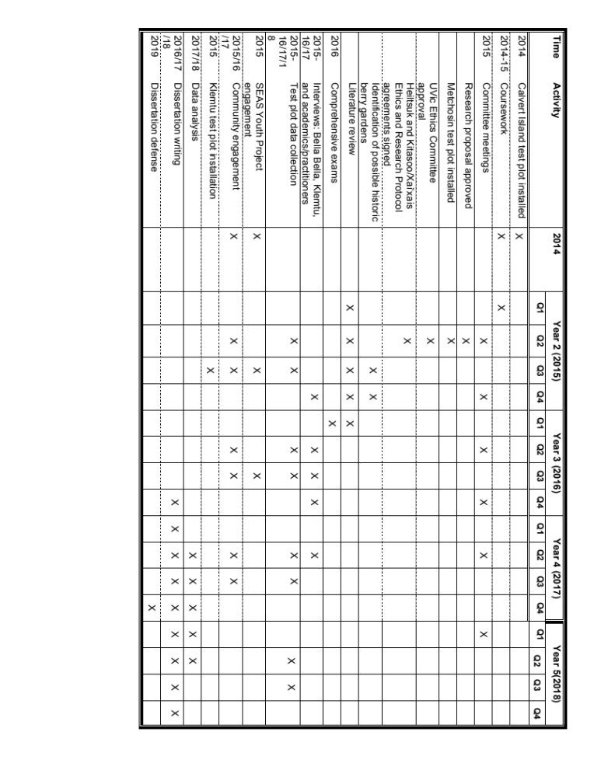

Funding
I currently hold a Tula Foundation fellowship valued at $23,000 per year for three years beginning in September 2014, with an additional travel grant of up to $7,500 for each funded year.

Activities | 2014 | 2015 | 2016 | 2017 | 2018 | 2019 | TOTAL
Travel |  |  |  |  |  |  | $0.00
Air Fares | $850.00 | $1,100.00 | $1,100.00 | $1,100.00 | $650.00 |  | $4,800.00
Boat / Skipper Fees |  | $400.00 | $700.00 | $500.00 |  |  | $1,600.00
Vehicle Expenses | $450.00 | $450.00 | $450.00 | $450.00 | $450.00 |  | $2,250.00
Gifts and Honorarium |  | $350.00 | $500.00 | $250.00 |  |  | $1,100.00
Research Assistant |  |  | $1,500.00 | $1,500.00 | $500.00 |  | $3,500.00
Food / Incidentals | $75.00 |  |  |  |  |  | $75.00
Test Plot fencing |  | $1,200.00 |  |  |  |  | $1,200.00
Field Gear and Incidentals |  | $300.00 | $300.00 | $200.00 | $200.00 |  | $1,000.00
Scientific Tests(soil sample, etc.) |  |  | $500.00 | $800.00 | $800.00 |  | $2,100.00
Stationery / Presentation Mat. |  | $75.00 | $75.00 | $75.00 | $450.00 |  | $675.00
Unforseen Expenses |  | $100.00 | $100.00 | $100.00 | $100.00 |  | $400.00
Total Expenditure | $1,375.00 | $3,975.00 | $5,225.00 | $4,975.00 | $3,150.00 | $0.00 | $18,700.00

Literature Cited
Berkes, Fikret. Sacred Ecology: Traditional Ecological Knowledge and Resource Management. 3rd Edition. Taylor and Francis, Philadelphia. 2012
Berkes, Fikret and J. Colding, C. Folke, Eds. Navigating Social and Ecological Systems: Building Resilience for Complexity and Change. Cambridge University Press. 2003
Chilisa, Bagele. Indigenous Research Methodologies. Sage Publications. 2011
Creswell, J. Research Design: Qualitative, quantitative and mixed methods approaches, 2nd edition. Sage publishing, Toronto. 2003
Davidson-Hunt, I. and M. O’Flaherty. ‘Researchers, Indigenous Peoples, and Place-Based Learning Communities. Society and Natural Resources, 20:291-305. 2007
Davis, Wade. Light at the Edge of the World: A Journey Through the Realm of Vanishing Cultures. Douglas and McIntyre, Vancouver. 2007
Deur, Douglas. “Wetland Cultivation on the Northwest Coast of North America.” MA thesis, Louisiana State University. 1998
Deur, Douglas. “A Domesticated Landscape: Native American Plant Cultivation on the Northwest Coast of North America.” PhD dissertation, Louisiana State University. 2000
Food Secure Canada. http://foodsecurecanada.org. Accessed April 4, 2015.
Government of Canada. Royal Commission Report on Aboriginal Peoples, Ottawa. 1996
Hamersley Chambers, Fiona and Nancy Turner. “Plant Use by NW Coast and Plateau Indigenous Peoples” in The Subsistence Economies of Indigenous North American Societies. Bruce D. Smith, Ed. Smithsonian Institution Scholarly Press in cooperation with Rowman and Littlefield Publishers, Inc. 2011
Hamersley Chambers, unpublished field notes, July 2014.
Hocking, Morgan. University of Victoria. Personal communication, February 2015.
Institute for Studies and Innovation in Community-University Engagement, University of Victoria. Symposium ‘Researching with Dignity in Aboriginal Communities’, Friday January 23, 2015.
Jupp, Victor. Ed. The SAGE Dictionary of Social Research Methods. Sage Publications. 2006
Karst, Amanda. “The Ethnoecology and Reproductive Ecology of Bakeapple (Rubus chamaemorus L. Rosaceae) in Southern Labrador”. MA thesis, University of Victoria, 2007.
Krebs, Charles. Ecological Methodology. UBC Press, Vancouver. 1998
Kuhnlein, Harriet and Nancy J. Turner. Traditional Plant Foods of Canadian Indigenous Peoples. Gordon and Breach Science Publishers. 1991
Kuhnlein, Harriet. B. Erasmus, H. Creed-Kanashiro, L. Engelberger, C. Okeke, N. Turner, L. Allen, J. Bhattacharjee. “Indigenous peoples’ food systems for health: finding interventions that work” Public Health and Nutrition December 9(8). 2006
Kumar, Somesh. Methods for Community Participation: a complete guide for practitioners. Vistaar Publications. 2002
La Via Campesina. http://viacampesina.org. Accessed April 4, 2015.
Lepofsky, Dana. Douglas Hallett, Ken Lertzman, Rolf Mathewes, Albert (Sonny) McHalsie, and Kevin Washbrook. ‘Documenting Precontact Plant Management on the NW Coast: An Example of Prescribed Burning in the Central and Upper Fraser River Valley, British Columbia’. Chapter 8, in Keeping it Living: Traditions of Plant Use and Cultivation on the NW Coast of North America. Douglas Deur and Nancy J. Turner, Eds. University of Washington Press. 2005.
Lightfoot, K., Rob Cuthrell, Chuck Striplet and Mark Hylkema. “Rethinking the Study of Landscape Management Practices Among Hunter-Gatherers in North America”. American Antiquity 78(2). 2013
Lloyd, Abe. “Cultivating the t{@kkillak#, the ethnoecology of ]@ks@m, Pacific silverweed or cinquefoil [Argentina egedii (Wormsk.) Rydb.; Rosaceae]: lessons from Kwaxsistalla, Clan Chief Adam Dick, of the Qawadiliq@lla Clan of the Dzawada%ēnuxw of Kingcome Inlet (Kwakwaka’wakw )”. MA thesis, University of Victoria. 2011
Milne, Ryan. Master of Science in Forestry, Faculty of Natural Resources Management Thesis: Exploring wild blueberries as a place-based socio-economic development opportunity in Ignace, Ontario. Lakehead University. May, 2013
Newing, Helen and contributions from C. Eagle, R. Puri and C.W. Watson. Conducting Research in Conservation: A Social Science Perspective. Routledge, New York. 2011
Parrish, Christopher C. Nancy J. Turner and Shirley M. Solberg, Eds. Resetting the Kitchen Table: Food Security, Culture, Health and Resilience in Coastal Communities. Nova Science Publishers, New York. 2008
Pretty, Jules, Bill Adams, Fikret Berket, Simone Ferreira de Athayde, Nigel Dudley, Eugene Hunn, Louisa Maffi, Kay Milton, David Rapport, Paul Robbins, Eleanor Sterling, Sue Stolton, Anna Tsing, Erin Vintinner and Sarah Pilgrim. “Biological Diversity and Cultural Diversity: Towards Integration”. Conservation and Society. 7(2). 2009
Recalma-Clutesi, Kim and Diane Woods, David Woods, Directors. Ancient Sea Gardens: Mystery of the Pacific Northwest. Documentary film. Toronto, ON: Aquaculture Pictures. 2005
Robinson, Michael P. ‘Shampoo Archaeology: Towards a participatory action research approach in civil society’. Canadian Journal of Native Studies. XVII (1):125-138. 1996
Smith, Linda. Decolonizing Methodologies: Research and Indigenous Peoples, Second Edition. Zed Books. 2012
Thornton, Thomas F. “TLEIKW AANI, the “Berried” landscape: The Structure of Tlingit Edible Fruit Resources at Glacier Bay, Alaska”. Journal of Ethnobiology 19(1):27-48. 1999
Turner, Nancy. Personal communications, March 2015.
Turner, Nancy. Unpublished field notes April 17-21, 2002, received by e-mail, October 23, 2013.
Turner, Nancy. Ancient Pathways, Ancestral Knowledge: Ethnobotany and Ecological Wisdom of Indigenous Peoples of Northwestern North America. McGill-Queens University Press. Montreal and Kingston. 2014
Turner, Nancy. ‘Not One Single Berry: Indigenous Knowledge and Environmental Change in British Columbia’. CINE Symposium, October 15, 2003
Turner, Nancy. The Earth’s Blanket: Traditional Teachings for Sustainable Living. Douglas and McIntyre, Vancouver. 2005
Turner, Nancy J., and Sandra Peacock. “‘Solving the Perennial Paradox’: Ethnobotanical Evidence for Plant Resource Management on the Northwest Coast.” In Keeping It Living”: Traditions of Plant Use and Cultivation on the Northwest Coast of North America, ed. Douglas Deur and Nancy J. Turner, 101-50. Seattle, WA: University of Washington Press; Vancouver, BC: UBC Press. 2005
Turner, Nancy and Katherine Turner. “Where our women used to get the food: cumulative effects and loss of ethnobotanical knowledge and practice; case study from coastal British Columbia”. Botany, NRC Canada. 2008
Turner, Nancy and Katherine Turner. “Traditional Food Systems: Erosion and Renewal in Northwestern North America”. Indian Journal of Traditional Knowledge. Vol 6(1). 2007
Turner, Nancy. Iain Davidson-Hunt and Michael O’Flaherty. “Living on the Edge: Ecological and Cultural Edges as Sources of Diversity for Social-Ecological Resilience”. Human Ecology 31(3). 2003
Turner, Nancy and Douglas Deur, Eds. Keeping it Living: Traditions of Plant Use and Cultivation on the NW Coast of North America. University of Washington Press. 2005
Turner, Nancy. Douglas Deur and Dana Lepofsky. ‘Plant Management Systems of British Columbia First Peoples’, BC Studies No, 179. Autumn, 2013
United Nations Food and Agriculture Organisation. http://www.who.int/trade/glossary/story028/en/. Accessed, April 2, 2015.
Wilson, Shawn. Research is Ceremony: Indigenous Research Methods. Fernwood Publishing, Halifax and Winnipeg. 2008
Wyllie de Echeverria, Victoria. Moolks (Pacific crabapple, Malus fusca) on the North Coast of British Columbia: Knowledge and Meaning in Gitga’at Culture MSc thesis, University of Victoria. 2013

“I get a feeling of complete bliss from a long day of berry-picking, searching the mountainsides and creek margins for the ultimate berry-laden bush. There, amidst the tranquil sound of running water and the spicy scent of evergreens, I surround the clustered berries with my fingers and feel the generous release when they part from the stems. I feel as if I am helping them to fulfill their ultimate evolutionary destiny, to multiply and disseminate themselves over the earth. As well as taking some for my own use, I leave behind plenty for the bears, the birds, the insects; to me, that is enriching.” (The Earth’s Blanket, p. 27 Turner, 2005).

