LTA/LFA DATA MINING ELEMENTS
Highest Priority
- Watershed and Aquatic Expression
  - Hydrologic regime
    - Climatic Regimes –
      - PRISM (average annual precipitation/temperature) (ask Chris Ringo for OSU data
      - NRCS SnoTel? snow depth (source: NRCS website?)
    - Water storage and routing
      - Surface runoff (Hydrologic Group) (from SRI or NRCS soil layers)
    - Groundwater inputs / aquifer recharge
      - Flow duration
    - Flooding potential (stream flow amounts) potential flooded area (terrain analysis?)
  - Physical Expression
    - Channel density - GIS
      - Stream type
        - Rosgen classification – Stream survey data (not comprehensive)
        - Stream reach response (source, transport, deposition) see Buffington paper 0-3%= deposition, 3-8%=transport, >8%=source
    - Disturbance Regimes (needed or embedded above and below?)
      - Floods
      - Wind?
      - Fire response
    - Erosional Processes
      - Surface Erosion (disturbed, undisturbed) (need to discuss how to get at this)
      - Mass Wasting -Jays LTA classification (needs refinement)
      - Scarps, Avalanche tracks, landslide tracks from SRI point layer and DOGAMI SLIDO
      - Slope (mean for LFA)
    - Sediment Regime
      - Production
        - Source – Base Geology (use Landslide Risk categorization of rock-type erodibility (see Chart at back of doc.)
        - Size – base on erodibility
      - Delivery
      - Aquatic Special Habitats
        - Seeps – springs point layer NHD and NWI, SRI point layer?
        - Ponds - NHD
        - Streams NHD, perennial, intermittent, ephemeral, any tools to get at pattern?
        - Riparian Vegetation??? (here or in veg) – use plant association mapping if available (GNN?),
      - Fish habitat (The info below only available for areas where fish habitat exists)
        - Fish Distribution / Maybe have a layer? (Karen to ask Jim)
        - Spawning Substrate Quality – Stream Survey –
        - Rearing potential - pools?(source: stream survey- )
      - Management Interpretations
        - Road construction / limitations - SRI
        - Recreation opportunities / considerations
          - Streams, meadows, wetlands, cirques, etc.
- Terrestrial Expression
      - Overview of vegetation types (Linkages with Sect. a. above.g., moraines most productive veg., conversely veg type landform / MU
        - climate, elevation, aspect
        - PNV (% of each in LFA) – includes non-forest areas - DONE
        - Inherent soil productivity
        - ?
        - Understory recovery
        - Overstory recovery
      - Disturbance regime
        - Fire – Landfire Fire Regime Groups (Ecoshare
        - Insects/ Disease – Regional coverage % area with xx basal area loss.
        - Invasives – see if there are any particular species by LTA?
        - Windthrow
      - Terrestrial Special Habitats – SRI point Data
        - Cliffs – escarpments – LTA itself
        - Caves – special habitat point layer?
        - Talus
        - Avalanche chutes SRI point layer
        - Wet meadow - NWI, special habitat (forest by forest)
        - Dry meadow - GNN
        - Grassland – This will come from LTA (Chris)
        - Hardwoods (e.g. oaks, aspen, chinquapin) – FIA/GNN current species
      - Management Interpretations
        - Forest Productivity (Timber)
        - Veg management Considerations – logging system suitability (compactions)
        - Range Productivity (cattle/sheep) -Range Considerations ???
        - Restoration considerations (e.g. Juniper encroachment, veg density) – expert opinion

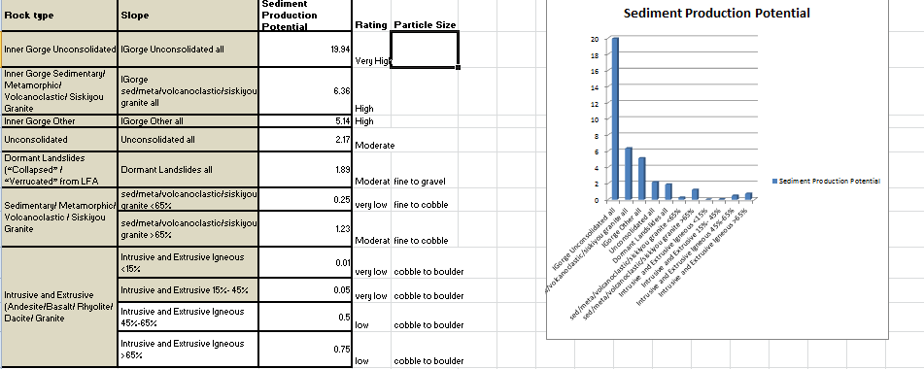

- Channel density - GIS
- PRISM (average annual precipitation/temperature) (ask Chris Ringo for OSU data
- Stream reach response (source, transport, deposition) see Buffington paper 0-3%= deposition, 3-8%=transport, >8%=source
- Surface runoff (Hydrologic Group) (from SRI or NRCS soil layers)
- elevation,
- aspect
- Slope (mean for LFA)
- Fish Distribution / Maybe have a layer? (Karen to ask Jim)
- Scarps, Avalanche tracks, landslide tracks from SRI point layer and DOGAMI SLIDO
- Seeps – springs point layer NHD and NWI, SRI point layer?
- Ponds - NHD
- Spawning Substrate Quality – Stream Survey –
- Rearing potential - pools?(source: stream survey- )
- Wet meadow - NWI, special habitat (forest by forest)

These are impt layers but still need work. I’ll let you know when they are ready.
- Mass Wasting -Jays LTA classification (needs refinement)
- Sediment Regime Source – Base Geology (use Landslide Risk categorization of rock-type erodibility (see Chart at back of doc – working with Carrie Gordon to edit.)
- Size – base on erodibility (above)
- Surface Erosion (disturbed, undisturbed) (need to discuss how to get at this)
- Rosgen classification – Stream survey data (not comprehensive)

