Blue Mountain Incised Plateaus
Plateau Any comparatively flat area of great extent and elevation; specifically an extensive land region considerably elevated (more than 150-300 m in altitude) above the adjacent country or above sea level; it is commonly limited on at least one side by an abrupt descent, has a flat or nearly smooth surface but is often dissected by deep valleys and surmounted by high hills or mountains, and has a large part of its total surface at or near the summit level. A plateau is usually higher and has more noticeable relief than a plain (it often represents an elevated plain), and is usually higher and more extensive than a mesa; it may be tectonic, residual, or volcanic in origin (Bates and Jackson, 1995). The Columbia River and associated basalt flows constitute one of the largest flood basalt flows in the world. The basalt flows emanated from a series of fractures in the earth surface. Initially they created a broad, nearly level plateau up to 8000 to 9000 feet thick that covered an area of 77,000 square miles across eastern Oregon and southwest Washington (Orr and Orr, 2012). Much of the plateau is without a perennial source of water.

Landform Association: Incised Plateaus:
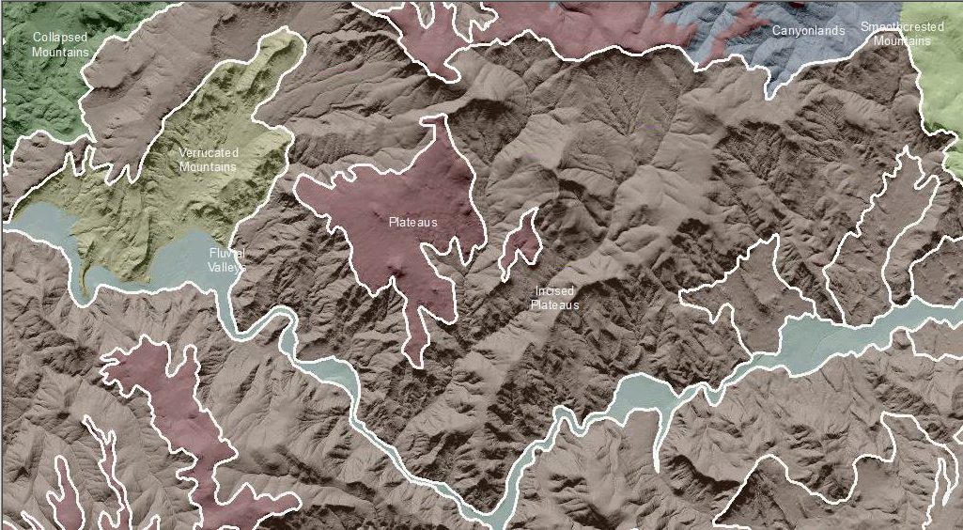

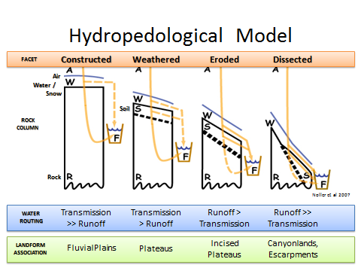
Incised refers to landscapes and landforms that retain their outlines and the majority of their mass but are experiencing and initial alteration of form due to weathering. Depending on stage of erosion, plateaus will manifest varying degrees of incision. Initially water is transmitted directly below ground through a series of fractures in the flow. As the original basalt flows weather, surface runoff increases. Fluvial erosion processes intiate incision and ephemeral stream channel formation. With increased weathering and erosion, runoff of snowment and precipitation dominates and deep incisions occur at weak points in the basalt flows. The plateau becomes highly incised, eventually giving way to deep incision of canyons which headcut back into the plateaus over time.
Figure XX: Noller depiction of landform relationships based on degree of weathering and erosion and runoff from the landscape.

Landtype Associations: Landtypes are formed by intersecting vegetation series or group of vegetation series with landform associations.
Landtype Association | Elevation  Average of MIN | Elevation Average of MAX | Elevation  Average of MEAN | Average of Proportion of North Aspect | Average of Proportion of South Aspect
Incised Plateaus | 1287.05 | 1548.85 | 1436.84 | 73.13% | 26.87%
Douglas-Fir | 1345.55 | 1563.42 | 1470.29 | 74.40% | 25.60%
Douglas-Fir - Grand Fir-White Fir | 1281.33 | 1493.07 | 1405.66 | 79.49% | 20.51%
Douglas-Fir - Grasslands / Meadows | 1178.59 | 1503.63 | 1371.37 | 69.22% | 30.78%
Douglas-Fir - Ponderosa Pine | 1298.33 | 1529.88 | 1434.49 | 71.17% | 28.83%
Douglas-Fir - Shrub-Steppe | 1169.93 | 1434.59 | 1316.61 | 77.59% | 22.41%
Douglas-Fir - Western Juniper | 1220.59 | 1360.14 | 1294.48 | 71.71% | 28.29%
Grand Fir-White Fir | 1327.74 | 1699.69 | 1543.15 | 82.95% | 17.05%
Grand Fir-White Fir - Douglas-Fir | 1409.32 | 1635.04 | 1551.74 | 81.15% | 18.85%
Grand Fir-White Fir - Ponderosa Pine | 1284.36 | 1468.25 | 1392.38 | 73.82% | 26.18%
Grand Fir-White Fir - Shrub-Steppe | 1149.23 | 1416.86 | 1312.76 | 75.00% | 25.00%
Grand Fir-White Fir - Subalpine Fir | 1554.79 | 1782.45 | 1695.41 | 85.59% | 14.41%
Grasslands / Meadows | 910.21 | 1293.95 | 1128.73 | 87.80% | 12.20%
Grasslands / Meadows - Douglas-Fir | 1026.19 | 1370.38 | 1182.79 | 96.16% | 3.84%
Grasslands / Meadows - Ponderosa Pine | 1019.40 | 1342.76 | 1183.26 | 70.72% | 29.28%
Grasslands / Meadows - Shrub-Steppe | 1459.45 | 1712.05 | 1581.67 | 57.95% | 42.05%
Grasslands / Meadows - Western Juniper | 866.55 | 1175.67 | 1078.56 | 67.70% | 32.30%
Parkland | 2233.71 | 2397.02 | 2306.29 | 74.59% | 25.41%
Ponderosa Pine | 1207.30 | 1480.68 | 1358.23 | 66.96% | 33.04%
Ponderosa Pine - Douglas-Fir | 1215.12 | 1493.66 | 1379.74 | 64.03% | 35.97%
Ponderosa Pine - Grand Fir-White Fir | 1219.60 | 1471.74 | 1366.45 | 59.94% | 40.06%
Ponderosa Pine - Grasslands / Meadows | 1093.36 | 1413.53 | 1256.81 | 48.62% | 51.38%
Ponderosa Pine - Shrub-Steppe | 1205.71 | 1454.52 | 1348.49 | 60.75% | 39.25%
Ponderosa Pine - Western Juniper | 906.46 | 1190.77 | 1071.02 | 77.80% | 22.20%
Shrub-Steppe | 1104.09 | 1312.18 | 1220.82 | 61.81% | 38.19%
Shrub-Steppe - Douglas-Fir | 1284.95 | 1444.10 | 1376.96 | 65.43% | 34.57%
Shrub-Steppe - Grand Fir-White Fir | 1063.23 | 1272.56 | 1150.58 | 53.55% | 46.45%
Shrub-Steppe - Grasslands / Meadows | 1331.72 | 1424.70 | 1384.70 | 54.62% | 45.38%
Shrub-Steppe - Ponderosa Pine | 1227.54 | 1435.54 | 1352.06 | 64.78% | 35.22%
Shrub-Steppe - Western Juniper | 1362.04 | 1502.54 | 1427.52 | 62.80% | 37.20%
Subalpine Fir | 1608.21 | 1949.49 | 1806.46 | 92.37% | 7.63%
Subalpine Fir - Grand Fir-White Fir | 1578.41 | 1841.03 | 1745.61 | 87.69% | 12.31%
Western Juniper | 1104.06 | 1422.45 | 1260.48 | 62.53% | 37.47%
Western Juniper - Douglas-Fir | 968.90 | 1248.19 | 1107.12 | 61.06% | 38.94%
Western Juniper - Ponderosa Pine | 874.98 | 995.08 | 954.53 | 62.38% | 37.62%
Incised Plateaus, Serpentinitic | 1615.66 | 1891.75 | 1759.41 | 60.49% | 39.51%
Grand Fir-White Fir | 1593.49 | 1872.21 | 1724.17 | 51.00% | 49.00%
Subalpine Fir | 1648.92 | 1921.05 | 1812.27 | 74.73% | 25.27%

Climate: Display this by vegzone as it varies with each veg zone (LTA) more than with LfA as a whole
Row Labels | Mean Annual Precipitation (mm) | Mean Annual Temperature | AET/PET ratio  June July Aug
Incised Plateaus | 629.88 | 6.63
Douglas-Fir | 622.18 | 6.41
Douglas-Fir - Grand Fir-White Fir | 578.89 | 6.75
Douglas-Fir - Grasslands / Meadows | 418.16 | 7.79
Douglas-Fir - Ponderosa Pine | 601.29 | 6.78
Douglas-Fir - Shrub-Steppe | 545.30 | 7.71
Douglas-Fir - Western Juniper | 420.89 | 7.22
Grand Fir-White Fir | 786.72 | 6.04
Grand Fir-White Fir - Douglas-Fir | 730.86 | 6.21
Grand Fir-White Fir - Ponderosa Pine | 621.19 | 6.64
Grand Fir-White Fir - Shrub-Steppe | 528.61 | 7.17
Grand Fir-White Fir - Subalpine Fir | 1108.62 | 5.62
Grasslands / Meadows | 386.88 | 8.67
Grasslands / Meadows - Douglas-Fir | 398.66 | 8.44
Grasslands / Meadows - Ponderosa Pine | 395.37 | 8.31
Grasslands / Meadows - Shrub-Steppe | 662.61 | 6.05
Grasslands / Meadows - Western Juniper | 373.60 | 8.87
Parkland | 1026.51 | 2.98
Ponderosa Pine | 537.04 | 6.99
Ponderosa Pine - Douglas-Fir | 624.42 | 6.86
Ponderosa Pine - Grand Fir-White Fir | 570.77 | 7.09
Ponderosa Pine - Grasslands / Meadows | 424.23 | 8.23
Ponderosa Pine - Shrub-Steppe | 520.61 | 7.19
Ponderosa Pine - Western Juniper | 410.23 | 8.61
Shrub-Steppe | 495.31 | 7.29
Shrub-Steppe - Douglas-Fir | 474.18 | 7.08
Shrub-Steppe - Grand Fir-White Fir | 494.34 | 7.01
Shrub-Steppe - Grasslands / Meadows | 452.13 | 6.91
Shrub-Steppe - Ponderosa Pine | 516.57 | 7.14
Shrub-Steppe - Western Juniper | 488.69 | 6.70
Subalpine Fir | 1008.05 | 5.05
Subalpine Fir - Grand Fir-White Fir | 1086.21 | 5.32
Western Juniper | 396.93 | 7.61
Western Juniper - Douglas-Fir | 403.86 | 8.63
Western Juniper - Ponderosa Pine | 403.41 | 8.97
Incised Plateaus, Serpentinitic | 723.46 | 5.34
Grand Fir-White Fir | 716.11 | 5.49
Subalpine Fir | 734.49 | 5.11

Geology:
- Bedrock Group - Extusive
- RockType - Basalt
Soils:
- Surface and subsurface soil texture
- Rock fragments
- Soil depth
- Depth To bedrock
- Drainage class
- Slope Mean: 18% Range: 14% - 36%
- Hydrologic runoff group
- Stability
  - Mass wasting potential
  - Shallow Rapid landslide potential
  - Surface soil erosion potential

Fire History:
- Fire Regime Group I -

Unique Habitats
- Seeps, springs
- Wetlands
- Lakes/ponds
- Scarps
- Debris Slides

Hydro/Water Quality:
- Stream Density
- Source/Transport Deposition
- Avg Sinuosity
- Bankfull Width (the survey data has an average bankfull width (ft) per surveyed stream length)
- Floodprone width (same here, this is an average value in ft)
- BF_W/D_ratio (same here, average value)
- Stream Temperature

Fish Habitat:
- Stream substrates
- Pools per mile
- Bull Trout
- Coho
- Reach Class

