Blue Mountain Incised Fluvial Plains
Plain [Landscape Term] A general term referring to an extensive, lowland area that ranges from level to gently sloping or undulating. A plain has few or no prominent hills or valleys, and usually occurs at low elevation relative to surrounding areas. (Bates and Jackson, 1980)

Landform Association:
Incised Fluvial Plains:

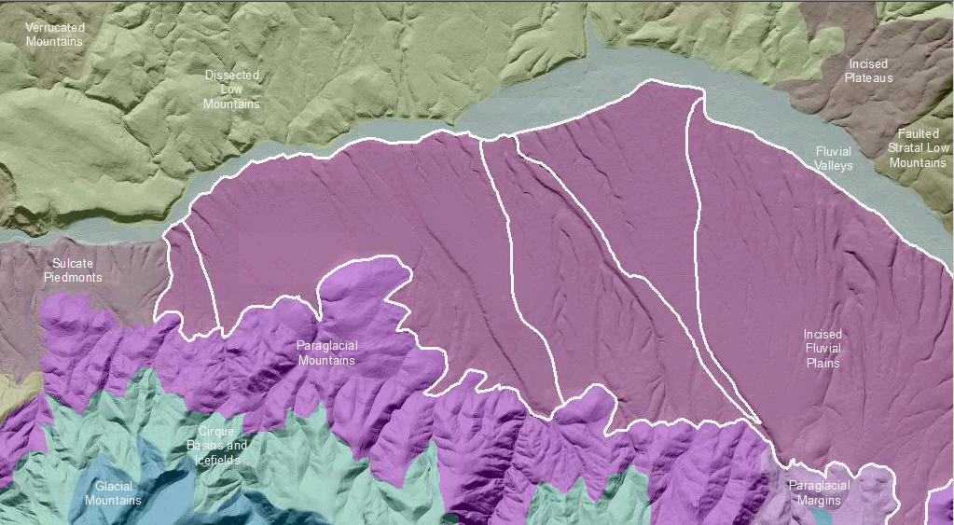

Incised Fluvial Plains are fluvial plains that have undergone deep incision by streams crossing the map unit. Fluvial Plains are an extensive, lowland area that ranges from level to gently sloping or undulating. Fluvial Plains are produced by migrating channels and floodplains of non-glacial streams. Locally, older deposits identified as terraces are included in this map unit. The bounds of fluvial plains conform to the surrounding uplands as they confine the streams. Uplift and or regional base level change leads to stream down cutting within Incised Fluvial Plains. The streams have developed deep V-shape to box-shape channels, some of which classify as small canyons. Remnants of the original surface are low to moderately sloping and weathered to deep soils. Local erosion down to bedrock leaves thin, immature soils. This unit is transitional to Piedmonts, which are more deeply incised.

This Landform Association is rare on National Forest System Lands.

Landtype Associations: Landtype Associations are formed by intersecting vegetation series or groups of vegetation series with Landform Associations.

Topography:
The following tables represent the average conditions for the Landform Association. Only lands within and adjacent to National Forest System Lands were mapped by this project. The entire EPA Level III Ecoregion is not covered by this mapping.

The percent of Landform Association (% of LfA) in bold in the table below refers to the percent of the Ecoregion represented by that Landform Association. The (% of LfA) numbers not in bold in the table below refer to the percent of each Landtype Association within the Landform Association.
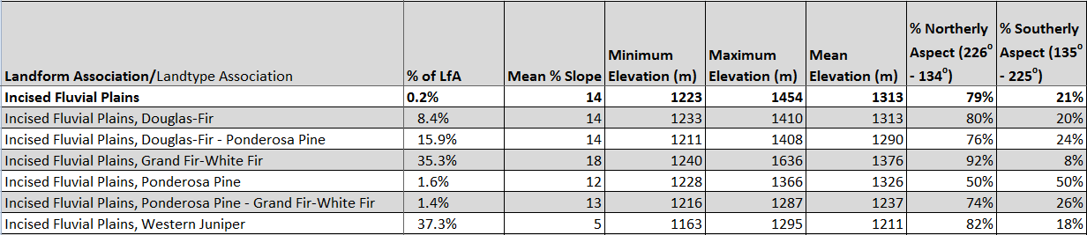

Climate:
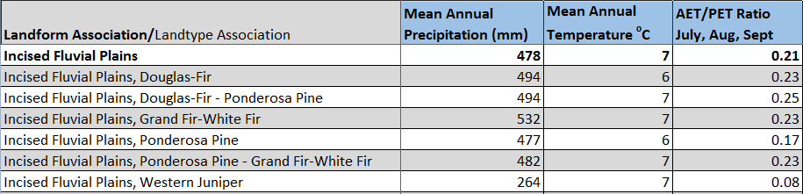

The ratio of Actual Evapotranspiration to Potential Evapotranspiration (AET/PET) is used as a broad-scale indicator of potential drought stress. We obtained modeled actual and potential evapotranspiration datasets from the Numerical Terradynamic Simulation Group at the University of Montana (http://www.ntsg.umt.edu/project/mod16) for a 30 year climate average. AET/PET ratio in the table above is based on a scale of zero to one. A value closer to 1 means the vegetation is transpiring close to its potential. A value farther from 1means that the Actual Evapotranspiration is below potential based on this climatic zone (Ringo, et. al. 2016 in draft).

