Blue Mountains Volcanoes and Flows
Terrain Class - Volcanoes: Volcanoes are edifies, typically conical in shape, with a central summit vent that erupts effusive magmatic material as ash, cinder, blocks and or lava that accumulates and build up the landform.
Landform Association –Volcanoes and Flows:
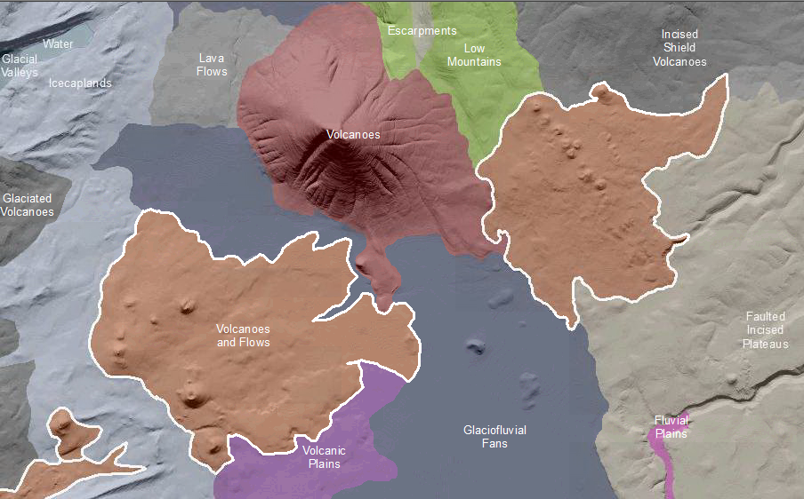

Volcanoes and Flows are volcanoes and their associated lava flows. The volcanoes are typically cinder cones which are conical in shape with steep sides formed by pyroclastic flows and air fall blocks. The cone is often breached by asymmetric basalt flows less commonly by flows of andesite or obsidian. Cones can be constructed by the full range of volcanic materials from basalt to andesite to dacite. Volcano summits are typically rounded off and side slopes may have gullies indicating soil profile development and the consequent decrease in transmissivity. Stream incision styles range from a sinuous, single threaded mainstem channel with limited tributaries, to dense and equally distributed networks of branching V-shaped channels.
Differential erosion along the margins of volcanoes and their associated lava flows yields mesa or low-relief plateau types of landforms. The volcanic rock shields this landscape from erosional land lowering as fast as adjacent landscapes.
Soils on this landscape are mature and have developed horizons that impede transmission of soil water, thence leading to the development of drainage networks. Soil taxa range from Mollisols with duripans (in dry climates) to Andisols (in humid climates). Lava flows can be recent exposures of raw lava or tree covered depending on environment.
This Landform Association has a common spatial extent on National Forest System Lands.

Landtype Associations: Landtype Associations are formed by intersecting vegetation series or groups of vegetation series with Landform Associations.

Topography:
The following tables represent the average conditions for the Landform Association. Only lands within and adjacent to National Forest System Lands were mapped by this project. The entire EPA Level III Ecoregion is not covered by this mapping.

The percent of Landform Association (% of LfA) in bold in the table below refers to the percent of the Ecoregion represented by that Landform Association. The (% of LfA) numbers not in bold in the table below refer to the percent of each Landtype Association within the Landform Associations.

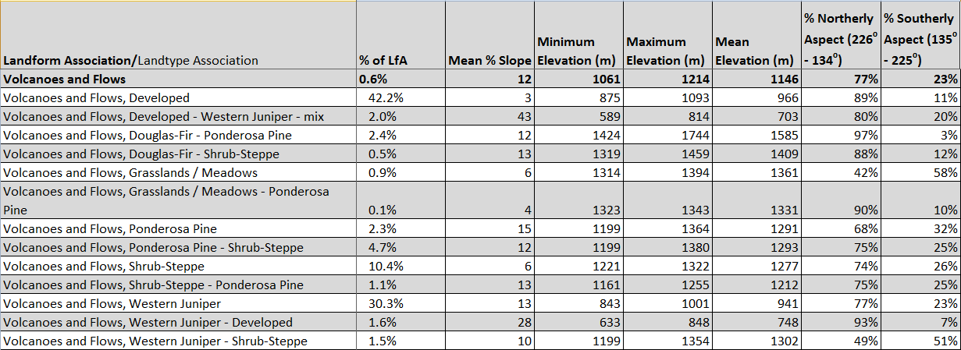

Climate:
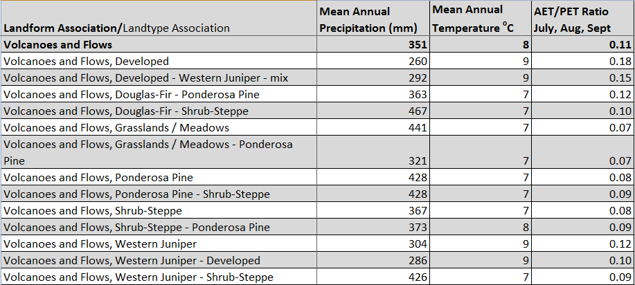

The ratio of Actual Evapotranspiration to Potential Evapotranspiration (AET/PET) is used as a broad-scale indicator of potential drought stress. We obtained modeled actual and potential evapotranspiration datasets from the Numerical Terradynamic Simulation Group at the University of Montana (http://www.ntsg.umt.edu/project/mod16) for a 30 year climate average. AET/PET ratio in the table above is based on a scale of zero to one. A value closer to 1 means the vegetation is transpiring close to its potential. A value farther from 1 means that the Actual Evapotranspiration is below potential based on this climatic zone (Ringo, et. al. 2016 in draft).

