Cascades Dissected High Mountains
Terrain Class: Mountains - No one process responsible for construction of mountains. They can be uplifted, tectonic, subduction of plates, folding, uplift, up and down warping of the mantle, inflation of molten lower crustal (batholiths), etc. Erosion of mountain systems occurs over time. The rate of erosion is dependent on the geomorphic process, the underlying rock structure, and the climate, including both freeze thaw and the amount and intensity of precipitation and runoff. Mountains are further defined and distinguished based on morphology, including the pattern and density of drainages, depth of drainages, overall morphology of the area between the drainages, evidence of a strong imprint of a surficial process such as glaciation, and presence of visible underlying rock structure.
Mountains have simple to very complex forms that have arisen due to inherited rock structure, rock history, and are the net result of local to regional spatial scales of competing rates of upbuilding/uplift and downgrading/erosion. Mountains will have an inherited history from weathering and degradation of the underlying stack of earth materials that forms them. Vegetation, habitat, water interception, collection and transport will share a similar history in the same type of uplift and rock.

Landform Association: Dissected High Mountains
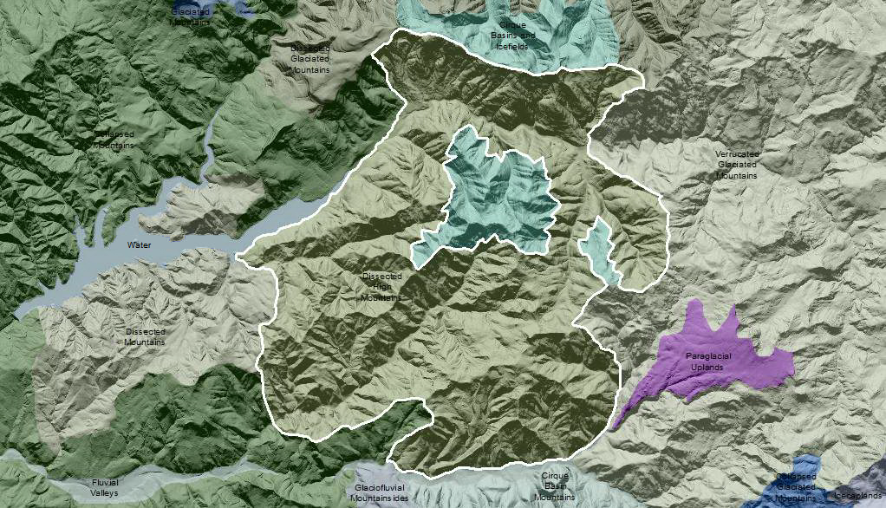

Dissected High Mountains are mountainous areas below the equilibrium line altitude for ice accumulation to have formed glaciers and that have a high degree of dissection. These areas belong to the “high” relief class. Fluvial erosion and mass wasting over time has resulted in a highly dissected landscape with deep V-shaped valley walls, planar in form, that are contiguous from ridge-top to valley bottom. It is no longer evident what the landscape was like previously. Some slope angles are greater than repose and are bare rock or outcroppings. Thickest soils gather in valley bottoms and collect in tributary gullies.

This Landform Association has a limited spatial extent on National Forest System Lands.

Landtype Associations: Landtype Associations are formed by intersecting vegetation series or groups of vegetation series with Landform Associations.

Topography:
The following tables represent the average conditions for the Landform Association. Only lands within and adjacent to National Forest System Lands were mapped by this project. The entire EPA Level III Ecoregion is not covered by this mapping.

The percent of Landform Association (% of LfA) in bold in the table below refers to the percent of the Ecoregion represented by that Landform Association. The (% of LfA) numbers not in bold in the table below refer to the percent of each Landtype Association within the Landform Association.

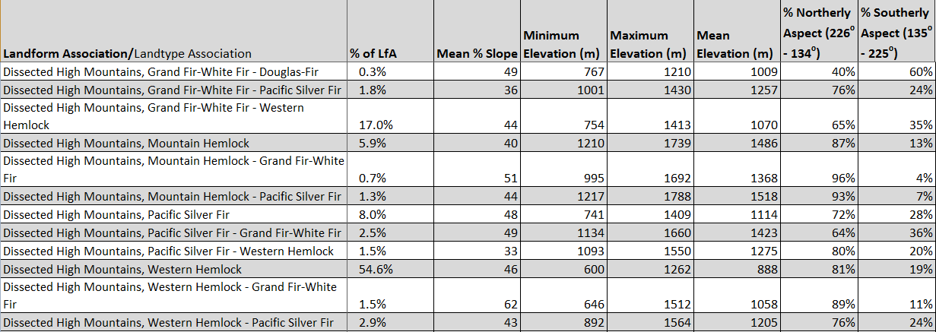

Climate:

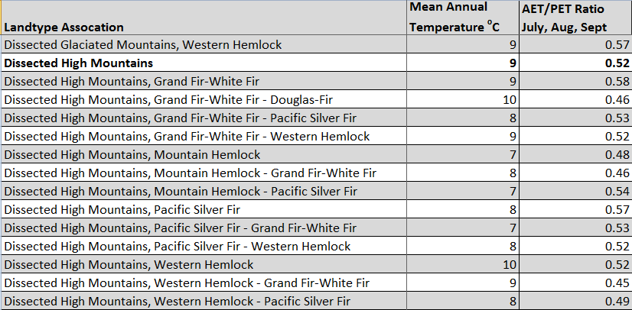

The ratio of Actual Evapotranspiration to Potential Evapotranspiration (AET/PET) is used as a broad-scale indicator of potential drought stress. We obtained modeled actual and potential evapotranspiration datasets from the Numerical Terradynamic Simulation Group at the University of Montana (http://www.ntsg.umt.edu/project/mod16) for a 30 year climate average. AET/PET ratio in the table above is based on a scale of zero to one. A value closer to 1 means the vegetation is transpiring close to its potential. A value farther from 1means that the Actual Evapotranspiration is below potential based on this climatic zone (Ringo, et. al. 2016 in draft).

