Cascades Lacustrine Plains
Overall Terrain:
Plains [Landscape Term] A general term referring to an extensive, lowland area that ranges from level to gently sloping or undulating. A plain has few or no prominent hills or valleys, and usually occurs at low elevation relative to surrounding areas. (Bates and Jackson, 1980)

Landform Association:
Lacustrine Plains:

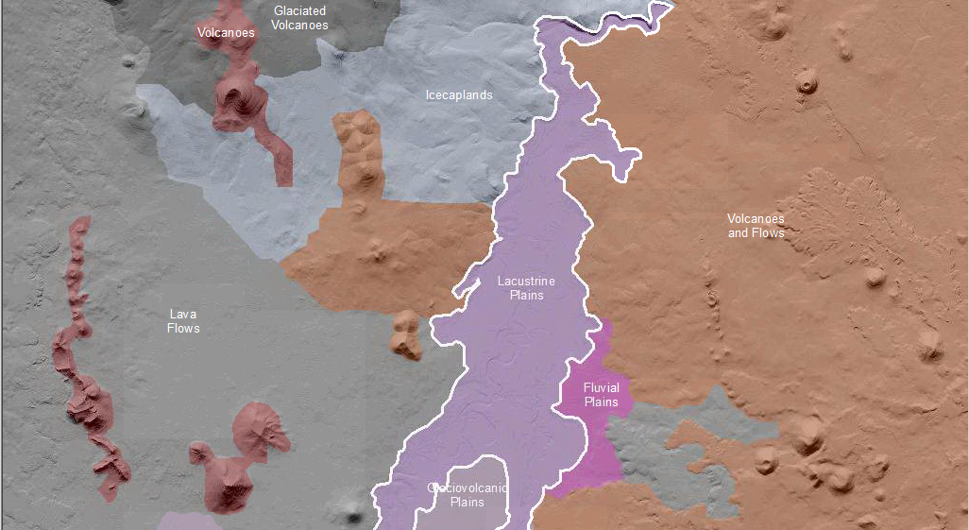

Lacustrine Plains
Lacustrine Plains are exposed lakebeds that are the relicts of (pluvial) Pleistocene lakes that were once ubiquitous in the Great Basin and the Northwest. This landform excludes relict lakebeds pluvially altered or incised by subsequent water flow and lakebeds that are the results of recent anthropogenic activities. The low angle or zero slope lakebed is the result of accumulated sediments in the lake bottoms. The collections of silt and clays provide productive soils when moisture is available. These deposits are sources of eolian dust and local sand dune fields. Soils on these deposits are typically Mollisols to Aridisols (especially along the margins of extant lakes where salts accumulate within the profile. Playas are at a smaller scale than the Lacustrine Plains and are in arid to semi-arid regions. Playas have oblong to circular shape. Lacustrine areas may or may not be connected to another watershed.

This Landform Association is rare on National Forest System Lands.

Landtype Associations: Landtype Associations are formed by intersecting vegetation series or groups of vegetation series with Landform Associations.

Topography:
The following tables represent the average conditions for the Landform Association. Only lands within and adjacent to National Forest System Lands were mapped by this project. The entire EPA Level III Ecoregion is not covered by this mapping.

The percent of Landform Association (% of LfA) in bold in the table below refers to the percent of the Ecoregion represented by that Landform Association. The (% of LfA) numbers not in bold in the table below refer to the percent of each Landtype Association within the Landform Association.
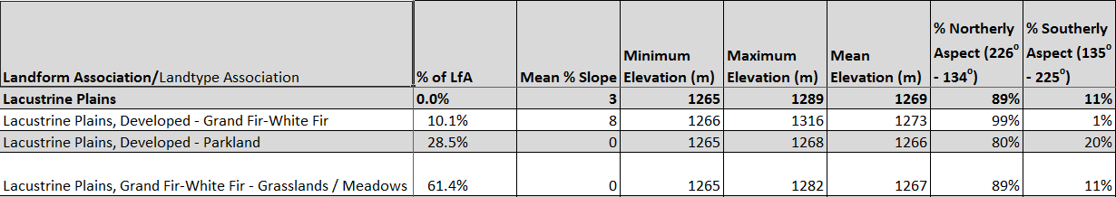

Climate:
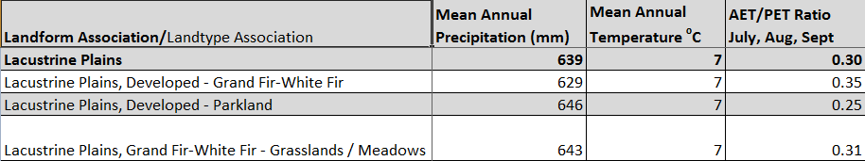

The ratio of Actual Evapotranspiration to Potential Evapotranspiration (AET/PET) is used as a broad-scale indicator of potential drought stress. We obtained modeled actual and potential evapotranspiration datasets from the Numerical Terradynamic Simulation Group at the University of Montana (http://www.ntsg.umt.edu/project/mod16) for a 30 year climate average. AET/PET ratio in the table above is based on a scale of zero to one. A value closer to 1 means the vegetation is transpiring close to its potential. A value farther from 1means that the Actual Evapotranspiration is below potential based on this climatic zone (Ringo, et. al. 2016 in draft).

