Cascades Glacial Plateaus
Overall Terrain:
Plateaus in the Pacific Northwest are predominantly underlain by stacked flows of the Columbia River Basalts and form extensive elevated plains bounded on one or more sides by steep slopes hundreds of feet above adjoining areas. Plateaus are differentiated from each other by the most-evident surficial processes of alteration.

Landform Association:
Glacial Plateaus:

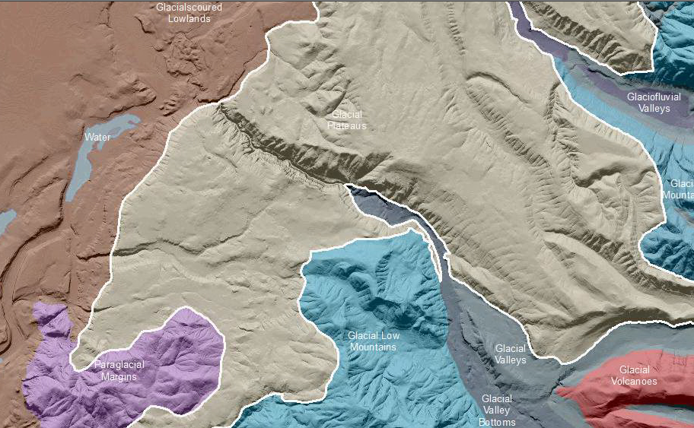

Glacial Plateaus are plateaus with obvious ice-carved landforms including cirques and U-shaped valleys. Plateaus adjacent to Mt. Rainier were eroded by alpine glaciers. Thin to no soil is present where the plateau is scoured and deeper soils develop in localizes area of till and meltwater deposition. The plateau will be scoured in places with deeper soils captured in areas of deposition. Undulating topography occurs on the plateau surface. High precipitation enhances weathering and creates an environment with high forest productivity. Steep bedrock scoured glacial valley walls occur with colluvial material at the base. Sorted sediments can be found across the valley floor.

This Landform Association is rare on National Forest System Lands.

Landtype Associations: Landtype Associations are formed by intersecting vegetation series or groups of vegetation series with Landform Associations.

Topography:
The following tables represent the average conditions for the Landform Association. Only lands within and adjacent to National Forest System Lands were mapped by this project. The entire EPA Level III Ecoregion is not covered by this mapping.

The percent of Landform Association (% of LfA) in bold in the table below refers to the percent of the Ecoregion represented by that Landform Association. The (% of LfA) numbers not in bold in the table below refer to the percent of each Landtype Association within the Landform Association.
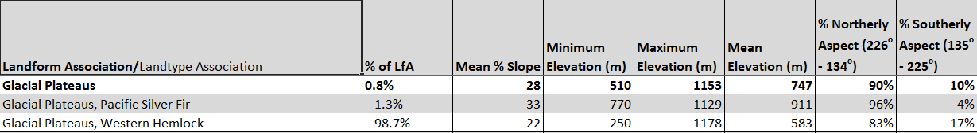

Climate:
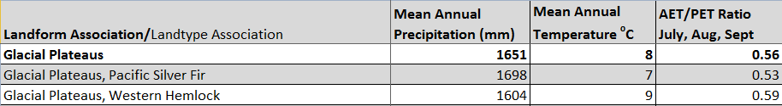

The ratio of Actual Evapotranspiration to Potential Evapotranspiration (AET/PET) is used as a broad-scale indicator of potential drought stress. We obtained modeled actual and potential evapotranspiration datasets from the Numerical Terradynamic Simulation Group at the University of Montana (http://www.ntsg.umt.edu/project/mod16) for a 30 year climate average. AET/PET ratio in the table above is based on a scale of zero to one. A value closer to 1 means the vegetation is transpiring close to its potential. A value farther from 1means that the Actual Evapotranspiration is below potential based on this climatic zone (Ringo, et. al. 2016 in draft).

