Cascades Canyons
Terrain Class: Valley [Landscape Term] (a) Any low-lying land bordered by higher ground; esp. an elongate, relatively large, gently sloping depression of the Earth's surface, commonly situated between two mountains or between ranges of hills or mountains, and often containing a stream with an outlet. It is usually developed by stream erosion, but may be formed by faulting. (b) A broad area of generally flat land extending inland for a considerable distance, drained or watered by a large river and its tributaries; a river basin. (Bates and Jackson, 1995)

Landform Association:
Canyons
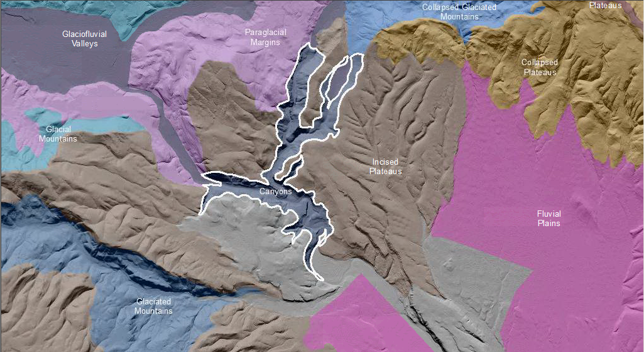

Canyons are long, deep, relatively narrow steep-sided valley confined between lofty and precipitous walls in a plateau or mountainous area, often with a stream at the bottom; similar to, but larger than, a gorge. It is characteristic of arid or semiarid areas where stream downcutting greatly exceeds weathering (BJ 1995, FS Geomorph). Canyons are often isolated low linear concave features that at the base have a fluvial channel that may or may not be active. The active channel processes that is visible may not be the original process that formed this landscape. The magnitude at present may not be representative of the magnitude in the past. A central active channel is cutting a narrow slot that erodes or causes the collapse and mass movement of material to the channel where water flow removes it. Rock removal occurs because of slope mass collapse or movement. Recognition of the different processes occurring along the walls of the feature parallel to the current river or stream is what differentiates these features from one another.

Canyons have predominantly droughty soil conditions. However, the colluvial soil in lower landscape positions trap water and sediments. This can result in well-developed soils that hold moisture and facilitate better vegetation, timber and habitat. In this colluvial terrain positive landforms have developed overtime changing from concave to convex. This colluvial terrain is often neglected and is a source of excellent habitat. Soils found on hilltops are deep and those by depressions or ponds are thin, counter to expectation.

This Landform Association does not exist on National Forest System Lands.

Landtype Associations: Landtype Associations are formed by intersecting vegetation series or groups of vegetation series with Landform Associations.

No information is available at this time since this is off of National Forest System lands.

