Cascades Meltwater Canyons
Terrain Class: Valley [Landscape Term] (a) Any low-lying land bordered by higher ground; esp. an elongate, relatively large, gently sloping depression of the Earth's surface, commonly situated between two mountains or between ranges of hills or mountains, and often containing a stream with an outlet. It is usually developed by stream erosion, but may be formed by faulting. (b) A broad area of generally flat land extending inland for a considerable distance, drained or watered by a large river and its tributaries; a river basin. (Bates and Jackson, 1995)

Landform Association: Meltwater Canyons
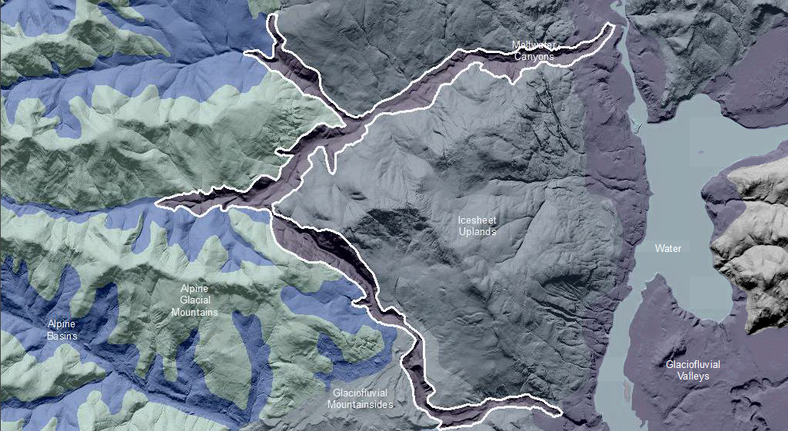

Meltwater Canyons are sometimes called “Coulees”. They are landforms sculpted by glaciofluvial process in subglacial and epi-glacial locations. Meltwater Canyons were created during the melting, collapse and recession of alpine or continental glaciers. As a result, they often break through ridge systems or topographic highs that appear today. The Meltwater Canyon landscape patterns are anastomosing, that is, the valleys truncate downstream sometimes coming together then diverting again. The canyon forming flow of water may be entirely opposite what it is today. Therefore sediments would be the opposite of what is expected and would coarsen in the lower portions of today’s channels; they are not gradient developed stream course deposits. Meltwater Canyons are typically recognized as valleys with under-fit streams too small to be the source of fluvial erosion that created the valley. If no streams are present, they are recognized as current day wind gaps which cross watershed divides. Current stream courses, if they do exist, would be starved of sediment since the original erosional processes no longer exist; they capture sediment by eroding stream banks and widening the stream course. The valley bottom deposits are highly variable in thickness. Valley walls are generally bedrock with little soil development. Meltwater Canyons are similar to Meltwater Valleys but they are steeper sided and deeper.

This Landform Association is rare on National Forest System Lands.

Landtype Associations: Landtype Associations are formed by intersecting vegetation series or groups of vegetation series with Landform Associations.

Topography:
The following tables represent the average conditions for the Landform Association. Only lands within and adjacent to National Forest System Lands were mapped by this project. The entire EPA Level III Ecoregion is not covered by this mapping.

The percent of Landform Association (% of LfA) in bold in the table below refers to the percent of the Ecoregion represented by that Landform Association. The (% of LfA) numbers not in bold in the table below refer to the percent of each Landtype Association within the Landform Association.

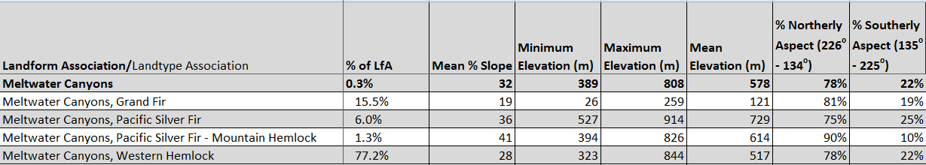

Climate:

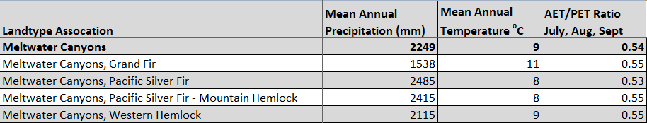

The ratio of Actual Evapotranspiration to Potential Evapotranspiration (AET/PET) is used as a broad-scale indicator of potential drought stress. We obtained modeled actual and potential evapotranspiration datasets from the Numerical Terradynamic Simulation Group at the University of Montana (http://www.ntsg.umt.edu/project/mod16) for a 30 year climate average. AET/PET ratio in the table above is based on a scale of zero to one. A value closer to 1 means the vegetation is transpiring close to its potential. A value farther from 1means that the Actual Evapotranspiration is below potential based on this climatic zone (Ringo, et. al. 2016 in draft).

