Cascades Dissected Volcanic Mountains
Volcanoes are edifies, typically conical in shape, with a central summit vent that erupts effusive magmatic material as ash, cinder, blocks and or lava that accumulates and build up the landform.
Landform Association – Dissected Volcanic Mountains:
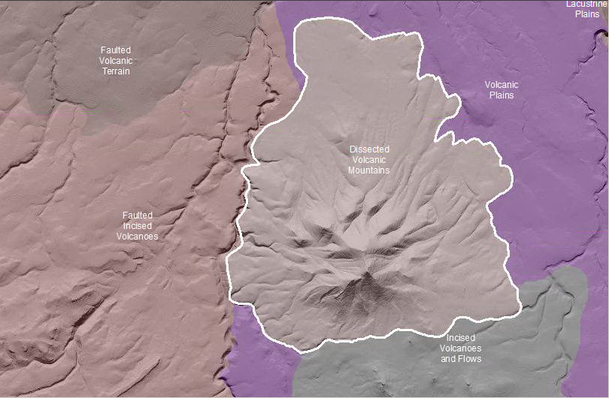

Dissected Volcanic Mountains are areas where volcanoes once occupied the landscape and belong to the mountain relief class. The original volcanoes are Tertiary to Quaternary in age. Dissected Volcanic Mountain landscapes have developed distinct stream systems. The stream channels have V-shaped valley walls that are linear-linear in form from ridge-top to valley bottom. It is no longer evident what the landscape was like previously. Some slope angles are greater than repose and are bare rock or outcroppings. Thickest soils gather in valley bottoms and collect in tributary headwalls.
This Landform Association has a limited spatial extent on National Forest System Lands.

Landtype Associations: Landtype Associations are formed by intersecting vegetation series or groups of vegetation series with Landform Associations.

Topography:
The following tables represent the average conditions for the Landform Association. Only lands within and adjacent to National Forest System Lands were mapped by this project. The entire EPA Level III Ecoregion is not covered by this mapping.

The percent of Landform Association (% of LfA) in bold in the table below refers to the percent of the Ecoregion represented by that Landform Association. The (% of LfA) numbers not in bold in the table below refer to the percent of each Landtype Association within the Landform Associations.
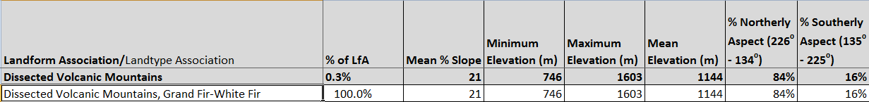

Climate:

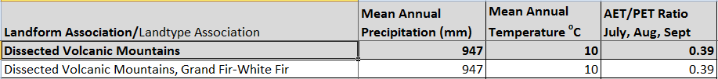
The ratio of Actual Evapotranspiration to Potential Evapotranspiration (AET/PET) is used as a broad-scale indicator of potential drought stress. We obtained modeled actual and potential evapotranspiration datasets from the Numerical Terradynamic Simulation Group at the University of Montana (http://www.ntsg.umt.edu/project/mod16) for a 30 year climate average. AET/PET ratio in the table above is based on a scale of zero to one. A value closer to 1 means the vegetation is transpiring close to its potential. A value farther from 1means that the Actual Evapotranspiration is below potential based on this climatic zone (Ringo, et. al. 2016 in draft).

