Cascades Volcano Mountains
Terrain Class - Volcanoes: Volcanoes are edifies, typically conical in shape, with a central summit vent that erupts effusive magmatic material as ash, cinder, blocks and or lava that accumulates and build up the landform.
Landform Association –Volcano Mountains:
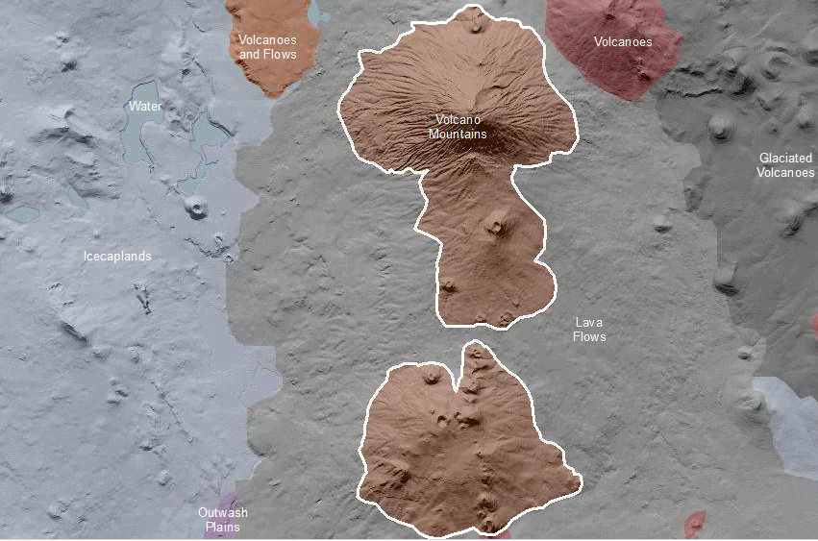

Volcano Mountains are volcanoes whose relief class are mountains and are not otherwise distinguished. Volcano Mountains are edifies, typically conical in shape, with a central summit vent that erupts effusive magmatic material as ash, cinder, blocks and or lava that accumulates and build up the landform.
Volcanoes in this undifferentiated unit lack one or more of the characteristic that would place them into one of the other volcano map units. Slopes vary from angle of repose or greater (>50%) on younger volcanoes to <10% on older, degraded volcanoes; soil profile development is inversely related in that lower slope gradients corresponds to mature soils, which are taxonomically classified as Andisols and Alfisols. High elevation areas tend to develop Spodosols either because of age, summit elevation and or latitude. These volcanoes lack defining features of glaciation. If of Pleistocene in age, these peaks must have been below the equilibrium line altitude for ice accumulation to have formed glaciers. If summits are above the Pleistocene equilibrium line altitude, then they must be too young (i.e. Holocene) to have accumulated ice to form glaciers.

This Landform Association has a limited spatial extent on National Forest System Lands.

Landtype Associations: Landtype Associations are formed by intersecting vegetation series or groups of vegetation series with Landform Associations.

Topography:
The following tables represent the average conditions for the Landform Association. Only lands within and adjacent to National Forest System Lands were mapped by this project. The entire EPA Level III Ecoregion is not covered by this mapping.

The percent of Landform Association (% of LfA) in bold in the table below refers to the percent of the Ecoregion represented by that Landform Association. The (% of LfA) numbers not in bold in the table below refer to the percent of each Landtype Association within the Landform Associations.

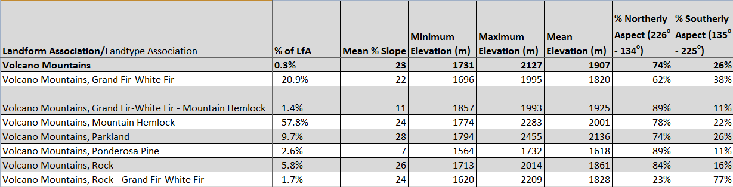

Climate:
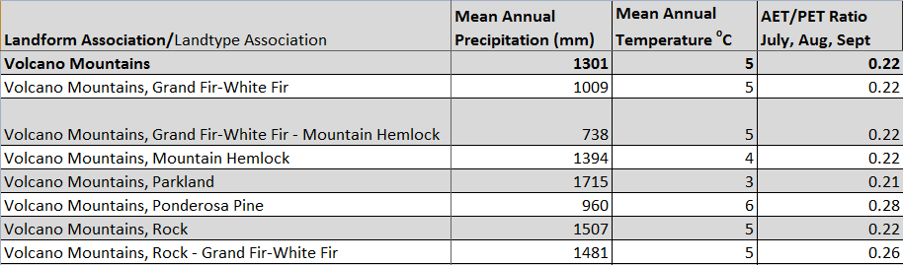

The ratio of Actual Evapotranspiration to Potential Evapotranspiration (AET/PET) is used as a broad-scale indicator of potential drought stress. We obtained modeled actual and potential evapotranspiration datasets from the Numerical Terradynamic Simulation Group at the University of Montana (http://www.ntsg.umt.edu/project/mod16) for a 30 year climate average. AET/PET ratio in the table above is based on a scale of zero to one. A value closer to 1 means the vegetation is transpiring close to its potential. A value farther from 1 means that the Actual Evapotranspiration is below potential based on this climatic zone (Ringo, et. al. 2016 in draft).

