Eastern Cascades Icecaplands
Terrain Class: Mountains - No one process responsible for construction of mountains. They can be uplifted, tectonic, subduction of plates, folding, uplift, up and down warping of the mantle, inflation of molten lower crustal (batholiths), etc. Erosion of mountain systems occurs over time. The rate of erosion is dependent on the geomorphic process, the underlying rock structure, and the climate, including both freeze thaw and the amount and intensity of precipitation and runoff. Mountains are further defined and distinguished based on morphology, including the pattern and density of drainages, depth of drainages, overall morphology of the area between the drainages, evidence of a strong imprint of a surficial process such as glaciation, and presence of visible underlying rock structure.
Mountains have simple to very complex forms that have arisen due to inherited rock structure, rock history, and are the net result of local to regional spatial scales of competing rates of upbuilding/uplift and downgrading/erosion. Mountains will have an inherited history from weathering and degradation of the underlying stack of earth materials that forms them. Vegetation, habitat, water interception, collection and transport will share a similar history in the same type of uplift and rock.

Landform Association: Icecaplands
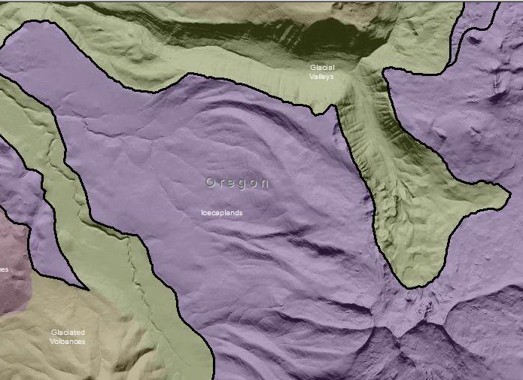

Icecaplands are a relatively new concept in mapping in the Cascades. This is terrain that has hosted or is hosting an ice cap. The terrain is a broadly scoured area and remnant glaciers may be present. The Olympic Mountains and North Cascades are examples of current icecaps. Upland areas show evidence of glaciation of an even greater magnitude than that which formed the adjoining glacial valley. Scouring and some deposition are evident at all elevations. In ranges where volcanism was present the tops of buttes that were extruded under the ice sheet have flat topped, fan or propeller shaped forms as a result of contact with the overlaying ice sheet. The ice sheet sheared the sub-glacial magma flows leaving these distinctly shaped forms. Eskers are left behind, as the ice cap melted. The eskers appear as cobble/sediment ridges and are the remains of deposits left in sub glacial channels. As water flowed under the ice cap there were areas of aggradation. As the ice cap melted these aggraded areas have a higher and linear relief above the scoured surrounding terrain. Eskers can be found ascending ridges as well as along valley floors. Moraines are also present with successive terminal moraines common and forming curvilinear ridges that fan across the landscape for miles. Medial moraines, that indicate the flow lines of glaciers long vanished, are often visible as ridges. Seemingly stranded in the landscape moraines or ice cap margins can indicate the borders of Pleistocene lakes and delineate icecap borderlands, landforms not entirely glacier formed that existed on the glacial margins. Ice cap uplands are mountains that the icecap flowed over and sculpted.

This Landform Association has an abundant spatial extent on National Forest System Lands.

Landtype Associations: Landtype Associations are formed by intersecting vegetation series or groups of vegetation series with Landform Associations.
Topography:
The following tables represent the average conditions for the Landform Association. Only lands within and adjacent to National Forest System Lands were mapped by this project. The entire EPA Level III Ecoregion is not covered by this mapping.

The percent of Landform Association (% of LfA) in bold in the table below refers to the percent of the Ecoregion represented by that Landform Association. The (% of LfA) numbers not in bold in the table below refer to the percent of each Landtype Association within the Landform Association.

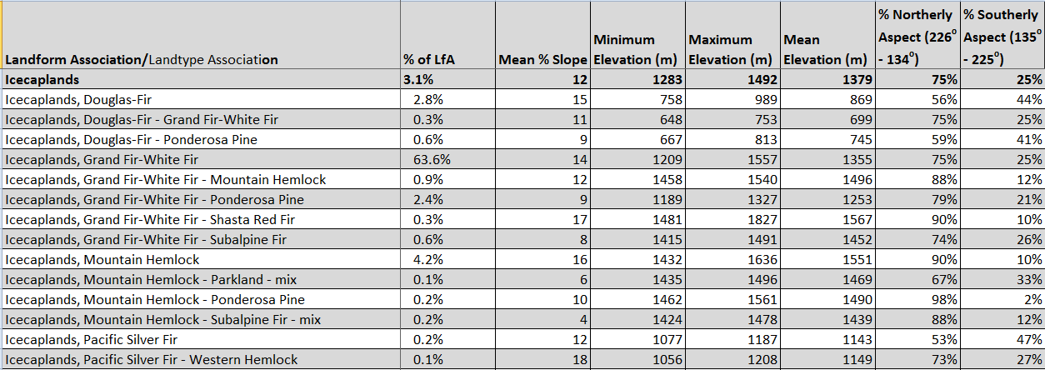

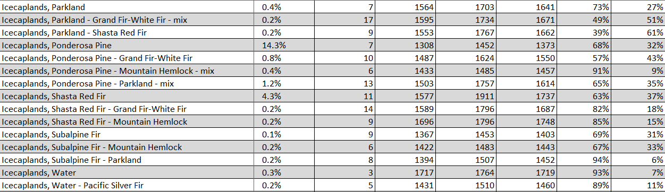

Climate:
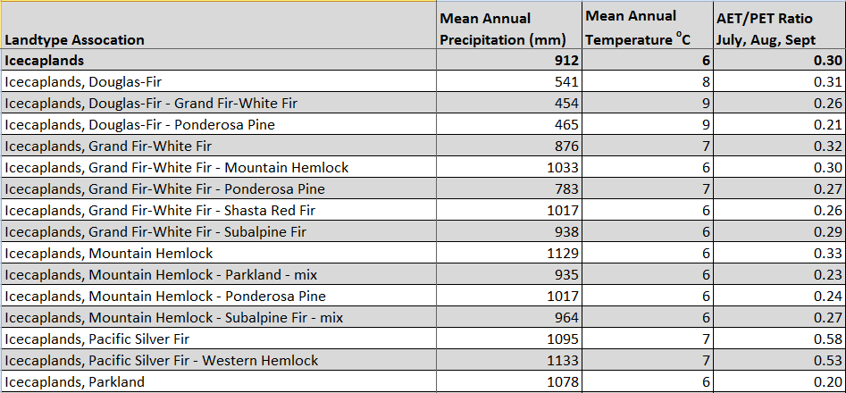
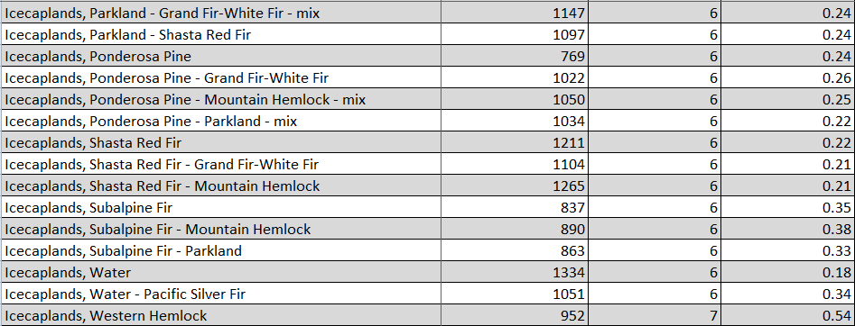

The ratio of Actual Evapotranspiration to Potential Evapotranspiration (AET/PET) is used as a broad-scale indicator of potential drought stress. We obtained modeled actual and potential evapotranspiration datasets from the Numerical Terradynamic Simulation Group at the University of Montana (http://www.ntsg.umt.edu/project/mod16) for a 30 year climate average. AET/PET ratio in the table above is based on a scale of zero to one. A value closer to 1 means the vegetation is transpiring close to its potential. A value farther from 1means that the Actual Evapotranspiration is below potential based on this climatic zone (Ringo, et. al. 2016 in draft).

