Eastern Cascades Faulted Incised Plains

Overall Terrain:
Plains [Landscape Term] A general term referring to an extensive, lowland area that ranges from level to gently sloping or undulating. A plain has few or no prominent hills or valleys, and usually occurs at low elevation relative to surrounding areas. (Bates and Jackson, 1980)

Landform Association:
Faulted Incised Plains:

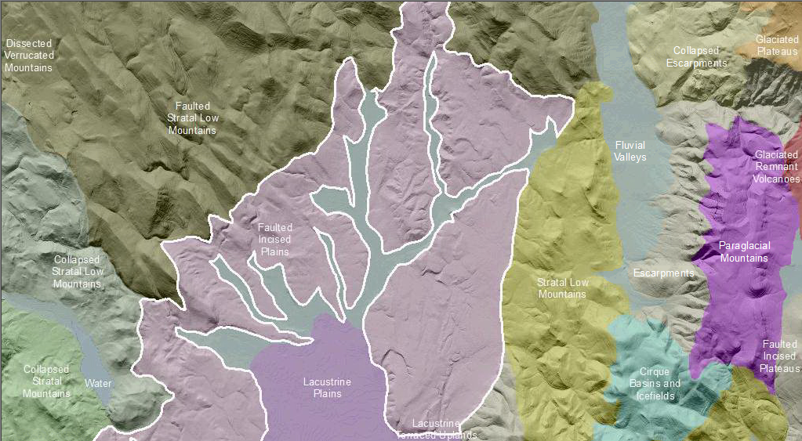

Faulted Incised Plains are broad lowland areas with diverse, angulate drainages and hilly topography. Fluvial processes are responsible for the deposition of the parent material forming the plain. Faulted Incised Plains are disrupted by fault movement. Faults provided the path for magma to leak or vent. Potentially active, these areas are cut by faults or fault scarps. Streams are entrenched in the surrounding landform and not necessarily connected to a floodplain. The landform may have a low surface roughness and likely lacks the "V-like" plan view common with dissected landforms
Faulting displacement of the plain surface has created positive (uplands) and negative (drainages) patterns with repeating topographic elements. These plains are characterized by numerous joints and faults over a broad area up to several kilometers in extent. Many of these faults show movement during the recent geologic past.

Faulted Incised Plains have a high drainage density with many ephemeral channels that follow the pattern of faults and deformed plains. Streams are captured and redirected by displacement of the fault blocks. This gives a zig-zag appearance to catchment channels. The faults are lined by crushed sediments that are more easily eroded and set up water flows along these zones. Deeper drainages develop than would be expected because of the captured discharge. Sediment is sometimes impounded by fault scarps, in closed depressions, and at locations with lower slope angle. In these pockets of sediment accumulation, as well as along joints and faults, soils develop faster and deeper.

This Landform Association is rare on National Forest System Lands.

Landtype Associations: Landtype Associations are formed by intersecting vegetation series or groups of vegetation series with Landform Associations.

Topography:
The following tables represent the average conditions for the Landform Association. Only lands within and adjacent to National Forest System Lands were mapped by this project. The entire EPA Level III Ecoregion is not covered by this mapping.

The percent of Landform Association (% of LfA) in bold in the table below refers to the percent of the Ecoregion represented by that Landform Association. The (% of LfA) numbers not in bold in the table below refer to the percent of each Landtype Association within the Landform Association.
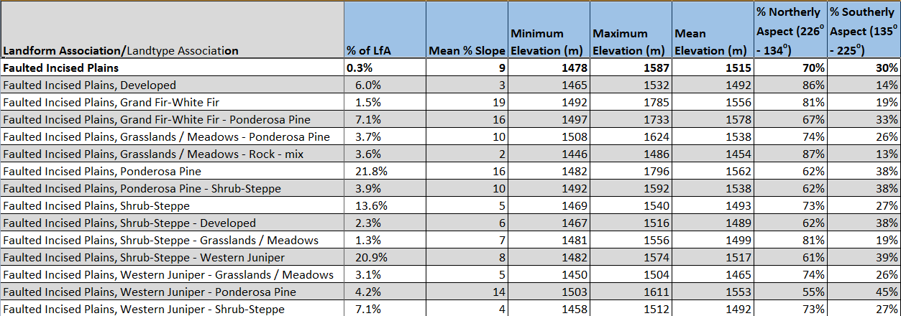

Climate:
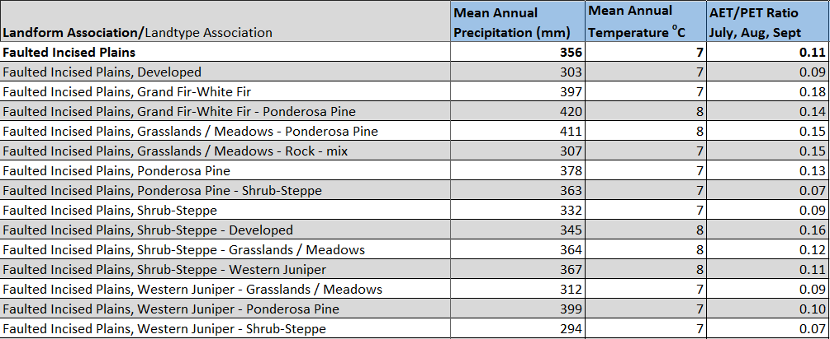

The ratio of Actual Evapotranspiration to Potential Evapotranspiration (AET/PET) is used as a broad-scale indicator of potential drought stress. We obtained modeled actual and potential evapotranspiration datasets from the Numerical Terradynamic Simulation Group at the University of Montana (http://www.ntsg.umt.edu/project/mod16) for a 30 year climate average. AET/PET ratio in the table above is based on a scale of zero to one. A value closer to 1 means the vegetation is transpiring close to its potential. A value farther from 1means that the Actual Evapotranspiration is below potential based on this climatic zone (Ringo, et. al. 2016 in draft).

