Eastern Cascades Glaciovolcanic Plains
Overall Terrain:
Plains [Landscape Term] A general term referring to an extensive, lowland area that ranges from level to gently sloping or undulating. A plain has few or no prominent hills or valleys, and usually occurs at low elevation relative to surrounding areas. (Bates and Jackson, 1980)

Landform Association:
Glaciovolcanic Plains:

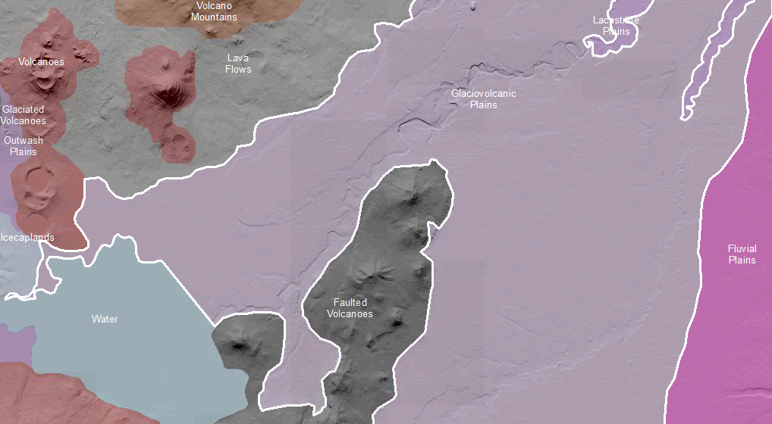

Glaciovolcanic Plains are plains derived from co-deposition of meltwater transported sediments and volcanic effusive deposits with rare flow rock. These plains front moraines of glacial valleys or margins of icecaplands. As such, they are similar to Outwash Plains. Glaciovolcanic Plains formed from braided water courses that deposited sediments in fans where unconfined and in long terraces where confined to valleys. Deposits are typically well sorted, ashy sands to ashy cobbly gravels. These deposits are typically many meters thick and yield deep Andisols. These deposits produce significant shallow aquifers.

This Landform Association has a limited spatial extent on National Forest System Lands.

Landtype Associations: Landtype Associations are formed by intersecting vegetation series or groups of vegetation series with Landform Associations.

Topography:
The following tables represent the average conditions for the Landform Association. Only lands within and adjacent to National Forest System Lands were mapped by this project. The entire EPA Level III Ecoregion is not covered by this mapping.

The percent of Landform Association (% of LfA) in bold in the table below refers to the percent of the Ecoregion represented by that Landform Association. The (% of LfA) numbers not in bold in the table below refer to the percent of each Landtype Association within the Landform Association.
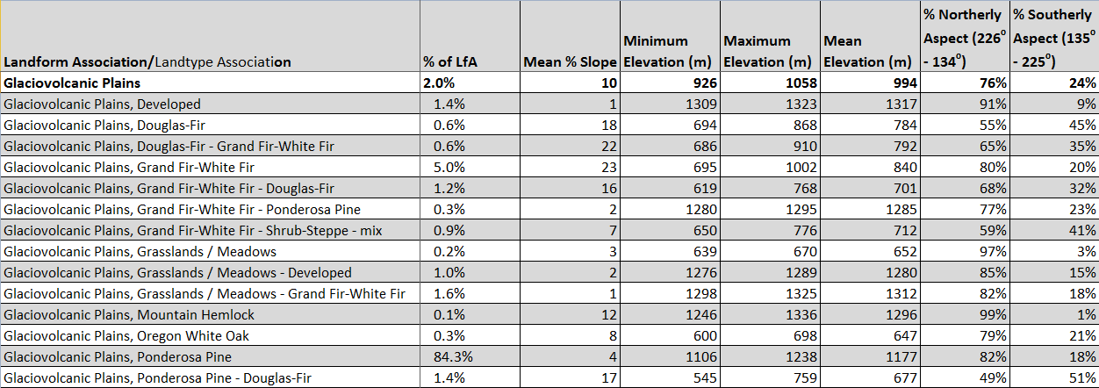

Climate:
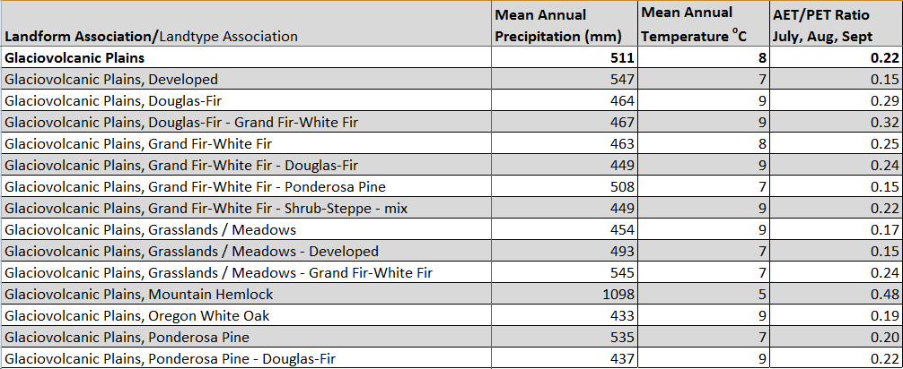
The ratio of Actual Evapotranspiration to Potential Evapotranspiration (AET/PET) is used as a broad-scale indicator of potential drought stress. We obtained modeled actual and potential evapotranspiration datasets from the Numerical Terradynamic Simulation Group at the University of Montana (http://www.ntsg.umt.edu/project/mod16) for a 30 year climate average. AET/PET ratio in the table above is based on a scale of zero to one. A value closer to 1 means the vegetation is transpiring close to its potential. A value farther from 1means that the Actual Evapotranspiration is below potential based on this climatic zone (Ringo, et. al. 2016 in draft).

