Eastern Cascade Sulcate Piedmonts
Overall Terrain:
Plain [Landscape Term] A general term referring to an extensive, lowland area that ranges from level to gently sloping or undulating. A plain has few or no prominent hills or valleys, and usually occurs at low elevation relative to surrounding areas. (Bates and Jackson, 1980)

Landform Association:
Sulcate Piedmonts:

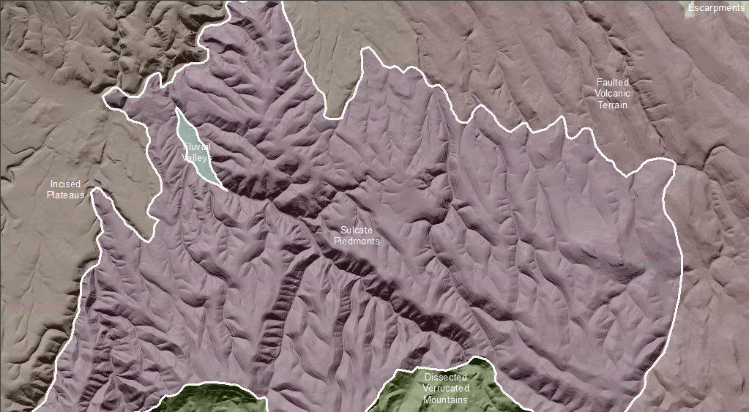

Sulcate Piedmonts are advance weathering and degradation phase of Piedmonts. They are characterized by surfaces with longitudinal furrows with crests that are smoothly convex and swales that are v-shaped. Drainage sideslopes are planar convex. Sulcate Piedmonts have repeating landform patterns of accordant ridges and swales. Unlike Piedmonts, the accordant ridges of this map unit are of unknown depth of erosion beneath the presumed original surface of the parent surface.

Soils on ridgetops tend to be rich in patterned ground, do-called biscuit scabland or mima mound micro-topography. The pattern ground or scabs tend to elongate on the backslopes forming stony stripes that virtually feed accumulation piles of stones at the toeslope position. Soil taxa vary from Ultisols in the west to Mollisols in the east.

This Landform Association has a limited spatial extent on National Forest System Lands.

Landtype Associations: Landtype Associations are formed by intersecting vegetation series or groups of vegetation series with Landform Associations.

Topography:
The following tables represent the average conditions for the Landform Association. Only lands within and adjacent to National Forest System Lands were mapped by this project. The entire EPA Level III Ecoregion is not covered by this mapping.

The percent of Landform Association (% of LfA) in bold in the table below refers to the percent of the Ecoregion represented by that Landform Association. The (% of LfA) numbers not in bold in the table below refer to the percent of each Landtype Association within the Landform Association.

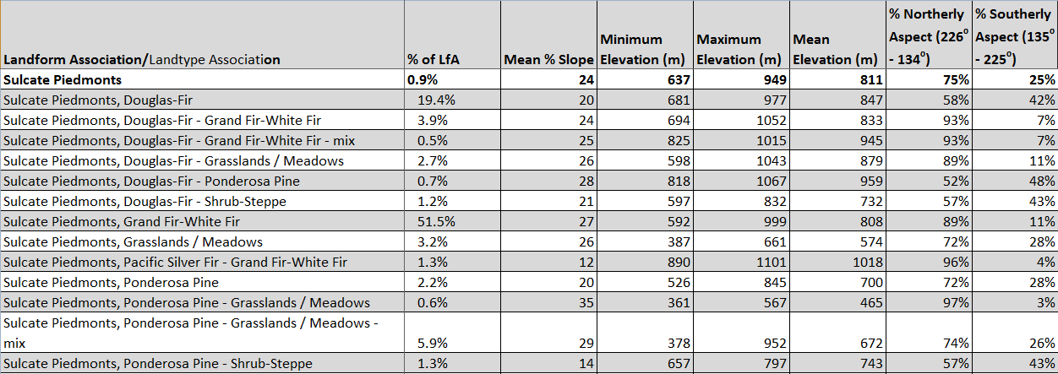
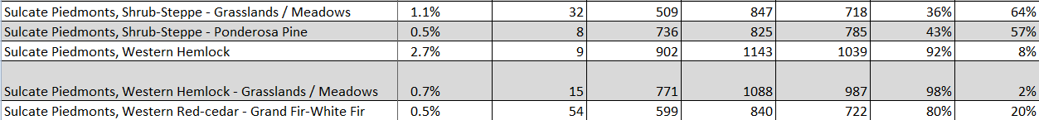

Climate:
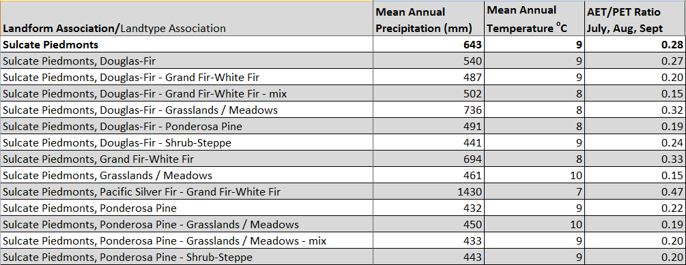
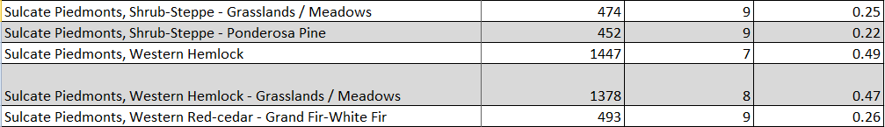

The ratio of Actual Evapotranspiration to Potential Evapotranspiration (AET/PET) is used as a broad-scale indicator of potential drought stress. We obtained modeled actual and potential evapotranspiration datasets from the Numerical Terradynamic Simulation Group at the University of Montana (http://www.ntsg.umt.edu/project/mod16) for a 30 year climate average. AET/PET ratio in the table above is based on a scale of zero to one. A value closer to 1 means the vegetation is transpiring close to its potential. A value farther from 1means that the Actual Evapotranspiration is below potential based on this climatic zone (Ringo, et. al. 2016 in draft).

