Eastern Cascades Collapsed Plateaus
Plateaus in the Pacific Northwest are predominantly underlain by stacked flows of the Columbia River Basalts and form extensive elevated plains bounded on one or more sides by steep slopes, hundreds of feet above adjoining areas. Plateaus are differentiated from each other by the most-evident surficial process of alteration.

Landform Association:
Collapsed Plateaus:
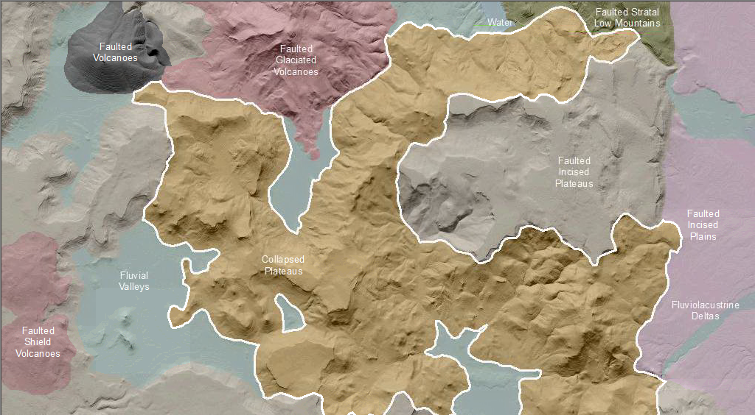
Collapsed Plateaus consists of plateaus that are dominated by landslides, with hummocky poorly-drained, chaotic fallen bedrock blocks that divert drainages and rivers. Landslide areas can cover many miles and may be from the pre-historic, past, or a recent and current development. Water routing through this landscape may be irregular due to recent and on-going slope failure with its accompanying surface and subsurface drainage diversions and impoundments. Sediment recruitment by streams is significant along the margins of collapsed plateaus. Sediment and water storage (such as a lake, meadow and or plain - current or historic) is locally significant upstream of collapsed landslide toes. Because of irregular slopes and varied surface water availability, this LfA has a most diverse upland habitat. The slide areas can hold deep soils, retain moisture and provide micro-climates that offer a variety of excellent resources for numerous floral and faunal communities.

This Landform Association is rare on National Forest System Lands.

Landtype Associations: Landtype Associations are formed by intersecting vegetation series or groups of vegetation series with Landform Associations.

Topography:
The following tables represent the average conditions for the Landform Association. Only lands within and adjacent to National Forest System Lands were mapped by this project. The entire EPA Level III Ecoregion is not covered by this mapping.

The percent of Landform Association (% of LfA) in bold in the table below refers to the percent of the Ecoregion represented by that Landform Association. The (% of LfA) numbers not in bold in the table below refer to the percent of each Landtype Association within the Landform Association.
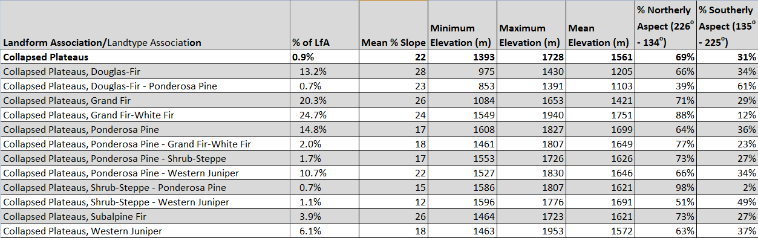

Climate:
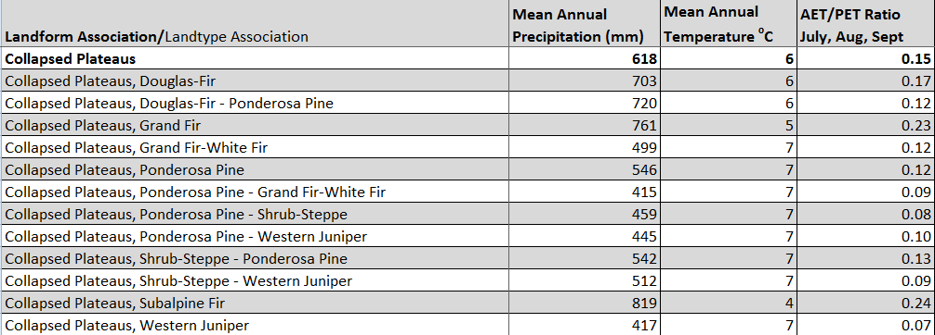

The ratio of Actual Evapotranspiration to Potential Evapotranspiration (AET/PET) is used as a broad-scale indicator of potential drought stress. We obtained modeled actual and potential evapotranspiration datasets from the Numerical Terradynamic Simulation Group at the University of Montana (http://www.ntsg.umt.edu/project/mod16) for a 30 year climate average. AET/PET ratio in the table above is based on a scale of zero to one. A value closer to 1 means the vegetation is transpiring close to its potential. A value farther from 1means that the Actual Evapotranspiration is below potential based on this climatic zone (Ringo, et. al. 2016 in draft).

